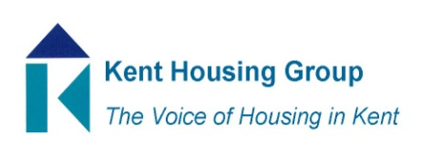
Asset Management Group
Agenda 16 January 2023 9.30-11.00 on Microsoft Teams

9.30 Introductions and matters arising from December 2022 meeting
9.40 Thermocill the energy saving passive device – Keith Rimmer
9.55 Update on Strategic Domestic Retrofit Group – Bethany Pepper
10.00 Standing Items;
Your questions and concerns
Dampness Mould and Condensation
Social Housing Decarbonisation fund – sharing ideas and good practice
Disrepair
Fire safety
10.45 KHG Fire Safety, Fuel Poverty and net zero and Autism events
10.50 AOB

MEETING TO CLOSE by 11.00

Asset Management’s objectives from K&M Housing Strategy;
Health and Wellbeing;
HW5 Promote and support the objectives of the Kent Fuel Poverty Strategy and the Kent Environment Strategy
HW9 Ensure housing is resilient to the future changes in climate to give the best possible health outcomes and prevent overheating

Working together for safer homes;
SH1 Anticipate, influence and shape implementation of new legislation and regulatory regime to improve the quality and safety of homes across the public and private sectors (for the public sector part)
SH2 Develop an even closer relationship with Kent Fire & Rescue around prioritising fire safety in all tenures, housing new and old, planning and infrastructure, prioritising any emerging legislation and regulation as a result of Grenfell (for the public sector buildings rather than behaviours part)
SH3 Share and learn from best practice locally, regionally and nationally to implement positive change to how homes are maintained
SH4 Strengthen the partnership working to include how Kent Housing Group respond collectively to local or national consultations that will impact upon the safety and well-being of Kent and Medway resident
SH5 Explore and learn about how new technology or approach can positively impact upon the delivery of new homes and enhance the condition of existing stock
Accelerating housing delivery
HD6 Explore, learn and share knowledge and experience of Modern Methods of Construction and to realise ambition regarding opportunities for off-site construction

