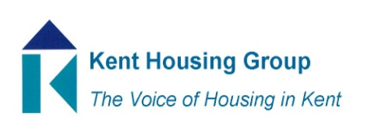
Kent Housing Engagement Group
7 November 10-11.00am
Agenda
- Matters arising from June Meeting
- How this group works, how to influence the agenda and be your organisations representative
- Introducing our new chair and seeking volunteers to be vice chair
- Talking about your job and how KHG Engagement group can support you
- How do you influence your communications service? How are they responding to TSMs? (SH7)
- Whole Systems Approach to Obesity – Abimbola Ojo, Public Health Specialist.
- Seeking venue for meeting on 3rd July, Any other business, topics for next time.
Dates for 2024; 8th February; 3rd July; 28th Nov; 10-11.15

Objectives for KEG in the K&M Housing Strategy;
Working together for safer homes;
SH1 Anticipate, influence and shape implementation of new legislation and regulatory regime to improve the quality and safety of homes across the public and private sectors
SH4 Strengthen the partnership working to include how Kent Housing Group respond collectively to local or national consultations that will impact upon the safety and well-being of Kent and Medway residents
SH6 Promote and facilitate the sharing of information about services that can be offered to residents to support the countywide and individual health and wellbeing agendas
SH7 Support and provide the opportunity for residents to share more effectively their voice on how their homes are managed and maintained, to provide them with confidence about their overall safety and well being
Affordability;
A8 Challenge the stigma associated with regards to social or affordable housing
A11 Promote and work in partnership with the third and voluntary sector to support all communities across Kent and Medway, when the services should be required

