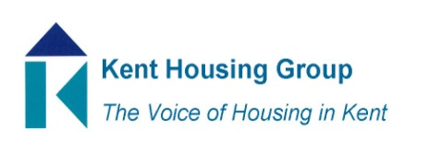
Kent Events Group Meeting Agenda
26 April 2023 10.00-11.00am

- Welcome new members, Lisa, Nicola and Robyn, and brief summary of what we do
- Update from actions in March meeting
- Awards 2023
- Identifying a venue - Becs
- Update on sponsors pledges - aim for £8500 – Becs
- Encouraging nominations - All
- Seek Kent based trophy and certificate frame providers Helen
- Events
Past events;
  - Launching the DA reciprocal agreement 3rd April - Feedback from Becs
Planning events
  - HSEG event for housing/planning/developers (Brian) (With Liz Crockford, Claire Pamberi, Simon Thomas and Nick Fenton)
  - Exempt accommodation (Becks & Helen)
  - Dampness and mould (with PSH, Asset Management, etc) (Robyn & Hannah)
  - Fire safety event on purpose built blocks of flats, KFRS, (27th June) (Helen)
- AOB
Date of Next meetings; 23 May; 20 June; 14 July; 6 Sept; 6 Oct; 16 Nov; 14 Dec and Judging KHG award nominations 23rd June.

