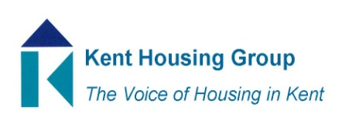
Kent Asset Management Group
21 February 2022 9.30-11.00 on Microsoft Teams
Agenda
9.30 Introductions
9.35 Kent and Medway Energy and Low Emissions Strategy – Sarah Deakin
9.45 KCC’s building standards for its own estate – Sarah Deakin
9.55 Members questions and concerns to include;
Social Housing Decarbonisation Fund – learning from wave 1 and planning for wave 2
Good practice for electric vehicle charging
Fire safety and future impact of Fire Safety Bill
Damp Mould and Disrepair
10.15 update on Net Carbon Zero trial subgroup
10.20 Terms of Reference – agree amended ToR
10.25 How this group delivers parts of K&M Housing Strategy
10.50 AOB and topics for next meeting
MEETING TO CLOSE by 11.00
Some objectives from K&M Housing Stratgegy;
Heading; Health and Wellbeing;
- Promote and support the objectives of the Kent Fuel Poverty Strategy and the Kent Environment Strategy
- Ensure housing is resilient to the future changes in climate to give the best possible health outcomes and prevent overheating

Heading; Working together for safer homes;
- Anticipate, influence and shape implementation of new legislation and regulatory regime to improve the quality and safety of homes across the public and private sectors (for the public sector part)
- Develop an even closer relationship with Kent Fire & Rescue around prioritising fire safety in all tenures, housing new and old, planning and infrastructure, prioritising any emerging legislation and regulation as a result of Grenfell (for the public sector buildings rather than behaviours part)
- Share and learn from best practice locally, regionally and nationally to implement positive change to how homes are maintained
- Explore and learn about how new technology or approach can positively impact upon the delivery of new homes and enhance the condition of existing stock

Heading; Accelerating housing delivery
- Explore, learn and share knowledge and experience of Modern Methods of Construction and to realise ambition regarding opportunities for off-site construction (does this group cover new stock or only existing)

