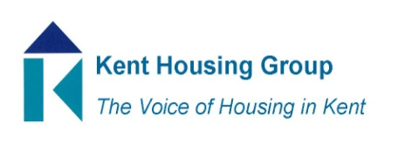
Kent Asset Management Group
2nd December 2021 9.30-11.00
Microsoft Teams (as shared in the calendar appointment)
Agenda
9.30 Introductions
9.35 GSE Energy Hub’s role in supporting Social Housing Decarbonisation fund bids
9.55 Procurement SEC new Framework – waiting for confirmation
Resident involvement
The dispose/improve decision
Trials and pilots – speaker to be confirmed
Learning from completed projects
10.35 Terms of Reference – Review suggested ToR
10.45 AOB and topics for next meeting

MEETING TO CLOSE by 11.00

