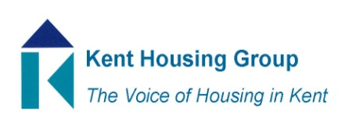
Kent Housing Engagement Group
2 November 2022 10-11am
Agenda
- Introductions and apologies
- Matters Arising from June meeting
- Improving tenant participation and STAP, Loren Paine (SH7)
- ReferKent, Stacey Clark (SH6)
- Group discussion; what should our standing items be?
- Any other business
Dates for 2023; 1st Feb; 22nd June; 8th November;

Objectives for KEG in the K&M Housing Strategy;
Working together for safer homes;
SH1 Anticipate, influence and shape implementation of new legislation and regulatory regime to improve the quality and safety of homes across the public and private sectors
SH4 Strengthen the partnership working to include how Kent Housing Group respond collectively to local or national consultations that will impact upon the safety and well-being of Kent and Medway residents
SH6 Promote and facilitate the sharing of information about services that can be offered to residents to support the countywide and individual health and wellbeing agendas
SH7 Support and provide the opportunity for residents to share more effectively their voice on how their homes are managed and maintained, to provide them with confidence about their overall safety and well being
Affordability;
A8 Challenge the stigma associated with regards to social or affordable housing
A11 Promote and work in partnership with the third and voluntary sector to support all communities across Kent and Medway, when the services should be required

