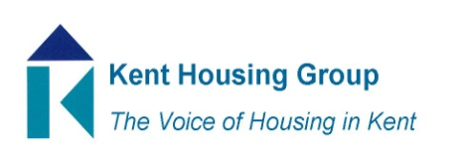
Kent Housing Engagement Group
Wednesday 24 November 2021 10-11
Microsoft Teams (as shared in the calendar appointment)
Agenda
- Introductions and apologies
- Matters Arising from September meeting
- White Paper
- CX Feedback tool – Lin Perkins
- Roundtable updates/discussions
- Chair and Vice Chair
- Topics for meeting on 10 February 2022
- Any other business

MEETING TO CLOSE by 11am

