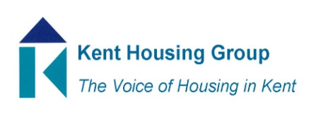
Kent Housing Engagement Group
29th June 2022 9-10am
Agenda
- Introductions and apologies
- Matters Arising from February meeting
- Which onboarding/welcome pack contents do you use and why?
- What to do next on delivering the Kent and Medway Housing Strategy
- Social Housing White Paper, Being Safe in your home, meeting tenants needs
- Becoming bid ready – a request from KHG Board
- Identifying topics for KHG events – a request from the Events group
- Topics for meeting on 2 November 2022
- Any other business

MEETING TO CLOSE by 10am
Objectives for KEG in the K&M Housing Strategy;
Working together for safer homes;
SH1 Anticipate, influence and shape implementation of new legislation and regulatory regime to improve the quality and safety of homes across the public and private sectors
SH4 Strengthen the partnership working to include how Kent Housing Group respond collectively to local or national consultations that will impact upon the safety and well-being of Kent and Medway residents
SH6 Promote and facilitate the sharing of information about services that can be offered to residents to support the countywide and individual health and wellbeing agendas
SH7 Support and provide the opportunity for residents to share more effectively their voice on how their homes are managed and maintained, to provide them with confidence about their overall safety and well being
Affordability;
A8 Challenge the stigma associated with regards to social or affordable housing
A11 Promote and work in partnership with the third and voluntary sector to support all communities across Kent and Medway, when the services should be required

