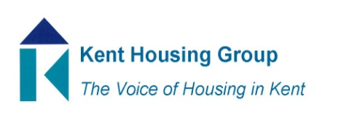
Kent Tenancy Fraud Forum
Thursday 18th November 10-11am
Microsoft Teams (as shared in the calendar appointment)
Agenda
- Introductions and apologies
- Matters Arising from meeting in May 2021
- Training session on unlawful profit orders
- Tenancy fraud awareness/another key amnesty
- General discussion
- Any other business

