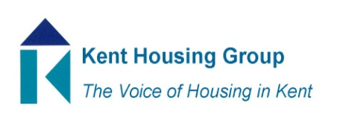
Kent Asset Management Group
1st October 2021 9.30-11.00
Microsoft Teams (as shared in the calendar appointment)
Agenda
9.30 Introductions
9.35 PAS2035: 2019 Peter Rickaby, Energy and Sustainability Consultant
10.05 Roundtable discussion on sustainability and decarbonisation including
Procurement
Resident involvement
The dispose/improve decision
Trials and pilots
Learning from completed projects
10.40 Terms of Reference (Aim, Objectives, How group operates, membership, etc.)
10.50 Volunteers for chair / vice chair role
10.55 AOB and topics for next meeting

MEETING TO CLOSE by 11.00

