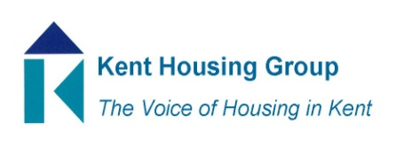
Kent Housing Options Group
Thursday 21st October 2021
The meeting will start promptly at 10.00am
Microsoft Teams (as shared in the calendar appointment)
Agenda
10.00 Matters Arising
10.10 DLUHC Update Alex Clarke
10.25 Research Practice Unit - Cynthia Allen and Adam Moll
10.40 SIG Pathway Partnership and new ways of working – Gill Arukpe
10.55 South East CFO Activity Hub – Nadia Hughes
11.05 Commissioning Updates (Adults, YP, DA,)
11.15 COMFORT BREAK
11.25 COMF Hardship Funding Update
11.40 Protocols update
12.05 Any Urgent National Policy, Case Law Updates
12.15 Agree amended ToR
12.20 AOB (to include any updates from our wider membership representation)

