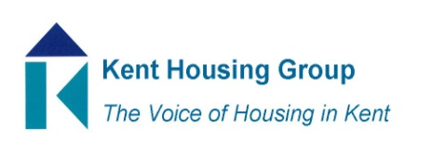
Kent Housing Options Group
Thursday 9th September 2021
The meeting will start promptly at 10.00am
Microsoft Teams (as shared in the calendar appointment)
Agenda
10.00am Matters Arising 24 June KHOG
10.05am MHCLG Update – Marie Gerald, MHCLG
10.20am KCC COMF Hardship Funding Update
10.40am Commissioning Updates (Adults, YP, DA, Drug and Alcohol)
10.55am Comfort break
11.05am KHG/KHOG Protocols Update
11.35am CAS3 Procurement, support, etc. Katie Sorrell, NPS
11.55pm Any Urgent National Policy, Case Law Updates
12:05pm Volunteers for vice chair role from December 2021
12.10 pm Review the KHOG Terms of Reference
12.20pm AOB (to include updates from wider membership representation)

MEETING TO CLOSE by 12.30pm

