HOUSING MANAGEMENT TEAM

Your Key Contacts
Please ring lawyers direct for general advice or call our main helpline number: 01962 678300

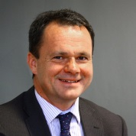 | DANIEL SKINNER  Partner  07841 004921  daniel.skinner@capsticks.com |  |  | HELEN GASCOIGNE  Associate  01962 678398  helen.gascoigne@capsticks.com | 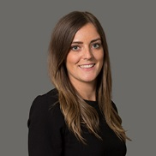 |  | VICTORIA SMITH  Solicitor  020 8780 4822  victoria.smith@capsticks.com
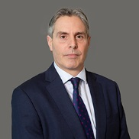 |  | Michael owen  Partner  01962 678376  michael.owen@capsticks.com | 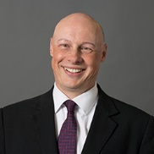 | JONATHAN HULLEY  Partner  020 8780 4826/07715 806584  jonathan.hulley@capsticks.com |  |  | CHRIS SKINNER  Partner  01962 678384  chris.skinner@capsticks.com
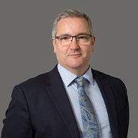 |  | PAUL LLOYD  Partner  01257 448141  paul.lloyd@capsticks.com | 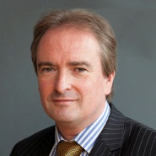 | CLIVE ADAMS  Legal Director  01962 678360  clive.adams@capsticks.com |  |  | SIMON STRELITZ  Barrister  07841 321905  simon.strelitz@capsticks.com
 |  | chris grose  Head of ASB Advisory Services  07894 807446  chris.grose@capsticks.com |  | REBECCA ASADY  Consultant  01257 448146  rebecca.asady@capsticks.com |  |  | SARAH CHRISTY  Associate  01962 678363  sarah.christy@capsticks.com
 |  | NATALIE HURST  Associate  01257 448142  natalie.hurst@capsticks.com |  | charlotte rawson  Associate  01962 678378  charlotte.rawson@capsticks.com | 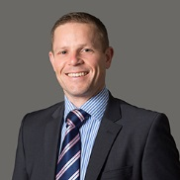 |  | IAN LARKINS  Associate  01257 448154  ian.larkins@capsticks.com
 |  | BRIDGET STARK-WILLS  Associate  0121 230 1504  bridget.stark-wills@capsticks.com |  | TOM BRADBURY  Solicitor  01257 448143  tom.bradbury@capsticks.com |  |  | CATHERINE AIREY  Solicitor  01962 678340  catherine.airey@capsticks.com
 |  | CLAIRE HOGAN-CLARK  Legal Executive  01257 448145  claire.hogan-clark@capsticks.com |  | JATINDER BHAMBER  Legal Executive  0208 780 6976  jatinder.bhamber@capsticks.com |  |  | HILARY DONLAN  Legal Assistant  01257 448147  hilary.donlan@capsticks.com
 |  | KAYLEIGH CHARLES  Legal Assistant  01962 678373  kayleigh.charles@capsticks.com |  | FILIP BODNAR  Senior Paralegal  01962 678390  filip.bodnar@capsticks.com |  |  | JAMES O’GRADY  Paralegal  01962 678332  james.o’grady@capsticks.com
 |  | BECKIE JAMES  Paralegal  0121 230 6563  beckie.james@capsticks.com | 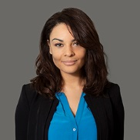 | IMA eKAETE  Paralegal  01962 678306  ima.ekaete@capsticks.com |  |  | DOM CHAPMAN  Paralegal  01962 678322  dom.chapman@capsticks.com
 |  | robyn barstow  Paralegal  01962 678316  robyn.barstow@capsticks.com | 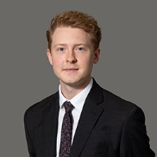 | GEORGE NICHOLAS  Paralegal  0121 262 6574  george.nicholas@capsticks.com
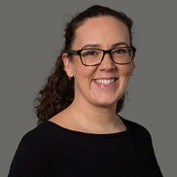 |  | RACHELLE BARNES  Personal Assistant  01962 678361  rachelle.barnes@capsticks.com | 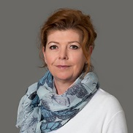 | NATALIE REID  Personal Assistant  01962 678399  natalie.reid@capsticks.com | 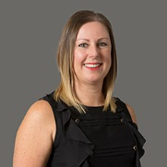 | JOANNA GREALLY  Personal Assistant  01257 448152  joanna.greally@capsticks.com
 |  | MICHELLE SOUTHERN  Personal Assistant  01257 448153  michelle.southern@capsticks.com |  | DONNA MCNALLY  Administrative Assistant  01257 448151  donna.mcnally@capsticks.com
Please feel free to ring lawyers direct for general advice or telephone our main number: 01962 678300

