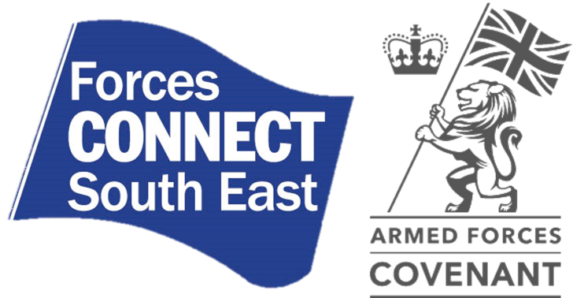
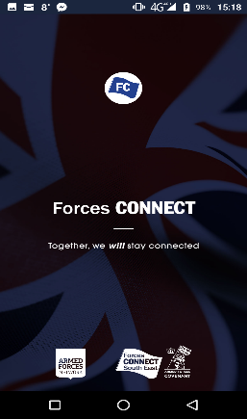
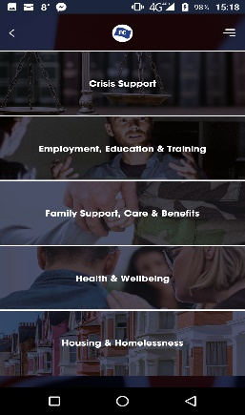
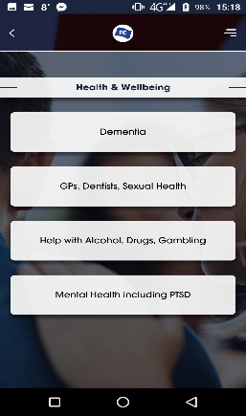
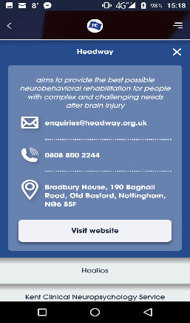

The Forces Connect South East Mobile Application
Key messages
- A brand-new mobile application is available to signpost the Armed Forces community to organisations that provide information, advice and support. Nothing like this currently exists.
- Development of the app was commissioned by Forces Connect South East as part of Armed Forces Covenant work
- The app is designed to be simple and easy to use, enabling simple navigation of thematic ‘Pathways’ (see comments under ‘App content’ below)
- It adopts a ‘4-click principle’. Within 4 clicks, you should be able find an organisation that addresses your needs
- It facilitates direct ‘multi-channel signposting’ - i.e. you can directly click through to a website, create an email, make a phone call, or access an address straight away
- The app can be used offline (an internet connection is required for initial download, updates and connectivity)
- The app is aimed at the entire Armed Forces community as well as practitioners and wider public sector staff
- The app is sustainably designed so that it can be expanded geographically – and there is considerable interest in other Regions to do this
- Please use it – it’s free, and you’ll find it by searching “Forces Connect” in your app store.
- Please give us feedback (the menu on the app has the contact details to do this), because it will be regularly updated and improved. So if you find errors, or there are other organisations you think should be included, let us know

Any questions – contact Tim Woolmer or Debra Exall.

