NOTES FROM JPPB AWAY DAY 6TH OCTOBER 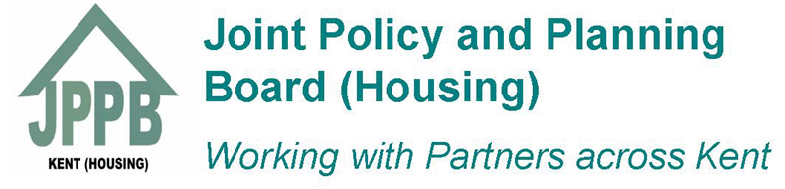
HOSPITAL DISCHARGE
What is important to your organisation in terms of service delivery and better outcomes for customers | What needs improvement in your view | What do you thinks are the barriers to these improvements | How can we break down these barriers | What are the quick wins
Better communication between agencies | Communication between agencies | Lack of communication, sharing of good practice etc | Better relationships across services and understanding of roles, e.g shadowing, networking | Better sharing of information , or assessments after discharge
Consistency across Kent | Understanding of roles | Front line pressures | Learn from customer experience | Named contacts to produce a list of each area organisation
Single point of contact both ways | Joint working | Datasharing around bed blocking, housing and so on | Information days across agencies | Use IT system (possibly Locata) for adapted properties
Ease of access to system for customer | Review of priorities | Lack of named contacts | Early joint working | Shadowing, closer working
Less homeless released onto the street | Recruitment | Unrealistic expectations of customers and their families | Trusted assessors | Recycle equipment and make available sooner
Clear partnership working | Faster recycling of equipment |  | Ability to negotiate better contracts with contractors | Funding based upon demand across county
Promote independence of choice | Homeless definition – there are differing views |  | Better use of shared budgets | Shared best practice to help with quick adaptations and those who are homeless
Reduce misplacements of people resulting in readmission to hospital | Clarification of what the HIAs can do quickly |  | Better buy in from members and senior staff
Prevention Support for clients in their own homes | More stepdown facilities for faster discharge – support/adequate adaptations to get patient home quickly where appropriate and to enable them to be safe |  | Demonstrate value in real terms of what housing can offer
Prior to discharge, early notification system for adaptations etc  Home Assessment for every discharge (frail elderly, long term conditions etc) |  |  | Commitment from everyone to do this
Treatment to be in own home wherever practical and possible
Better engagement with ambulance crews

JPPB PRIORITIES
General consensus for board priorities going forward are below. There are also some really good suggestions for work streams from this workshop, which will help us to develop the action plan.
Priority 1: Hospital discharge/falls prevention

Priority 2: Health inequalities for young people, including care leavers

Priority 3: Addressing health inequalities for street population/sofa surfers

Priority 4: Mental ill health/substance misuse/dual diagnosis – from prevention to crisis

Clearly there are some ongoing priorities such as dementia and our existing protocols that the board will still have a watchful eye on, so these above are not exclusive but to help us form the main focus of our work going ahead.

