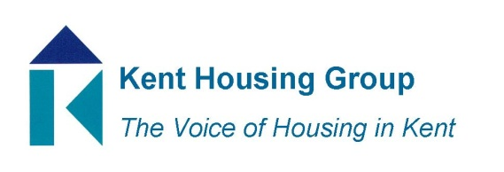

Media Release Summer 2023

“Let’s Stay Fire Safe” is the rallying call from the Kent Housing Group

A fire safety campaign entitled “Let’s Stay Fire Safe” has been launched in Kent and Medway.
The Kent Housing Group (KHG) has teamed up with a number of housing associations and local councils to deliver the potentially life-saving campaign. Although primarily aimed at residents living in social housing, the fire safety advice and tips are just as important to all householders.
The campaign is split into two parts, covering fire safety advice in the home and guidance on keeping communal areas safe in blocks of flats.
Prior to the launch, KHG shared details of the campaign with Kent & Fire Rescue Service (KFRS) to ensure that the fire safety messages are in line with official guidance, which KFRS confirmed.
Brian Horton, Interim Chair of KHG, said: “Social housing landlords in Kent and Medway will be sharing details of this campaign with their tenants, to encourage them to take simple steps to keep themselves, their families and neighbours fire safe.”
Participating landlords will be contacting their tenants with details of the “Let’s Stay Fire Safe” campaign. It includes two animations (fully accessible with subtitle options), and a toolkit for landlords including images, social media assets and posts, QR codes, posters for communal areas and a dedicated KHG webpage.
At the heart of the “Let’s Stay Fire Safe” campaign are the following key messages:
- Have a working smoke detector, and test it regularly,
- Make sure you do not overload your electrical sockets,
- Read the fire safety advice for any portable heaters you use,
- Don’t lot leave lit candles or cigarettes unattended in your home,
- Shut fire doors in communal areas and report any damage to them to your landlord straight away,
- Keep communal areas like corridors, entrance halls and stairwells clear from clutter,
- Don’t charge personal items in communal areas or store them in communal cupboards,
- Don’t light open fires or BBQs in your home, balcony or communal gardens (without gaining permission of the landlord),
- Make sure you and your family know what the fire escape plan is for your building
Brian Horton added: “A fire can happen at any time but there are some simple things we can all do to stay fire safe, in our homes and communal areas. By social housing landlords coming together like this and speaking with one voice, we hope that our “Let’s Stay Fire Safe” messages are heard loud and clear.”
Speak to your landlord today about any concerns
KHG are encouraging tenants to speak with their landlord if they have any concerns about fire safety, either in the home or within the block. This could be reporting damage to fire doors, concern about clutter building up in communal areas like hallways, corridors or stairwells, issues surrounding the safety of electrical sockets and more.
For more information on the campaign visit www.kenthousinggroup.org.uk/fire-safe
ENDS
Note for Editors:
The Kent Housing Group (KHG) is the voice of the housing sector in Kent and Medway. It has representation from all 12 Kent local authorities, Medway Council, 13 housing associations, Kent County Council and Kent Public Health. KHG also has representation from organisations who work in partnership with social housing landlords, including Homes England, the National Housing Federation, the National Landlords Residents Association and the South East Local Enterprise Partnership (SELEP). Visit www.kenthousinggroup.org.uk
Press enquiries:
Jeff Sims, Senior Communications Officer
Ashford Borough Council
Tel: 01233 330543 / 07810 527979
jeff.sims@ashford.gov.uk

