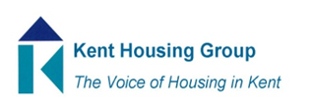

AGENDA – 30th June 2021
09.30am to 11.30am, via Teams

9.30am - Welcome & Introductions to Speakers – Neil Diddams, West Kent HA

9.35am - Neil Diddams, WKHA
West Kent’s approach to Building Safety and the Green Agenda

10.00am - Richard Barwick, WKHA
The retrofit agenda. What retrofit standard should you be working to, and how might the different options impact your long term (30 year) asset management strategy?

10.20am – Comfort Break (10 mins)

10.30am - Steve Stratford, Golding Homes
Development and current progress of Golding Homes Asset Management Strategy

10.50am - David Ashby, South East Consortium
SEC has formed a building safety working group consisting of a number of Housing Directors, contractors, consultants and members of Professional organisations. The objective of the building safety group is to develop practical procurement guidance for members in respect of the proposed Building Safety Act and related legislation/regulation, enforcing quality through the appointment of reputable organisations. The aim of the guidance is to be clear, succinct and easy to read/use. David Ashby is the lead for SEC and he will update on the progress so far on the working group.
11.10am – Questions
11.30am – Session to Close

