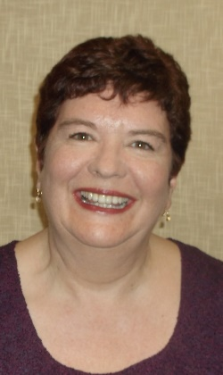

Sharon is the Head of Housing at Ashford Borough Council, a role she has held since 2016. She oversees the vast array of functions that the council’s housing service undertakes – from its new build programme to its planned maintenance and repairs functions – keeping a close eye with officers on the contracts and scope of the work. However, her background as a housing operations manager within the authority saw her responsible for homelessness, allocations and private sector housing. During her time in that role she introduced initiatives to reduce homelessness – such as the acquisition of a former commercial building that was renovated into a short-stay accommodation facility for eight households, which means homeless families do not have to live out of suitcases in bed and breakfast or paid nightly bedsits. A second such facility is due to open in January 2021.

Sharon is one of a growing number of female members of the council’s management team, something the council is very proud of. In addition to her experience at Ashford, Sharon previously worked at Medway. Sharon is widely respected for the achievements she has already overseen and the way she is driving forward the delivery of such an ambitious build, acquisition and enabling programme across the borough.

She has overseen the single biggest acquisition in HRA history at Ashford with the purchase of two blocks of flats at “The New Quarter” in Ashford town centre. This sees 109 units being added to the Council’s stock which will be prioritised for keyworkers with a housing need following the implementation of a policy recognising those who have contributed to Ashford’s economic recovery during the pandemic.

On a corporate level, Sharon took a lead role during the pandemic, working on a variety of cells that were set up to aid our most vulnerable residents. This is part of her strategic work as part of our resilience response.

