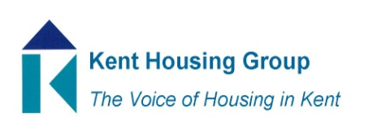
Kent Tenancy Management Sub Group Meeting
Tuesday 23rd February 2021
The meeting will start promptly at 09.30am
Microsoft Teams – joining instructions in the appointment
Agenda

- Introductions and apologies
- Kent Domestic Abuse Reciprocal Transfer Options
- Older Persons Accommodation Reviews
- Feedback from CPN Workshop in January 2021
- Any additional training requirements?
- Standing Items –
- Implementation & Impact of the Amendments to Court Proceedings
- Lettings/viewings – any changes or updates to procedures?
- Round Table Discussion – best practice sharing/top two issues
- Any other business

MEETING TO CLOSE by 10.30am

