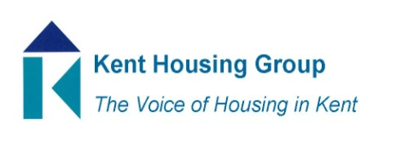
Kent Tenancy Management Sub Group Meeting
Tuesday 27th April 2021

The meeting will start promptly at 11.30am

Microsoft Teams – joining instructions in the appointment

Agenda

- Introductions and apologies
- Hyde Foundation, Partnership Working Opportunity – Maddassar Arif, Hyde Foundation
- We Are Resource - ElliotElliot Cierpiol, Business Development Manager
- GCHA Tenant Support & Wellbeing Services Feedback/Update – Felicity Dunmall, GCHA
- Round Table Discussion – best practice sharing/top two issues
- Any other business

MEETING TO CLOSE by 13.00pm

