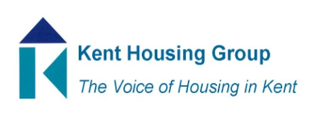
Kent Tenancy Management Sub Group Meeting
Tuesday 8th December 2020
The meeting will start promptly at 10.00am
Microsoft Teams – joining instructions in the appointment
Agenda

- Introductions and apologies
- Changing Minds Kent Overview – Steve Migan, CMK
- Housing White Paper – Initial Thoughts/Impact/Opportunities
https://www.gov.uk/government/publications/the-charter-for-social-housing-residents-social-housing-white-paper
- Round Table Discussion – best practice sharing/top two issues
- Any other business

MEETING TO CLOSE by 11.00am

