[](http://www.kpho.org.uk)

**Domestic Abuse Needs Assessment**

**October 2020**



**|**

Contents

1 1. Executive Summary 6

1.1 Key Findings 6

1.2 Recommendations 9

2 2. Introduction 10

2.1 Key facts (nationally): 10

2.2 What is domestic abuse? 10

2.3 Governance structures within Kent and Medway 11

2.4 Scope of report 12

2.5 Methodology 12

2.5.1 Data sources 13

2.6 What is the impact of domestic abuse? 14

2.6.1 Health impacts of domestic abuse 14

2.6.2 Economic cost of domestic abuse 16

2.7 Policy and Current Context 18

2.7.1 Summary of Domestic Abuse Bill 2019-21 (and changes to roles and responsibilities) 18

2.7.2 Covid-19 21

3 Estimated Need 25

3.1 National trends / Types of abuse 26

3.2 Gender and age 27

3.3 Deprivation and age 28

3.4 Ethnicity 30

3.5 Place of Birth 31

3.6 Employment 32

3.7 Disability 32

3.8 Co-morbidities and at risk groups 33

3.8.1 Alcohol and drug misuse 33

3.8.2 Mental Health 33

3.8.3 Older victims 34

3.8.4 Children and families of victims 35

3.8.5 Homelessness, 35

3.8.6 Other equity and household characteristics 36

3.9 Summary of estimates 36

3.10 Modelled geographic distribution 37

4 Recorded Incidence 40

4.1 Recorded police incidents 40

4.2 Risk ratings / severity 41

4.3 Police records and estimated prevalence 43

4.4 Age 44

4.5 Gender 48

4.6 Ethnicity 49

4.7 Geographic variation 51

4.8 MARACs 54

4.8.1 Referrals 55

4.8.2 Protected characteristics 61

4.9 Probation services 64

4.10 Domestic Homicides and Safeguarding Adults Reviews………………………………………….67

4.11 Safeguarding Adults Reviews ……………………………………………………………………………………68

4.12 Child Safeguarding Practice Reviews ………………………………………………………………………..69

5 In treatment: support services 72

5.1 Referrals 73

5.2 Geographic variation 76

5.3 Age 77

5.4 Gender 80

5.5 Ethnicity 80

5.6 Sexual Identity 81

5.7 One Stop Shops 82

5.8 Adult Social Care (safeguarding alerts) 89

5.9 Kent Fire and Rescue 91

**|**

# 1. Executive Summary

## Key Findings

**Policy imperatives**

**Two major policy occurrences will affect how public sector partners working across domestic abuse will need to respond in 2020-21 and thereafter.**

The **Domestic Abuse Bill 2019-21** which states new statutory obligations for the Kent and Medway domestic abuse and sexual violence executive (KMDASVG) and introduces the role of Domestic Abuse Commissioner with a focus on quality of service and consistency of offer over area. KMDASVG partners will need to work together to respond to the legal changes and guidance issued.

**A series of ‘lock-down’ measures announced by the UK Government to tackle the Coronavirus outbreak are widely considered to have increased the general risk of domestic abuse.**  Kent Police have been monitoring and reporting on volumes of received calls to assess the impact of the lockdown in the local area.  Call volumes have been higher than that normally seen and showed an increase as the quarantine period progressed. In particular non-crime calls have increased by over 30% from 17th May to 14th June. Kent Police report that increases have been fairly evenly distributed across Medway and the Kent districts.

**Estimated prevalence**

**Domestic abuse (DA) is highly prevalent across Kent and Medway.** Modelled estimates, based on national survey data, suggest some 75,000 to 80,000 individuals (circa 5.7% of the adult population) are affected by DA annually across the county. Considering that police recorded incidents are higher in Kent and Medway than national averages in England and Wales, the figure could be even higher at around 92,000 individuals.

**Domestic abuse is more prevalent in certain groups.** DA occurs across the whole of society, regardless of age, sex, ethnicity, income or where people live. However, there appears to be increased risk in some socio-economic and demographic groups. For example:

* around two-thirds of DA victims are female.
* younger people are more likely to be affected by DA, particularly young females aged 16 to 34.
* individuals in the most deprived quintile (5th) of the population are 25% more likely to experience DA than average. Conversely, those in the least deprived are 25% less likely.
* DA is reported at nearly double the rate in those with a disability.
* ‘mixed race’ (12.9%), ‘Black/African/Caribbean/Black British’ (7.1%) and ‘Other’ (6.7%) ethnic groups were reported as having higher rates than the White British majority (5.9%).

**Domestic abuse has probably been in decline over the last decade but may now be increasing again.** Overall, rates of DA nationally has declined over the last 8 years, although this picture is slightly complicated by the trend increasing in the most recent 3 years. It is thought that the Coronavirus pandemic is likely to increase incidents of DA.

**The economic and social costs of domestic abuse incidents is estimated to be some £2.6bn per year across Kent and Medway.**

**Police recorded incidents**

**At least 40% of DA in the community could be going unreported to the Police.** Kent Police reported some 45,000 incidents of DA in 2019, 34,000 of which led to a crime being recorded. This means that approximately 60% of the estimated prevalence in Kent is reported to the police. Just under half (46%) of the estimated prevalence leads to a crime being recorded.

**Recorded incidents and crime have generally increased over the last 5 years, although there are differences by socio-economic and demographic groups.** The following groups are more likely to be a recorded victim:

**Gender:**69% of the estimated prevalence of DA is reported for females, compared to only 46% in males. Males who do contact the police are more likely to lead to a crime recording than females.

**Age:**Those aged 15 to 34 make up approximately half of those who report DA to the police, with those aged 25 to 29 making up the highest 5-year age band as a proportion of all incidents, at around 15% of the total. Those aged 20 to 44 are most likely to report DA, but they are also least likely to lead to a recording of a crime. Those aged 15 to 19, and 45 to 64 are slightly less likely to report DA to the police, but more likely to lead to a crime recording if they do.

**District of residence:** There are clear variations between the rates of incidents and crimes reported by district in Kent. Those in more deprived areas tend to have higher rates of reported incidents, with Thanet district having the highest rate at 36.4 per 1,000 adult population, more than double that in Sevenoaks district which has the lowest at 16.0 per 1,000. Crimes followed a similar pattern, and all districts had a similar rate of crimes per incident.

**Ethnicity:** More than 5,000 police incidents were recorded as ‘not stated / unknown’ in 2019, double the amount in 2015. Recording of ethnicity should be considered of paramount importance in order to measure the impact of DA more accurately on minority groups, and tailor support appropriately.

**Cases discussed at MARAC**

**Utilisation of (Multi Agency Risk Assessment Conference) MARACs could be low in Kent, but further information would be needed to be certain of this conclusion.**SafeLives83 report that nationally there are 4.0 adult females per 1,000 experiencing DA and discussed in a MARAC in 2019, which is also the rate they consider to be the minimum safe level. Locally in Kent, the calculated figure is around 3 per 1,000 females. When comparing Kent to the remainder of the country more needs to be known about rates of recorded crime and also the seriousness of incidents and suitability of individual cases to be discussed at MARAC.

**Referrals by Kent Police made up a higher proportion of total referrals into MARAC than that seen nationally.**Combined with Kent’s lower than average referral rate, there may be scope for other agencies involved in DA to recognise higher risk cases and proactively refer to MARAC.

**Rates of referral into MARACs vary by age, gender, disability, district of residence, and other equity vectors.**For example, the MARAC data we received indicated there is a considerably lower proportion of disabled people being discussed at MARAC than would be expected to suffer some form of DA. We were not able to elucidate the reasons for this from the data we received, but it could be a lower need, or data capture or quality.  Data / recording should be improved in this area.

**Access to services**

**There are clear variations in rates of accessing services by district in Kent and Medway.**Of the districts with full data, Ashford had the highest proportion of its population in support services at 3.3 per 1,000 adults, followed by Dartford (3.1), Canterbury (2.9) and Thanet (2.6 per 1,000).

**There may be scope for services to further appeal and cater to males, and younger or older clients.** Around 95% (or more) of service users are female. Clients aged 20 to 40 make up approximately two-thirds of service users, with 25 to 35-year olds being the age groups with the highest usage. Those aged 25 to 45 are more likely to receive support than those younger or older, when comparing to the rates of incidents and crimes reported to the police.

**Availability of data**

**There is reasonable data on volumes of domestic abuse incidents, but, as with numerous other public health topics, a comprehensive assessment of health need following domestic abuse has been hampered by issues of data paucity and data quality.** This is especially apparent when assessing health and well-being impacts. Justifiable controls aimed at preserving the confidentiality of individuals and difficulties surrounding the attribution of health and well-being harms to their root causes in domestic abuse make it difficult to properly assess the scale and pattern of DA from a health perspective.

## 1.2 Recommendations

1. The findings of the needs assessment should be:

* shared and investigated strategically; and implemented through the action plan.
* checked and challenged to explore reasons for key equality differences (inclusive of gender, age, deprivation, disability, ethnicity).
* used to support the development of a baseline for progress and as a framework for the creation of future reports.

2. Service mapping around client group (which also recognises the intersectionality of the family) should be completed across the partnership to strengthen awareness and understanding of referral options, and how different services can support each other.

3. This needs assessment highlights high levels of DA within Kent and Medway. We must develop a picture of how well service capacity meets need in order to shape future commissioning. Linked to this recording of protected characteristics including ethnicity and disability should be strengthened.

4. Service users’ views through qualitative methodologies should be sought and incorporated into the design of future needs assessments, both Kent and Medway are seeking routes to enable this.

5. Given the high numbers of women who have children who engage with IDVA services it is key that the interconnectedness of services supporting adults and children is recognised, and children are understood as survivors in their own right.

6. Review whether utilisation of the MARAC process is low in Kent (and capacity requirements if there was a need to increase MARAC referrals). Increase awareness of referral routes outside of Police. Improve data recording of protected characteristics if required.

7. Consider stronger coordination across One Stop Shop (OSS) provision, and how to support access of services to those who do not attend OSS (younger people/older people, men). Consider the geographical placement of OSS given data on need included within this assessment.

8. This strategic assessment highlights disparity between numbers referred and those who receive support from services. This disparity should be further explored including disparities in relation to gender (men are more likely not to receive support).

9. In preparation for the next iteration of the strategic assessment, principles should be provided to those being asked for data in advance, so that they are able to collect comparable information as part of their commissioning processes where possible.

**|**

# 2. Introduction

The impact of domestic abuse (DA) on anyone and can be devastating. The effects are often hidden, leaving lasting physical, mental, social, and economic damage which can last a lifetime. It is estimated nationally that the cost of DA is upwards of £66 billion annually, most notably in costs associated with the long lasting emotional or mental impacts of DA, but also significantly in physical healthcare, policing, criminal justice, and lost productivity.

In addition to a policing and social issue, domestic abuse is a public health issue. Preventative action to reduce the number of incidents is a primary focus of local public health teams, working with a range of partner organisations.

## Key facts (nationally):

At a national level we know that:

* The prevalence of those experiencing domestic abuse across England and Wales (in the year prior to survey interview) has reduced from 8.9% in the year ending March 2005 to 6.3% in the year ending March 2019. This indicates a gradual, long term downward trend.
* However, recent data for the last 3 years suggests the trend could be increasing again.
* Domestic abuse is highly ‘prevalent’. In the year ending March 2018, an estimated 2.0 million adults aged 16 to 59 years experienced domestic abuse across England and Wales (1.3 million women and 695,000 men).
* The economic cost of domestic abuse is vast, estimated at approximately £66bn for victims of domestic abuse in England and Wales for the year ending March 2017.[1]

## What is domestic abuse?

In the forthcoming Domestic Abuse Bill 2019-21, the Government definition of DA has been updated to include:

*(1) Behaviour of a person (“A”) towards another person (“B”) is “domestic abuse” if—*

*(a) A and B are each aged 16 or over and are personally connected to each other, and*

*(b) the behaviour is abusive.*

*(2) Behaviour is “abusive” if it consists of any of the following—*

*(a) physical or sexual abuse;*

*(b) violent or threatening behaviour;*

*(c) controlling or coercive behaviour;*

*(d) economic abuse*

*(e) psychological, emotional or other abuse;*

*and it does not matter whether the behaviour consists of a single incident or a course of conduct.” [2]*

Previous government definitions have operated on a non-statutory basis; however, the new definition will be statutory. The definition has been developed to include all forms of DA and recognises economic abuse, stating that “’economic abuse’ means any behaviour that has a substantial adverse effect on B’s [the victims] ability to— (a) acquire, use or maintain money or other property, or (b) obtain goods or services.” 6 The definition is gender-neutral to ensure that no victim is excluded from protection.

## Governance structures within Kent and Medway

In 2017, The Kent and Medway Domestic Abuse and Sexual Violence Executive (KMDASVE) partnership was established. Its overarching purpose is to reduce domestic abuse and change attitudes, acting as a coordinating body between partners.

The KMDASVE is a “partnership between the Kent Police and Crime Commissioner’s office, Medway Council, Kent County Council, NHS organisations, Kent Fire and Rescue Service, the National Probation Service, KSS Community Rehabilitation and District Councils”.

It aims to work “together to avoid duplication, consolidate evidence, explore what works best, share information early and thus ensure the best use of available resources across the partnership.”

To support partnership working across Kent and Medway the Kent and Medway Domestic Abuse Strategy was launched in March 2020. This strategy defines 5 priority areas.

1) Driving change together - which works to promote change through joint commitment, leadership and partnership working across services.

2) Prevention and early intervention - which seeks to reduce the incidence of domestic abuse through effective prevention, education, a skilled and resourced workforce, and earlier intervention.

3) Provision of services - which supports responsive and effective services for those affected by domestic abuse.

4) Minimising harm - which focuses on providing positive outcomes, and promoting equality of access of services, recognising and reducing barriers to reporting and supporting where possible individuals and families with longer term support needs.

5) Justice, recovery and ongoing protection - which focuses on the provision of effective, engaged, supportive, responsive and timely protection and justice.

A Kent and Medway domestic abuse action plan has been developed which supports the recommendations of this strategic assessment and works to action the Kent and Medway domestic abuse strategy.

KMDASVE update the Kent and Medway Community Safety Partnerships, the Kent and Medway Safeguarding Adults Board, the Kent Safeguarding Children multiagency partnership and the Medway Safeguarding Children’s Board with progress.

## Scope of report

This is the first strategic assessment which has been commissioned by KMDASVE to the Kent Public Health Observatory, it is also being developed prior to the passing of the Domestic Abuse Act and its associated statutory obligations.

As such the aim of this Needs Assessment is threefold:

* to bring together available data across KMDASVE, to understand what data is available, and how this data may need to be developed and improved to support requirements moving forward;
* to use available data to describe levels of domestic abuse in Kent and Medway, and to understand if/how, these vary by equity characteristics;
* to help form a benchmark from which the ongoing assessment of DA in Kent and Medway can be measured.

In line with the above, this document is intended to inform commissioning arrangements and the future strategic direction of domestic abuse services in the county. In order to report in time to influence the 2020-21 commissioning cycle, this needs assessment has needed to focus exclusively on quantitative data from published sources and extracted from datasets maintained by key local stakeholder organisations. Data may not be fully comprehensive or exhaustive despite significant efforts to request all known relevant data. Moving forward, commissioners in both Medway and Kent are also exploring routes to collect qualitative information which will influence policy and service provision.

## Methodology

Collation of evidence for this needs assessment has consisted of 3 steps, led by the Kent Public Health Observatory (KPHO):

1. A literature review to describe the policy and provision implications of the upcoming Domestic Abuse Bill;
2. A review of the available national and local data sources to describe the epidemiology of domestic abuse across Kent and Medway;
3. Quantitative analysis to provide:
   1. a synthetic assessment of the prevalence, recorded incidence and treatment of DA across Kent and Medway
   2. a consideration of differences in reporting and accessing treatment between different equity groups (based on protected characteristics).

A literature review is being developed as an appendix to allow for further input from service providers.

### Data sources

Data for this needs assessment was requested from the following organisations:

* Kent Police
* Kent Police and Crime Commissioners Office
* Kent County Council (KCC) commissioning teams
* Medway’s commissioned Domestic Abuse Service (Choices)
* KCC Adult Social Care
* KCC Public Health
* Medway Council
* Kent Integrated Dataset
* Kent Community Safety Partnership
* Her Majesty’s Prison and Probation Service
* KSS Community Rehabilitation Company
* Kent Fire and Rescue Services
* Sevenoaks, Swale and Maidstone districts
* Kent and Medway One Stop Shop Steering Group

KPHO also accessed open source data made available by national Government, including the Home Office and the Office for National Statistics.

KPHO assessed the utility of the data we receive from acute hospital and primary care settings via the Kent Integrated Dataset (a whole population, person-level, pseudonymised dataset). We found that data on domestic abuse is excluded from the primary care data extracts we receive as these are considered too sensitive to share. We also found substantive data completeness concerns within hospital inpatient data, where a patient was coded with ‘Adult and child abuse, neglect and other maltreatment, confirmed’ (ICD = T74). Neither source was usable within this assessment. Further, KPHO explored the utility of both national maternity and local health visiting datasets (particularly to report on the risk to women postnatally), but neither held analysable records related to DA. For future iterations of this report partners may wish to approach acute hospital trusts directly, regarding the maternity data they hold.

## What is the impact of domestic abuse?

### Health impacts of domestic abuse

The physical and mental impact of DA can be devastating, and victims and families typically endure abuse over a long period of time. DA and its impacts are often hidden from view. On average medium-risk victims suffer 50 incidents of abuse over 3 years before seeking help (SafeLives 2015[3]). The Department of Health and Social Care consider common health impacts of DA to include[4]:

* **Emotional or psychological symptoms:** 
  + depression,
  + fear,
  + anxiety,
  + post-traumatic stress disorder (PTSD),
  + sleep disorders,
  + self-harming or suicidal tendencies,
  + alcohol or drug misuse.
* **Physical symptoms:** 
  + injuries such as bruises, cuts, broken bones, injuries to organs,
  + problems with the central nervous system – headaches,
  + cognitive problems, hearing loss,
  + long-term gastrointestinal symptoms, genitourinary symptoms, including frequent bladder or kidney infections, long-term pain.
* **Reproductive/sexual health issues and post-natal escalation of abuse:** 
  + pelvic pain and sexual dysfunction adverse reproductive outcomes,
  + unintended, pregnancies or terminations/miscarriages,
  + delayed antenatal care,
  + history of premature labours or stillbirths,
  + vaginal bleeding,
  + recurring sexually transmitted infections or recurring urinary tract infections.

**Additional impacts for young children:**

Additional immediate and long-term impacts for young people witnessing domestic abuse include increased likelihood of:

* + behavioural issues,
  + poor educational outcomes,
  + involvement in bullying,
  + fear, hidden anxiety and other mental health impact of children,
  + sleep deprivation,
  + involvement in criminality, and
  + increased tendency for violence.

The major health impacts, associated quality-adjusted life years (QALY) losses and costs of DA, have been discussed in detail in the Home Office’s 2019 report, *The Economic and Social Cost of Domestic Abuse[5]*. Figure 1 below presents a summary of the main impacts of DA, as measured across the population of England and Wales. QALY losses are defined as a ‘health or quality of life loss’ over a year, where a value of ‘1’ is a year spent in perfect health. Unit costs of treatment and other impacts are also shown in the table.

Figure 1 clearly shows the emotional and mental health impacts of DA are substantially greater than physical impacts. Those who suffer consequential mental health and substance misuse from an episode of DA equate to the largest QALY losses in the population, due to the length of time the conditions last in the victims, and the high overall likelihood of them occurring.

Figure1: QALY loss, unit costs and other health impacts of DA in adults

### Economic cost of domestic abuse

In addition to poor health outcomes, DA has an economic impact to both victims and wider society. *The Economic and Social Cost of Domestic Abuse*[6] report aimed to estimate the cost of DA in England and Wales for incidents occurring in the year ending 31st March 2017. The estimated cost of DA across the population of England and Wales for victims over this period was approximately £66 billion, or £34,015 per person. The costs were divided into the following areas:

* Anticipation (expenditure on protective and preventive measures)
* Consequence (property damage, physical and emotional harm (and reduction in future health-related quality of life), lost output/productivity, health and victims’ services)
* Response (police, criminal justice system)

The costs cover the whole duration of the DA incident, and the average length of abuse for a victim is 3 years (SafeLives, 2018).

The report states that “the largest element of the domestic abuse cost is the physical and emotional hardship suffered by the victims themselves (£47 billion) – figure 2 below. The next highest cost arises from lost output time taken off work and reduced productivity afterwards (£14 billion).”

**Applying these national estimates to the Kent and Medway population gives an unadjusted economic and social cost to society of DA of around £2.6bn per year** (based on an estimated 75,000 annual incidents in Kent and Medway at a cost of £34,015 per victim). Our considered view is this is more likely to be an underestimate than an overestimate.

The table below shows how the estimated costs are broken down into anticipatory costs, consequential costs and costs in response. These are shown per person, as a national cost and as an estimated cost for Kent based on 75,000 victims.

As discussed in the previous chapter, emotional impacts are extremely common, prolonged, and often severe. Combined with the acute physical costs, these make up well over half of the estimated cost per victim and £1.8 billion of the overall estimate for Kent of £2.6bn. Lost economic output is the second largest contributor, and costs over half a billion annually in Kent.

Figure 2: Estimated costs of domestic abuse



Specific costs by abuse type were detailed in *The Economic and Social Cost of Domestic Abuse* and we have summarised this breakdown in the table below. Homicide is considerably more costly than other forms of abuse, but also much less frequent.

Figure 3: cost of domestic abuse by abuse type

Violence without injury is the most common type of DA cited in the analysis and the average cost is £30k per victim. The cost increases significantly to £74k per victim if there is violence involved, and this category is the second most prevalent. Combined, violent abuse with or without injury makes up the vast majority of the cost of DA overall.

Figure 4: Incidence and estimated costs of domestic abuse by type



## Policy and Current Context

### Summary of Domestic Abuse Bill 2019-21 (and changes to roles and responsibilities)

This section outlines the changes that the new Domestic Abuse Bill 2019-21 brings in terms of responsibilities and procedures for tackling DA.

In 2019 the government announced that it would reintroduce a bill to tackle the “horrific crime” of domestic abuse[7] and on 3rd March 2020 the Bill was brought to the House of Commons for the first reading. At the time of writing the Bill had moved through the Commons and is being considered by the Lords.

**Summary of new Bill:**

* Proposes to offer the first statutory government definition of domestic abuse.
* Will place a legal duty on local authorities to deliver support to survivors of domestic abuse. This will be in the form of supportive and accessible emergency accommodation.
* Aims to improve the effectiveness of the justice system in providing protection for victims of domestic abuse and bringing perpetrators to justice.
* Establishes a national Domestic Abuse Commissioner to provide public leadership on domestic abuse issues.
* Provides for a new Domestic Abuse Protection Notice and Domestic Abuse Protection Order.

These government steps were defined after consultation, and aim to set out a new approach to supporting those affected by DA.[8]

**Domestic Abuse Commissioner**

The Bill aims to establish a new national Domestic Abuse Commissioner as a statutory office holder. This has been enacted before the Bill has received assent and Nicole Jacobs has been appointed, designate. The Domestic Abuse Commissioner has responsibility for supporting victims and survivors of DA and will be responsible for the “prevention, detection, investigation and prosecution of offences involving DA.” 6 The Commissioner will also raise awareness and understanding of the means by which coercive control is operated, provide public leadership on DA issues and encourage good practice in preventing DA.

The Home Office expects that the Domestic Abuse Commissioner will bring services together and offer guidance and challenge across the system to ensure joined up and comprehensive service provision and to reduce the risks associated with a ‘postcode lottery’. [9]

The Home Office states:

• the commissioner will have the power to publish reports and make recommendations, and statutory agencies and government ministers will be required by law to respond to those recommendations publicly

• we believe that this will exert considerable pressure to effect change, while maintaining local accountability and independence. 10

The Bill states that the commissioner will be responsible for producing (and consulting on) a strategic plan which will set out key actions to tackle DA over the next three years. Local authorities will also have a duty to respond to the reports containing recommendations by the commissioner.

**Implications for Local Authorities and districts**

In relation to accommodation-based support the Bill states that each local authority in England must:

a) access or make arrangements for the assessment of the need for DA in its area

b) prepare and publish a strategy for provision of such support in its area and

c) give effect to the strategy through commissioning or decommissioning decisions

d) monitor and evaluate the effectiveness of this strategy6

e) report back to central government

f) Require tier two councils to co-operate with the lead local authority

Local authorities will be required to hold Local Partnership Boards. As a minimum, the Boards will include persons representing local authorities, victims and their children, domestic abuse charities or voluntary organisations, health care providers and the police or other criminal justice agencies.

The Bill also outlines that there will be a duty on local housing authorities to provide secure tenancies, rather than flexible tenancies, where a new tenancy is granted for reasons relating to DA. The Government announced in the Social Housing Green Paper that where local authorities offer further tenancies to lifetime social tenants as a result of DA, such tenancies are granted on a lifetime basis to support victims in social housing to leave their abusive partners without fear of losing their lifetime tenancy. These requirements were already outlined in The Secure Tenancies (Victims of Domestic Abuse) Act 2018, “The main purpose of the 2018 statutory guidance is to improve access to social housing for victims of domestic abuse who are in refuges or other forms of safe temporary accommodation.” [10] This should prevent victims being left homeless as a result of fleeing an abusive partner.

**Implications for Police**

The new Bill will introduce a Domestic Abuse Protection Notice (DAPN) which is an adaptation of the previous Domestic Violence Protection Notice (DVPN) and will be issued by police to give immediate protection to victims. DAPNs could, for example, require a perpetrator to leave the victim’s home for up to 48 hours.[11]

DAPNs will be used when a senior police officer has reasonable grounds for believing that an individual has been abusive to a person that they are personally connected with aged 16+, or if a senior police officer has reasonable grounds for believing that it is necessary to give the notice to protect that person from DA or a risk of DA. The Bill states that where the police have grounds to believe that the notice has been breached by a perpetrator, the perpetrator can subsequently be arrested.

The new Bill will also mandate the Domestic Violence Disclosure Scheme (DVDS, also known as “Clare’s Law”) which will allow police to disclose information about a partner or ex-partner’s previous abusive or violent behaviour to a victim or potential victim. The DVDS was implemented across all police forces in England and Wales in 2014, however the new bill requires the Secretary of State to issue guidance to chief officers of police which will provide the police with a “clear framework, with recognised and consistent processes, for the exercise of these powers in the context of domestic abuse.” [12]

The Home Office report that implementing the measures set out in the Bill should be cost-saving:

*The impact assessment published alongside the Bill indicates that the current estimated cost of the measures in the Bill applying to England and Wales is between £128 to £146 million per year once fully implemented.*

*The impact assessment shows that only a small reduction (0.2%) in the prevalence of domestic abuse as a result of the measures in the Bill would be required for the benefits of the Bill to outweigh the costs.[13]*

The Bill’s impact assessment gives suggested costs of the bill over a 10-year period[14].

Figure 5: Summary of the estimated annual costs:

|  |  |
| --- | --- |
| Home office/Police | £4.5 to 15.1m |
| HM Courts and Tribunals Service | £4.7-5.9m |
| The Crown Prosecution Service | £1.5-1.7m |
| Legal Aid Agency | £6 – 8.5m |
| HM Prison and Probation Service | £12.6m to 13.8m |
| MoJ Central Funds | £5.1 – 7.7m |
| Local authorities | £90m |
| Other | £3.7m |

Information was not available on how this may be distributed over area.

### Covid-19

In March 2020, the Coronavirus pandemic broke out in the UK. A series of measures were announced by the Government to tackle the outbreak, many of which radically changed people’s day-to-day lives. The measures culminated in a national ‘lock-down’ (quarantine) with individuals only allowed to leave their homes for tightly prescribed reasons such as shopping for food and daily exercise.

It is widely considered that necessary Government instructions to stay at home, as well as high levels of anxiety, and pressures on finance caused by the pandemic, increased the general risk of domestic abuse amongst the population. As such, in April 2020, the Home Office announced £2 million of funding to immediately support domestic abuse helplines. Subsequently, a further £10m was announced for Voluntary and Community Support (VCS), specific support for accommodation-based services and Ministry of Justice funds.

An immediate review published in the Lancet[15] explored the social, economic, and psychological impact of quarantine and how it might impact intimate partner violence. It considered the effects of quarantine as similar to some of the methods used by perpetrators in abusive relationships and recognising that quarantine can cut victims off from vital support such as friends and family and direct contact with support or public services. It also considered the impacts on children who may lack the safety and security of a school environment during a quarantine period.

The review recommended increasing both public and frontline worker awareness of the issue and to demonstrate to those at risk how to contact support services. They recommended funding should be increased during periods of lockdown, including social protection, shelters, and trauma-centred support for family members. The authors also considered the continuation of social safety nets to be vital for vulnerable adults, as well as access to support services and shelters.

Peterman *et al* (2020)[16] also explored the impacts of pandemics on intimate partner violence in detail, in another recent review. They considered 9 potential pathways that can increase rates of domestic violence during pandemics, and the potential response and policy options to address them:

* economic insecurity and poverty-related stress
* social isolation in quarantine
* disaster and conflict-related unrest and instability
* exposure to exploitative relationships due to changing demographics
* reduced health service availability and access to first responders
* inability of women to temporarily escape abusive partners
* virus-specific sources of violence
* exposure to violence and coercion in response efforts
* violence perpetrated against health care workers

**Local impact during quarantine**

At the time of writing, the scale, duration and impact of quarantine on DA in Kent and Medway is unknown and difficult to estimate. One charity (Refuge) estimated a 25% rise in domestic abuse incidents at the beginning of the Coronavirus lockdown, although this is based on national data.[17]

Kent Police have been monitoring and reporting on volumes of received calls to assess the impact of the lockdown in the local area. Call volumes over that normally seen have been supplied by Kent Police, and show an increase as the quarantine period has progressed (see Figure 6 below). Much of the extra volume was deemed medium or lower risk and did not lead to crimes being recorded, but non-crime calls have increased by over 30% from 17th May to 14th June. Kent Police considered that the increases seen were fairly evenly distributed across Medway and the Kent districts, and, consequently, report no discernible differences linked to deprivation. It was noted however there was a larger increase seen in calls requesting immediate attendance or assistance.

Figure 6: Police call increases during quarantine

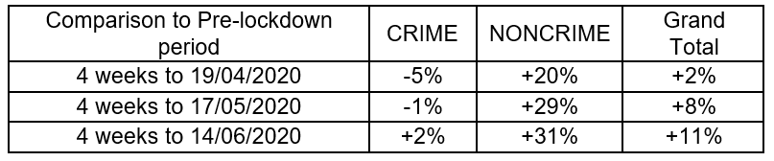

**Predictions on post-COVID levels of need:**

It will be necessary to continuously review the help and support available to those experiencing DA including police response, online support, helplines, refuges and other services. Whilst the ‘lockdown’ doesn’t appear to have initially produced a vast increase in incidents of DA, loosening controls could yet have this impact.

Post lockdown, and based on the data presented throughout this assessment, it is considered that immediate levels of DA incidents may be higher than pre-COVID. This is for 2 principal reasons. Firstly, recent trends suggest that numbers of DA incidents have been increasing in the 2 years to 2018-19 (the most up-to-date data we have access to). Secondly, younger adults and those in lower socio-economic groups (who are on average younger), are expected to be more adversely affected by the economic impacts of Coronavirus, and it is amongst these groups that DA disproportionately occurs.

Further, recent unemployment figures have shown a nearly 80% increase in unemployment benefits in the early lockdown period[18]. Larger increases have generally been seen in the least deprived areas, but overall unemployment remains higher with increasing deprivation.

# Estimated Need

This section of the needs assessment aims to provide a best possible estimate of the prevalence of domestic abuse (DA) in Kent and Medway, prior to the Coronavirus outbreak.

No data source exists that can definitively state the rates at which DA occurs at a local authority level. It is, however, possible to calculate local estimates by applying national data to the characteristics of the local population in Kent and Medway.

The most comprehensive source of information to estimate the prevalence of DA is an annually published national survey, **The Crime Survey for England and Wales[19] (CSFEW)** produced by the Office for National Statistics (ONS). The most recent publication covers survey interviews conducted during 2018/19 relating to the year prior to the interview date. The survey covers circa 13,000 interviewees, carefully selected to be representative of the characteristics of the population.

According to the CSFEW, an estimated 2.4 million adults experienced DA in the year prior to interview across England and Wales, of which two-thirds were women. By comparison, the Police recorded 750,000 DA related crimes and made 215,000 arrests.

Domestic abuse represents 31% of the total abuse reported in the survey. The definitions of DA used in the survey broadly match cross-government definitions[20], but, importantly, do not completely capture the new offence of ‘coercive and controlling behaviour’, introduced in December 2015[21],[22],[23].

**The data presented in the CSFEW generally covers the age ranges 16–59 and 16-74. We acknowledge that there is significant abuse that occurs outside of these age ranges.**

## National trends / Types of abuse

Nationally, the point prevalence of DA has slightly fallen over the past 8 years, although the last 3 years may indicate a return to an increasing trend.

The CSFEW reports an overall decrease in prevalence from **7.0% of respondents age 16-59 in 2011/12 to 6.3% in 2018/19 experiencing DA in the year prior to interview.** Rates for both females and males have declined over the 8 years, but rates for females have increased since 2016/17 from a low of 7.5% to 8.4% in 2018/19. Rates for males have remained level at around 4.2% for the past couple of years.

Taking a more life-course view, 21.1% (28.4% of women and 13.6% of men) of adults aged 16-74 reported any kind of abuse since the age of 16, and 5.7% (7.5% female, 3.8% male) reported abuse in the year prior to interview.

Figure 7: Trend of self-reported DA from the CSFEW

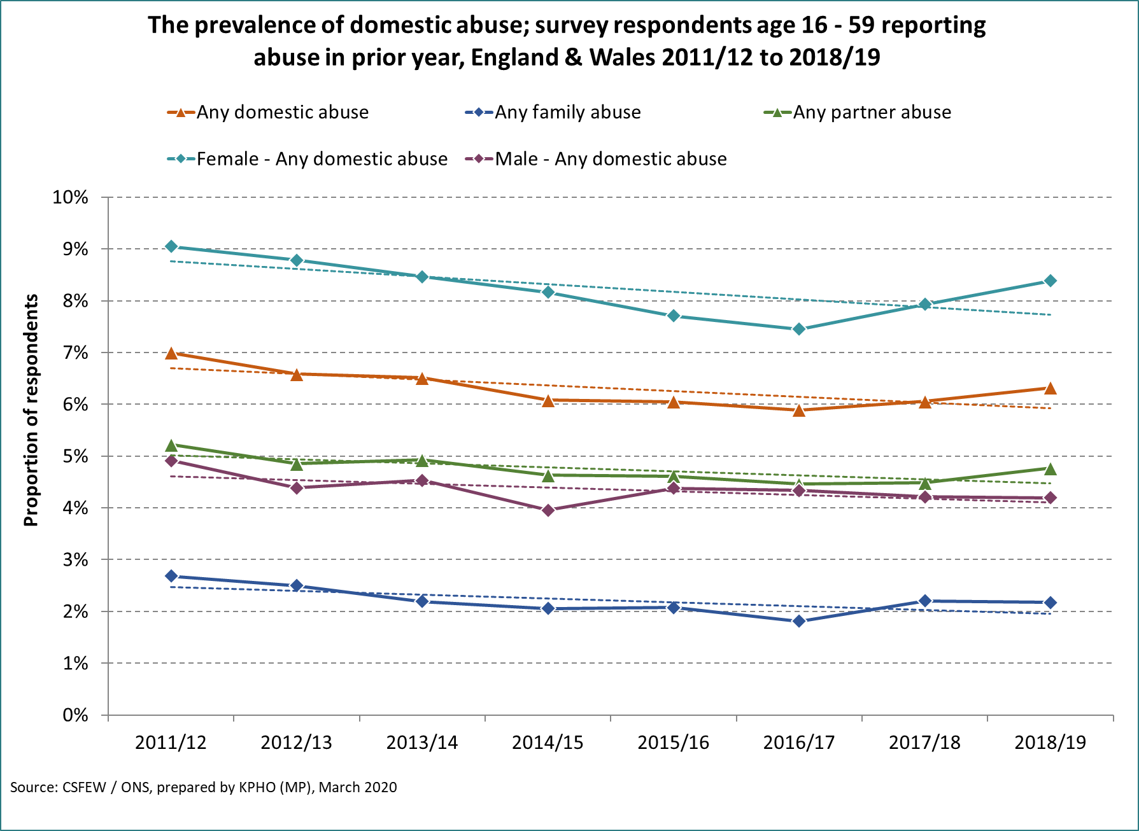

The CSFEW categorises types of abuse into partner or family abuse. Partner abuse is reported at roughly double the rate of family abuse. Both categories of abuse have declined since 2011/12 but have increased since 2016/17.

The table below shows simple linear regression analysis of the annual reported prevalences using 2011/12 (8 year) or 2016/17 (3 year) as a baseline, and the annual % change to 2018/19. Although less prevalent overall, ‘partner non-physical sexual abuse’ has been the only category to have increased since 2011/12 and has seen larger increases since 2016/17.

Figure 8: Prevalence of Domestic Abuse by category from the CSFEW



## Gender and age

The CSFEW shows that, at national level, there are large differences in the prevalence of DA by gender and age, with females and younger people typically experiencing higher rates. Those aged 20-24 are 3 times more likely to report experiencing DA than those age 60-74. The differences seen are even starker for females, with around 15% of females aged 20-24 reporting abuse, equating to over 8,000 in Kent. A third of domestic abuse victims are male.

Modelled to the population of Kent and Medway, an estimated 75,000 people age 16 – 74 experience DA annually. The graph below shows how these are broken down by age and gender, relative to the prevalence reported in the CSFEW.

Figure 9: Estimates of DA by age and gender in Kent and Medway, 2018/19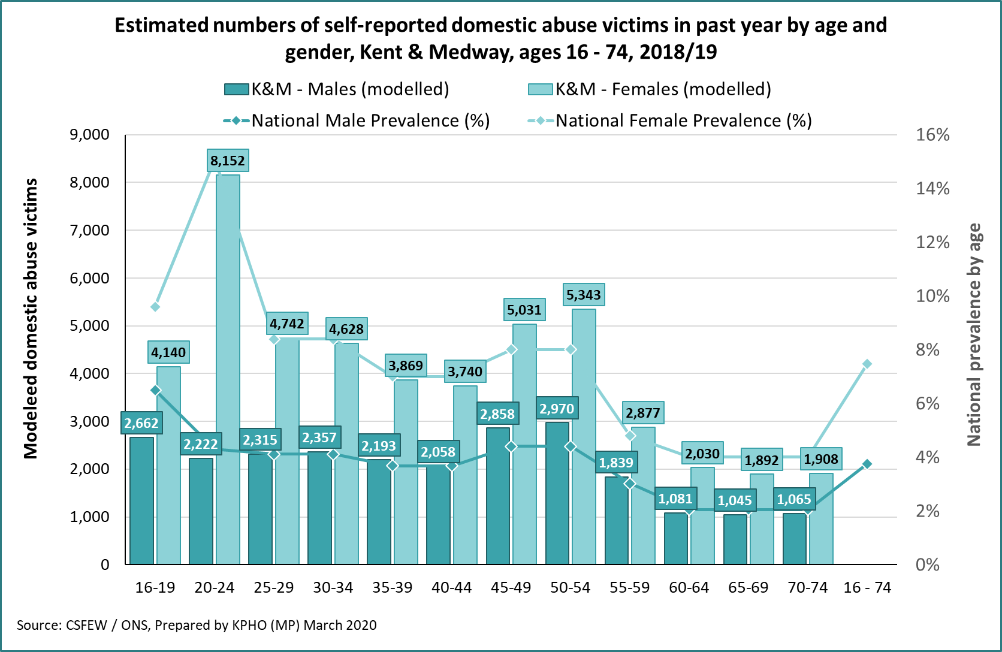

Females have seen larger recent increases (since 2016-17) in reported DA than males, in particular with family abuse and partner sexual abuse.

Figure 10: Estimated prevalence of DA by type and gender



## Deprivation and age

Deprivation is also a significant factor in the prevalence of DA, with those in the most deprived quintile (5th) of the population 25% more likely to experience DA than average. Conversely the least deprived quintile is 25% less likely to experience DA. The most deprived report a prevalence of DA of 7.1% in the past year, and the least deprived 4.3%.

**CSFEW results demonstrate that gender, age, and deprivation are major drivers of rates of DA. We have used this demographic information, in combination, to calculate localised geographical estimates of need across Kent and Medway**. **It is important to note there is a significant level of ‘hidden harm’ which remains unreported in the survey data, and may be higher in certain age groups, ethnicities and communities.**

The graphs below estimates numbers of DA victims in Kent and Medway (Fig 11) and in individual districts (Fig 12) using the nationally reported figures from the CSFEW and adjusts for deprivation differences.

Figure 11: Deprivation-adjusted estimates of DA in Kent, 2018/19

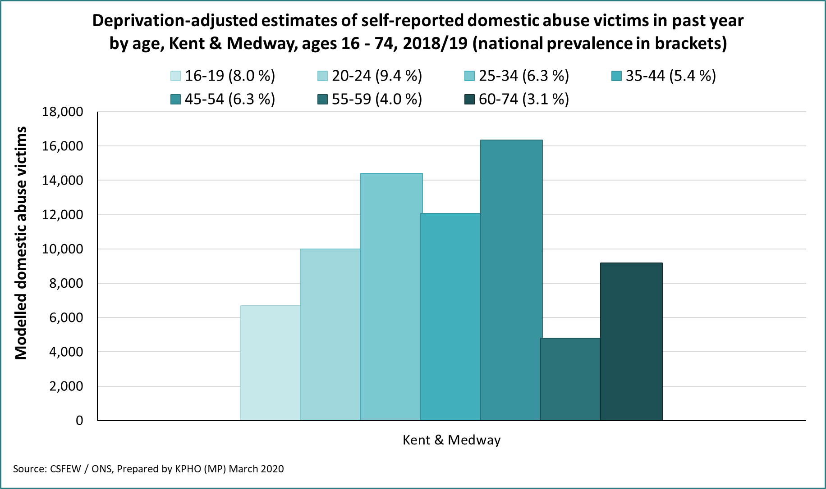

The graph below shows estimated numbers of domestic abuse victims by District. This is not presented as a population rate, so Medway shows the largest overall volume of DA. This is mainly due to the overall adult population size, but deprivation is a smaller but significant factor.

Figure 12: Deprivation-adjusted estimates of DA by district, 2018/19

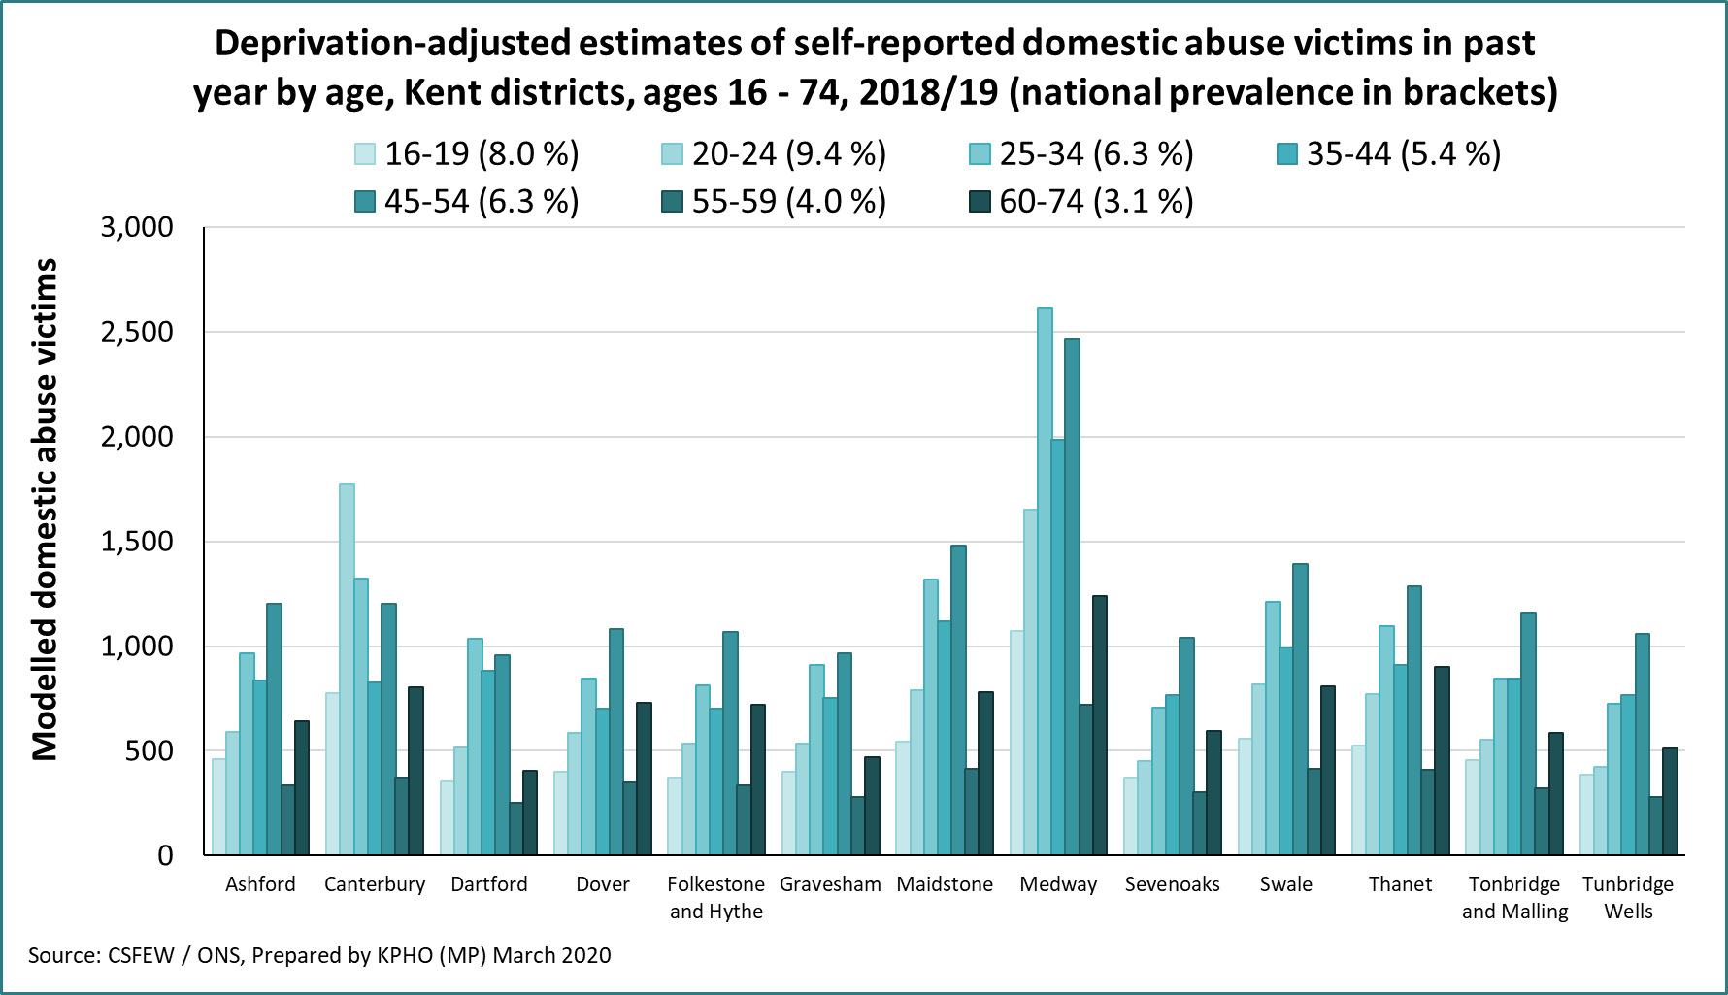

## Ethnicity

Department of Health and Social Care guidance[24] reports that Black and ethnic minority (BAME) women are disproportionately affected by different forms of abuse, for example, forced marriage, dowry abuse, honour-based violence, sexual exploitation through trafficking and female genital mutilation. They are more likely to experience threats of deportation and abandonment, isolation, entrapment, multiple perpetrators, and violence that may be indirectly condoned by family and community, for instance, for reasons of culture or perceived dishonour.

A 2017 report by SafeLives reports that nationally in 2014 a Freedom of Information request to UK police forces revealed that over 11,000 cases of so-called ‘honour’ crime were recorded between 2010-14 (including forced marriage and female genital mutilation). Many victims will not come forward, so the actual number will be much higher [25].

The CSFEW showed differences in prevalence of DA by ethnicity at national level. The 2011 census reported 89% of the Kent & Medway population as ‘White British’, which experience a prevalence of DA at 5.9%. Other ethnic groups reported higher rates than the ‘White British’ majority, ‘mixed race’ (12.9%), ‘Black/African/Caribbean/Black British’ (7.1%) and ‘Other’ (6.7%).

SafeLives report[26] that disclosure about DA is much lower in BAME victims, and they typically suffer abuse for 1.5 times longer before seeking help. A third of BAME clients are at risk of honour-based violence and are three times more likely to be abused by multiple perpetrators. Nationally, a quarter of BME clients need interpreter support, and a fifth have no access to public funds. These ‘hidden harms’ and cultural, language, demographic or service access barriers likely indicate the prevalence of DA is far higher amongst ethnic minority groups than the CSFEW prevalence figures suggest.

The graph below shows the estimated number of DA victims for the main ethnic groups in Kent based on the 2011 census, which is the most recent reliable source available to quantify ethnicity in adults. It is thought many ethnic minority groups have increased as a proportion of the total population of Kent and Medway since the 2011 census was conducted.

Figure 13: Estimated DA victims by ethnicity



## Place of Birth

The CSFEW reports that those born in the UK are more likely to be a victim of DA than those born outside the UK. The table below summarises the estimated numbers experiencing DA in Kent and Medway based on the reported prevalences. Please note the populations below were taken at the last reliable source, the 2011 census.

Figure 14: Estimates of non-UK born suffering DA



## Employment

The prevalence of DA is reported to vary with employment status. The short and long-term sick (11%) and the unemployed (10.5%) are most likely to be victims, when compared to other employment categories. The table below presents the estimated numbers in Kent in each category, based on figures published in the Annual Population Survey[27],[28] for 2018/19.

Figure 15: DA estimates by employment status



## Disability

The CSFEW and Annual Population Survey reports on disability defined by the Equalities Act 2010, which covers any physical or mental disability which has a substantial and long-term impact on a person’s ability to do normal day-to-day activities. Around 240,000 adults age 16 – 64 in Kent and Medway are considered disabled by this definition. Disabled females are more likely to suffer abuse than males, with 13.8% reporting abuse compared to 7.1% of disabled males.

Figure 16: Estimates of DA in the disabled population



## Co-morbidities and at-risk groups

### Alcohol and drug misuse

There are strong associations between domestic abuse and substance misuse, and it has been well documented that there is an increased risk of one harm happening if the other is present.

The CSFEW reports that 36% of victims of a domestic violence incident consider the perpetrator to be under the influence of alcohol. The CSFEW also reports that 17% of offenders in cases of partner abuse were under the influence of alcohol, and 11% drugs. 8% of victims were under the influence of alcohol, and 2% drugs. Victims of DA are also more likely to be regular drinkers and drug takers than the general population. Victims who drank were marginally more likely to be a victim of DA than those who did not. 9.7% of victims who had used drugs in the past year were also DA victims, compared with 3.9% of non-drug users. Other estimates put the figure of domestic violence perpetrators under the influence of alcohol considerably higher than this[29],[30].

In support services, it was reported that 7% of clients to an Independent Domestic Abuse Adviser (IDVA) services had drug misuse problems, and 9% had alcohol misuse problems.

Alcohol abuse is more common than drug abuse, and is even more common in cases linked with DA. It has been widely acknowledged the dis-inhibiting effects of alcohol can increase the frequency and severity of domestic violence incidents.

To access further literature related to drug and alcohol misuse, please find a link to Kent’s Drug and Alcohol Strategy 2017-2022 here:

<https://www.kent.gov.uk/__data/assets/pdf_file/0010/79219/Kent-Drug-and-Alcohol-strategy.pdf>

### Mental Health[31]

Victims of domestic abuse are at increased risk of experiencing mental health problems such as depression, anxiety disorders including PTSD, eating disorders, bipolar disorders (I and II), psychotic disorders, antenatal and postnatal mental health disorders, and alcohol and substance misuse. The CSFEW reported that nationally, 49% of adults developed mental or emotional problems following abuse, 25% reported mistrust and relationship problems and 8% had attempted suicide. 36% had received specialist mental or psychological support. Within support services, 42% of clients in IDVA, 38% of women in refuges and 28% in community services were found to have mental health issues[32].

The severity of the victim’s mental health appears to be directly related to the severity and duration of physical intimate partner violence. Even after controlling for physical violence, injuries and sexual coercion, psychological abuse (and stalking) is found to be predictive of post-traumatic stress disorder and depression.

**Domestic abuse can result in self-harm and attempted suicide**, including for pregnant women: one-third of women attending emergency departments for self-harm were domestic abuse survivors; abused women are five times more likely to attempt suicide; and one-third of all female suicide attempts can be attributed to current or past experience of domestic violence. SafeLives[33] estimate that 30 women attempt suicide every day as a result of DA, and 3 take their own lives each week. The Department of Health[34] reports as many as 500 suicides could occur per year as a result of DA.

Recent work completed by Kent Public Health highlights the relationship between domestic abuse and suicide. Work with providers found that for both male and female victims there is a strong relationship between feeling suicidal and being a victim of DA. In a review of available Domestic Homicide Reviews, it was found that within the 93 DHR reviewed 10 suicides were completed by the victim and 13 suicides completed by the perpetrator (after killing their victim[35]). Local recommendations include domestic abuse training is completed by all mental health staff (and vice versa), review of specific areas of the DASH and further qualitative research.

### Older victims

While the CSFEW reports that the overall prevalence of DA is lowest in older people, SafeLives report that older victims of DA suffer abuse for twice as long as those aged under 61 years before they seek help, and nearly half of these individuals are recorded as having a disability. They suggest that this is due to cultural and generational attitudes around family and married life which may prevent some from reaching out for help.44 Being the care giver or being cared for by the abuser may also result in the individual feeling isolated.

Data from SafeLives shows that older victims are most likely to be referred to a MARAC service by the police or, second, by a healthcare service, and very rarely refer themselves. Data also shows that although the majority of older victims are women, a higher proportion of older men experience DA (16%) compared to men under 61 (4%).[36]

### Children and families of victims

The CSFEW reports that ‘single adult and children’ households are significantly more likely to experience abuse (20.3% in the previous year) than ‘adults and children’ (4.3%) or ‘adults with no children’ (5.6%). 36.7% of DA victims felt they could not leave shared accommodation with an abusive partner because of children. Children were present in the house in 40.9% of DA cases, and over 20% of the time the victim thought the child had witnessed DA incidents.

In 2017/18, 3,500 children in Kent and Medway were affected by cases discussed in MARAC, averaging 1.6 children per case discussed. 64% of adults accessing IDVA services have children, and 7% were pregnant.

A higher proportion of younger children are under IDVA services; 75% are aged 11 or under. Nationally, more children were placed into refuges than adults, with 62% of women in refuges being there with children. More children were supported by community services than adults, either directly or indirectly.

### Homelessness[37],[38]

Domestic abuse is inextricably linked with housing. Most domestic abuse occurs at home, and housing is a key barrier to people escaping domestic abuse. Due to financial difficulties that survivors face when fleeing domestic abuse (e.g. housing, food, childcare and transportation costs) many find themselves facing the very serious risk of homelessness if they are to flee perpetrators. Official statistics for England show that 12% of all homeless acceptances granted by local authorities are because of a violent relationship breakdown. Victims of domestic abuse can then be left at risk of ongoing homelessness if they are not given appropriate support.

Under current legislation, people who are homeless due to domestic abuse are not automatically considered to be in priority need for settled accommodation. In order to access many services, applicants are required to prove a series of prioritised vulnerabilities. Without such access, there is a risk that survivors will be left with no option but to return to a dangerous situation or sleep rough putting themselves at risk of further abuse and exploitation. The DA Bill 2019-21 seeks to address these access issues.

### Other equity and household characteristics

Other equity characteristics have been demonstrated to be associated with higher or lower rates of DA, but limited local data means accurate quantification is not possible at Kent and Medway level.

* **Sexual orientation:** 17% of bisexual women and 12% of bisexual men reported abuse, more than double the rate of heterosexual males (3.7%) or females (7.3%). Gay or lesbian adults also reported higher rates at 5.1% and 10.2% respectively.
* **Marital status:** 17.7% of ‘Separated’ adults reported DA, compared with 13.5% in divorced, 8.3% single 6.9% cohabiting and 2.8% married.
* **Religion:** ‘no religion’ reported DA at 6.5% compared to ‘Christian’ at 5.1%, Hindu 4.5% and Muslim at 2.9%.
* **Urbanity:** Those in urban settings are more likely to report DA at 6%, compared to rural settings at 4.2%.
* **Owner/renter:** Renters are more than twice as likely to report DA than house owners at 8.5% for social renters and 8.3% private renters compared with 4% for house owners.
* **Dwelling type:** Those living in ‘flats/maisonettes’ showed higher rates at 8.1% than those in terraced houses (6.8%) semi-detached (4.9%) and detached (3.8%).

## Summary of estimates

The table below summarises some of the key estimates presented in the chapter above. **Assuming DA in Kent and Medway occurs at the same national rate reported in the CSFEW, our considered estimate of the number of domestic abuse incidents involving adults aged 16 to 74 is 75,000 to 80,000 per year.** The variations shown relate to the differing reported prevalences, and the different demographic bases that were worked from.

Figure 17: Summary of Kent estimates of DA



Two pieces of evidence suggest that Kent may have a higher rate of DA than the national rate.

1. The ONS reports that police recorded incidents are higher in Kent than England and Wales – at 27 per 1,000 population compared to 22 per 1,000 nationally. Scaling this up proportionally from the lower estimate of 75,000 gives a higher estimate of **92,000 DA incidents for Kent.**
2. The CSFEW also reports a regional figure for DA. The South East England prevalence is very similar to England overall at 5.8% experiencing DA in the last year, compared to 5.7% nationally. Looking at gender however, females in the South East suffer a greater degree of DA, at 8.6% compared to 7.5% nationally. Conversely, abuse suffered by men is lower. **It is therefore likely that our estimates for DA prevalence for females in Kent are underestimates.**

**Data quality and caveats on estimates:**

It is important to note, however, that all of these estimates relate to models based on a national survey with circa 13,000 interviewees representing the UK in 2018/19. When individual characteristics are examined a much smaller number of individuals are interviewed. It is crucial to bear this in mind when interpreting these estimates.

## Modelled geographic distribution

Survey data from the CSFEW is reported nationally and the relatively low numbers of respondents involved means it is not possible to produce accurate localised data from the survey alone.

This needs assessment identifies age, gender, and deprivation as three key equity characteristics that affect the overall prevalence of DA. Using the CSFEW prevalence, each Lower Super Output Area (LSOAs, on average 1,700 population) in Kent and Medway was profiled for age and deprivation. Estimated incidences and prevalences were then calculated based on the mid-year population estimates (2018) published by the ONS.

The figure below shows the estimated annual incidence of DA by LSOA in Kent. This shows higher variation than the overall prevalence, but this is largely due to the different population sizes of each LSOA and more directly relates to the volume of incidents expected to happen in each area.

Figure 18: Kent LSOA map of estimated DA incidence

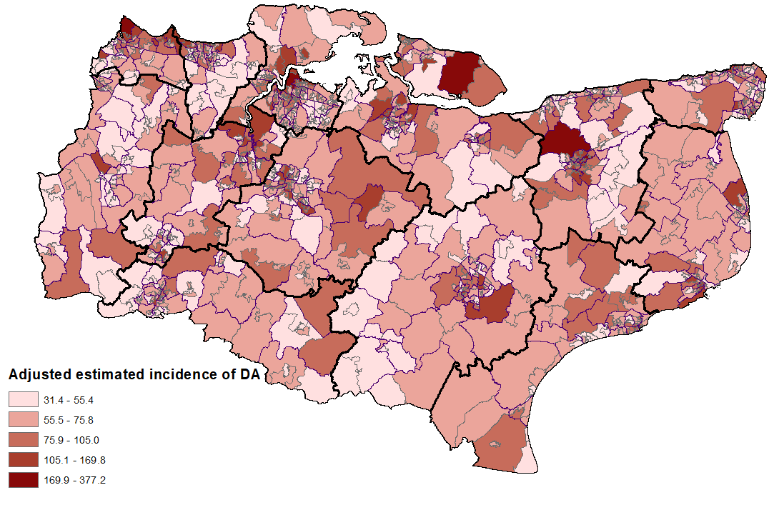

The figure below presents the age and deprivation adjusted prevalence by LSOA in Kent. This shows narrower variation than the incidence as the population size differences are not factored in, it is purely a reflection of the age and deprivation profiles of each area.

Figure 19: Kent LSOA map of estimated DA prevalence

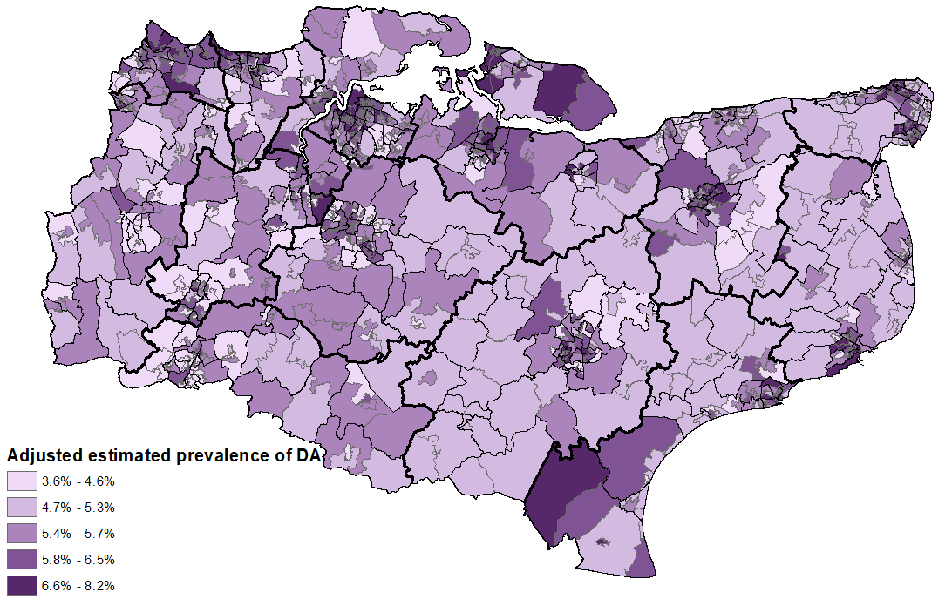

# Recorded Incidence

## Recorded police incidents

The most comprehensive indicator of recorded domestic abuse in Kent and Medway is incidents reported to Kent Police. Incidents can be broken down into recorded crime (where a crime has been committed e.g. assault) and non-crime (where a crime has not taken place, but an incident has been reported to police).[39] Kent Police reported 45,000 incidents of DA in 2019, 34,000 of which led to a crime being recorded.

Recorded incidents and crime have generally increased over the last 5 years. In 2019 incidents were slightly lower than 2018, although 2018 had the highest volumes on record. The proportion of incidents that led to a crime has also marginally increased over this time.

As a proportion of all crime, Kent Police record more DA related crime than the national average; 18% of all recorded crime by Kent Police is for DA, higher than the national rate of 14%. 11,500 incidents did not lead to a crime being recorded in 2019 (non-crimes).

Figure 20: trend of incidents and crimes recorded by Kent Police, 2015 - 2019

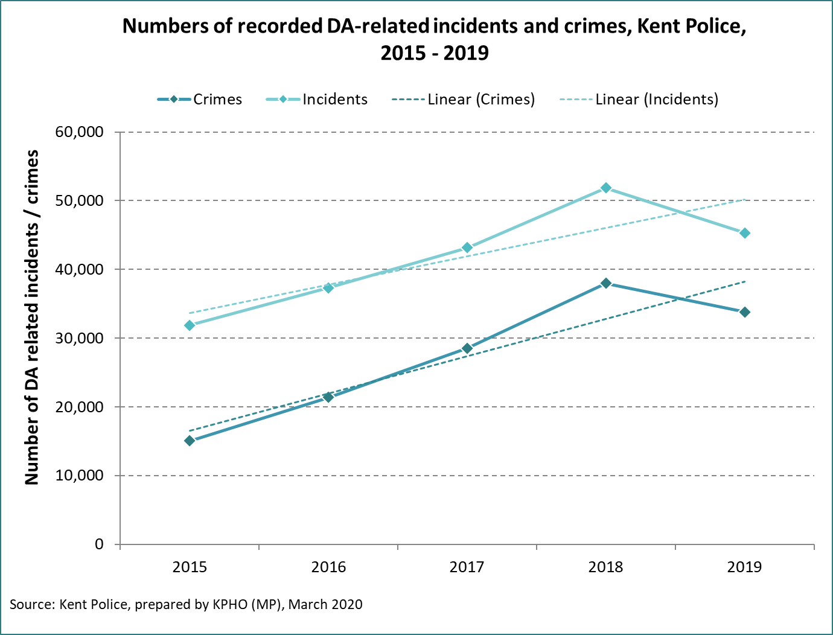

The table below shows a breakdown of medium and high-risk crime and non-crime incidents. In 2019, 19.8% of the calls categorised as crimes amongst medium or high-risk victims were in the high-risk category, compared with 13.9% of non-crime calls.

Figure 21: Incidents and crimes recorded by Kent Police



## Risk ratings / severity

Most Police recorded incidents are graded (either as low, medium, or high risk of harm) according to set criteria for Police officers – the DARA (Domestic Abuse Risk Assessment) (see below). This risk rating determines what happens next with the incident, as well as the level of support offered to the victim. Some calls amongst victims at high risk of abuse are not classified as a crime but they may have suffered abuse in the past or have been previously deemed at high risk of DA occurring.

|  |
| --- |
| **DASH / DARA assessment**  Most Kent organisations involved with DA use the Domestic Abuse, Stalking and Harassment and Honour Based Violence (DASH, 2009) Risk Identification and Assessment and Management Model. Kent Police are piloting the Domestic Abuse Risk Identification (DARA) and Assessment and Management Model (DARA) by front line officers. Those deemed at high risk after either assessment of these would qualify for referral to a MARAC. |

Figure 22 shows recorded incidents and crimes that were graded as medium or high risk from 2015 to 2019. A change in the police crime recording system in 2019 added in the ‘standard risk’ category, but this has been omitted from the analysis for consistency with previous years.

Medium risk crime has more than doubled from around 6,000 in 2015 to 14,000 in 2019. High risk crimes have also significantly increased, from around 2,000 to 4,000 between 2015 and 2019.

Figure 22: Police crime and non-crime medium and high-risk categories, 2015 - 2019

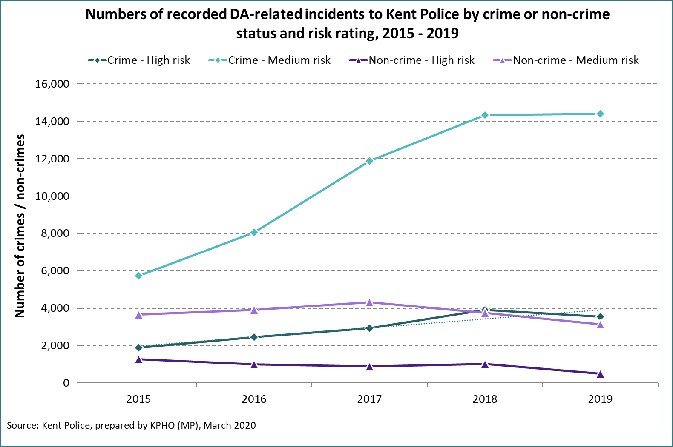

In 2019 a new Police recording system was introduced which allowed a standard category to be recorded for the first time. The diagrams below show the breakdown for incidents, crimes, and non-crimes in 2019. Incidents that lead to a recording of a crime typically have a higher risk rating than non-crimes.

Figure 23: Risk level of DA and DA non-crime incidents

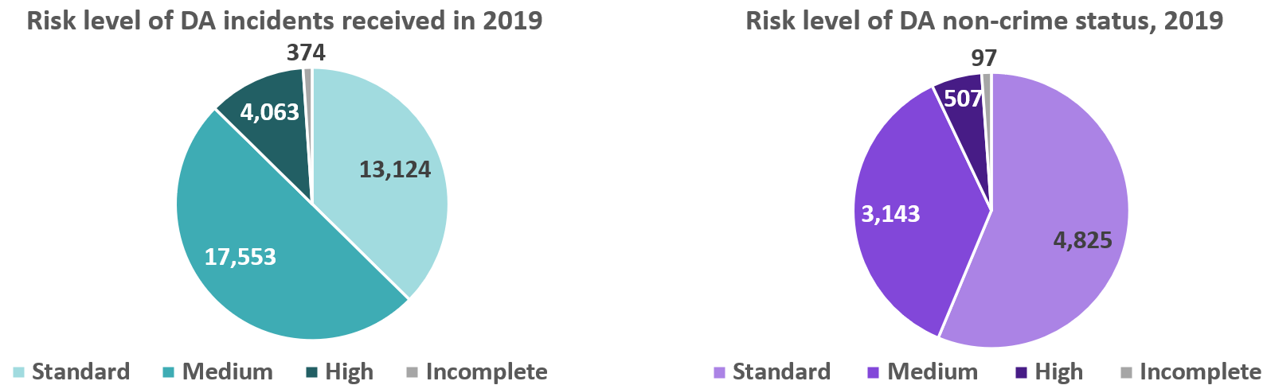

## Police records and estimated prevalence

In this section of the chapter we compare the estimated prevalences from chapter 3 with police incidents and crimes. Figure 24 below shows that some 61% of the estimated prevalence of DA in Kent is reported to the police, based on our assumption of 75,000 individuals experiencing DA annually.[40] 46% of the estimated prevalence leads to a crime being recorded.

Differences between males and females can be seen, with 69% of the estimated prevalence in females being reported, compared to only 46% in males. 51% of the estimated DA in females leads to a crime in Kent, compared with 36% of males. 78% of incidents in males are recorded as crimes, compared to 74% in females.

Figure 24: Ratios of incidents, crimes and estimated prevalence in Kent.

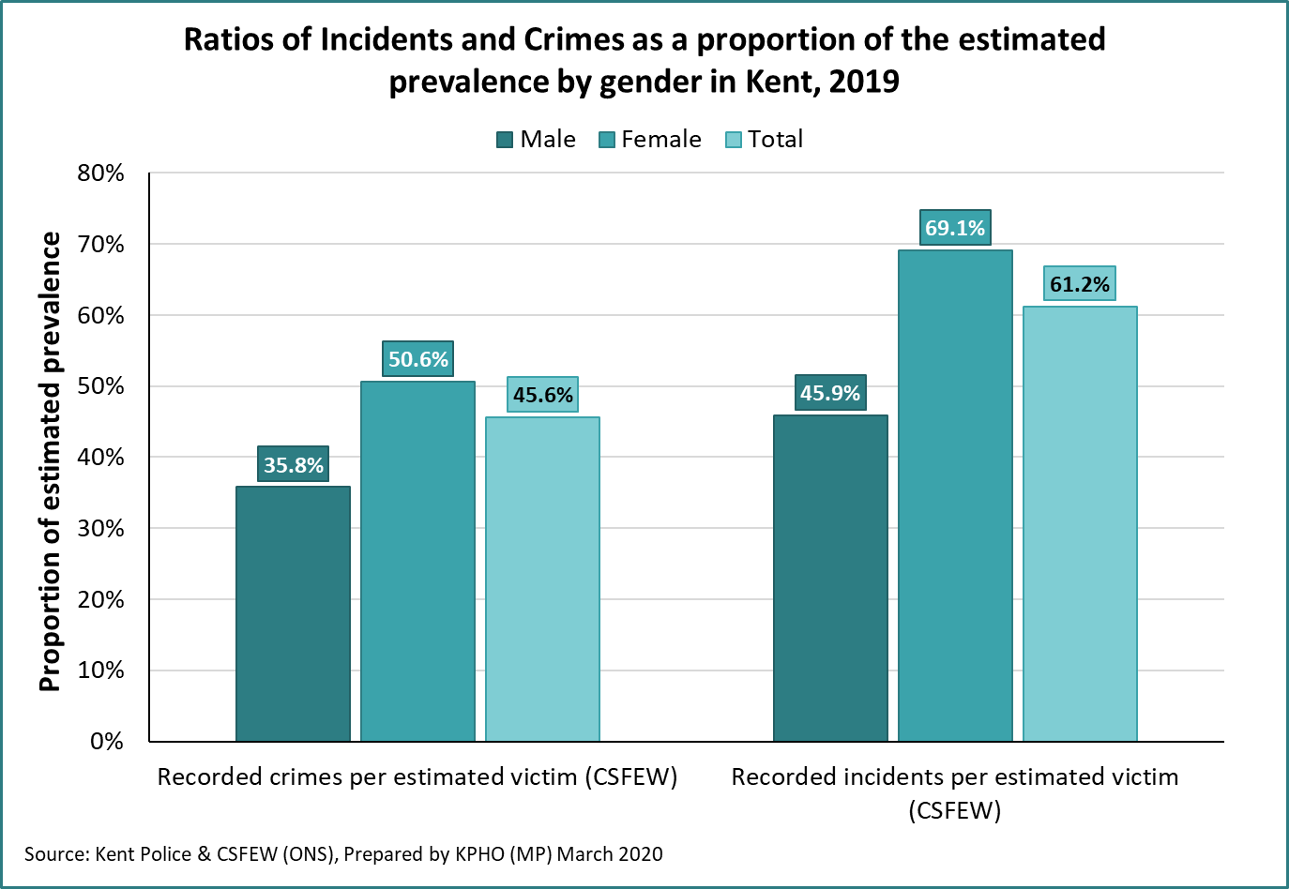

## Age

There are clear differences in the age profile of victims of DA within Kent Police data, with the young more likely to be a victim. Those aged 15 to 34 make up approximately half of those who report DA to the police, with those aged 25 to 29 making up the highest 5-year age band as a proportion of all incidents, at around 15% of the total.

Looking at the last 5 years of Police incidents by volume, however, proportional increases have been seen in 30-34, 35-39, and 55-59 year olds, and decreases in 15-19, 20-24, and 45-49 year olds.

Figure 25: DA incidents by age band, 2015 - 2019

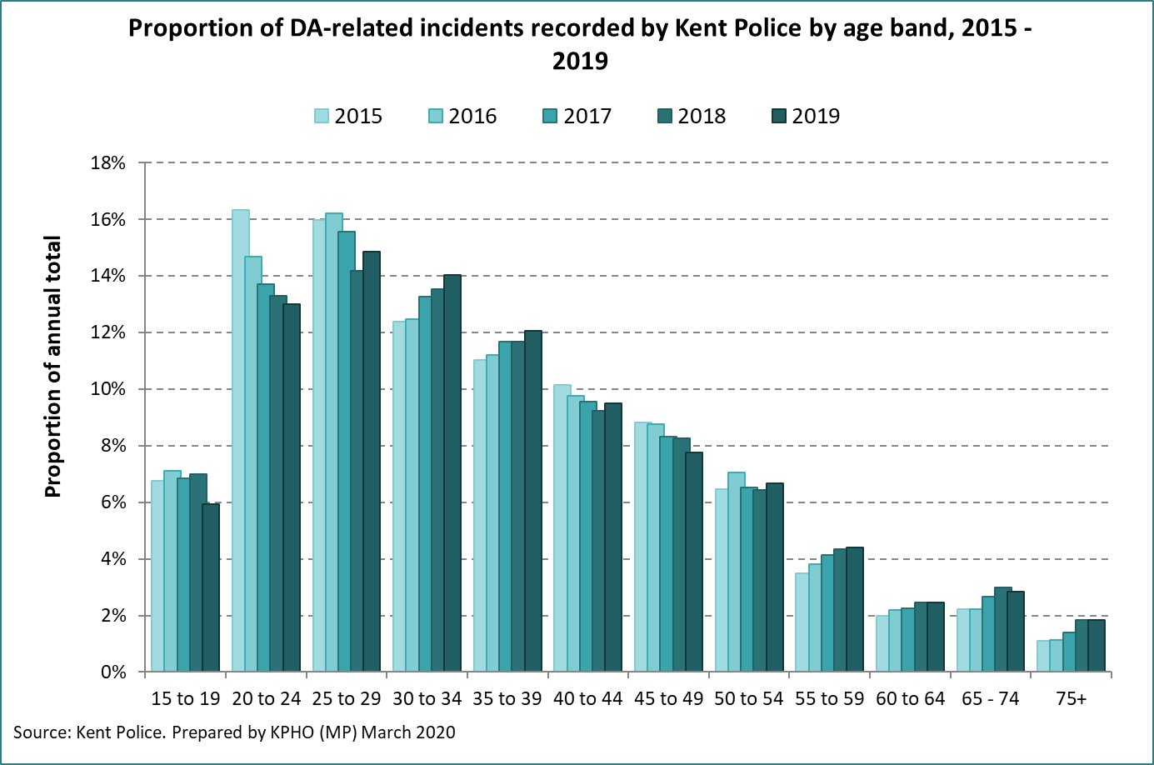

Another way to highlight the differences in age in recorded incidents is to present the data as a population rate. The reported police data was compared to mid-year population estimates published by the ONS, with results shown below as a rate per 1,000 residents in that age band.

This shows again that 20-24 and 25-29-year olds are reporting the most DA, closely followed by 30-34- and 35-39-year olds.

In line with the overall annual totals, 2018 showed the highest rates of DA for the majority of ages. As a population rate, those age 30-34, 35-39 and 40-44 showed the largest increases between 2015 and 2018.

Figure 26: Incidents of DA as a rate per 1,000 resident population by age band.

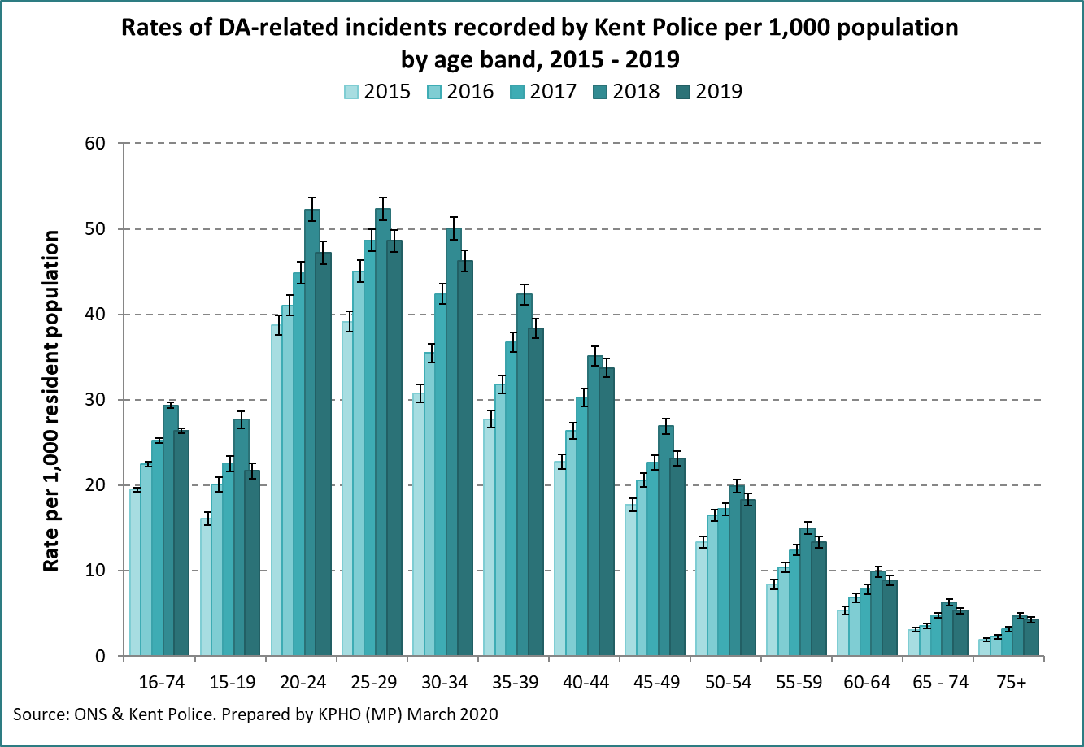

The graph below shows the records of incidents and crimes per 1,000 population, and by age band and compares to the proportion of incidents leading to a crime. Those aged 20 to 44 are most likely to report DA, but they are also least likely to lead to a recording of a crime. Those age 15 to 19, and 45 to 64 are less likely to report DA to the police, but more likely to lead to a crime recording if they do, although the difference is not substantial.

Figure 27: Rate of DA crimes and non-crimes by age band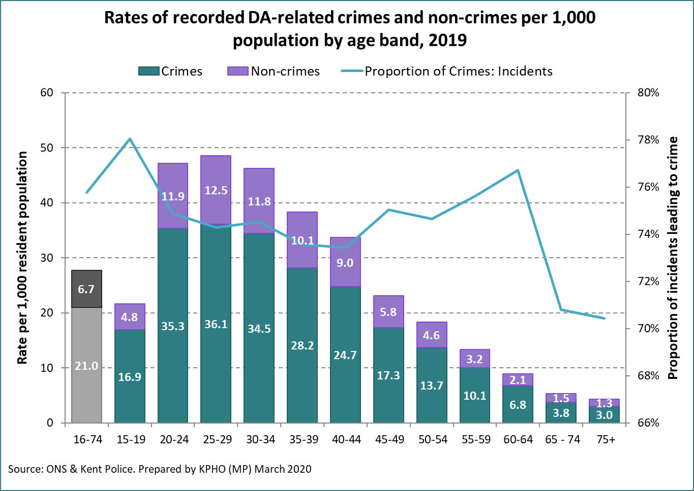

Those aged 25 to 44 appear more likely to report abuse they suffer than those younger or older, comparing the estimated prevalence of DA and recorded incidents, by age band. The graph below shows the estimated prevalence from the CSFEW against the incidents reported to Kent Police.

Figure 28: Estimated prevalence of DA and reported incidents by age band

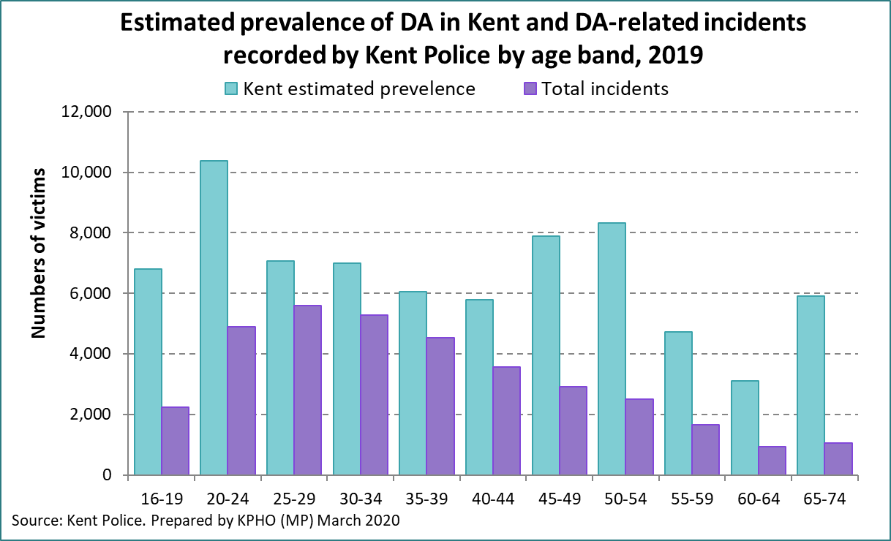

## Gender

As we have reported elsewhere in this needs assessment, DA affects males and females differently. The graph below shows police recorded crimes, police recorded non-crimes, and estimated prevalence as a population rate for males and females. Females are more likely to be victims of DA, and also appear more likely to contact the police if they are victims than males. Males who do contact the police are more likely to see a crime being recorded than females (in proportional terms).

Figure 29: Incidents, crimes and estimated prevalence of DA by gender per 1,000 population

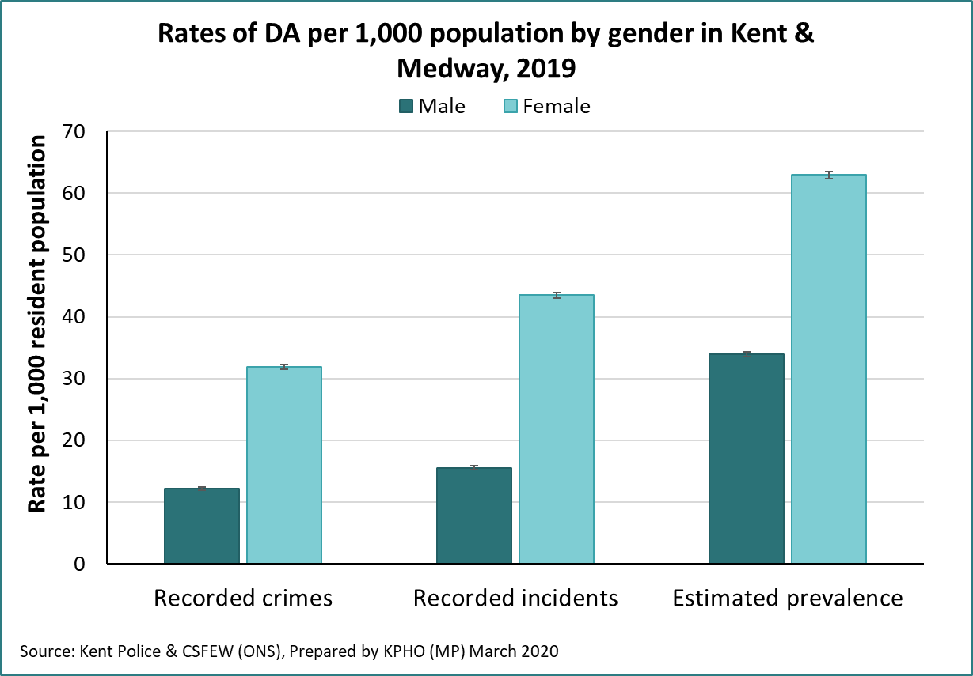

The table below summarises the volumes of victims of DA by gender, and shows recorded crimes, incidents and the estimated prevalence in Kent.

Figure 30: Incidents, crimes and estimated prevalence of DA by gender



## Ethnicity

The ethnicity of the general population is difficult to accurately quantify, and the 2011 census remains the most recent accurate recording. The graphs below show that most crimes and incidents are amongst White British victims, however the low numbers of other ethnic categories and the lack of recent demographic data available make quantification of under or over reporting of ethnic minorities difficult.

Recording of ethnicity within Police records is also an issue. The number of crimes where ethnicity is not stated or is unknown to the Police has increased between 2015 and 2019. Combined with the inaccurate demographic data available, it is not possible to tell if ethnic minority groups are under-reporting DA.

Figure 31: Crimes and incidents by ethnicity

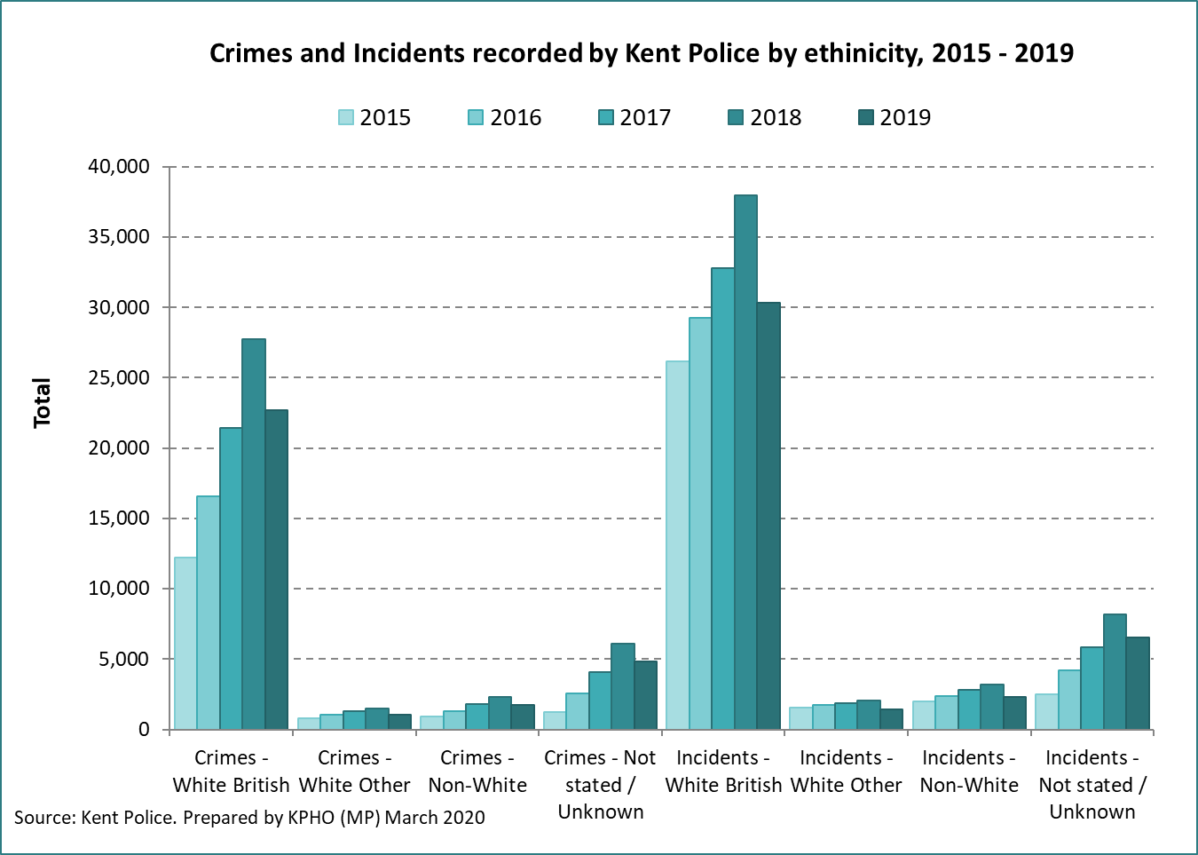

Figure 32: Proportional split of crimes by ethnicity

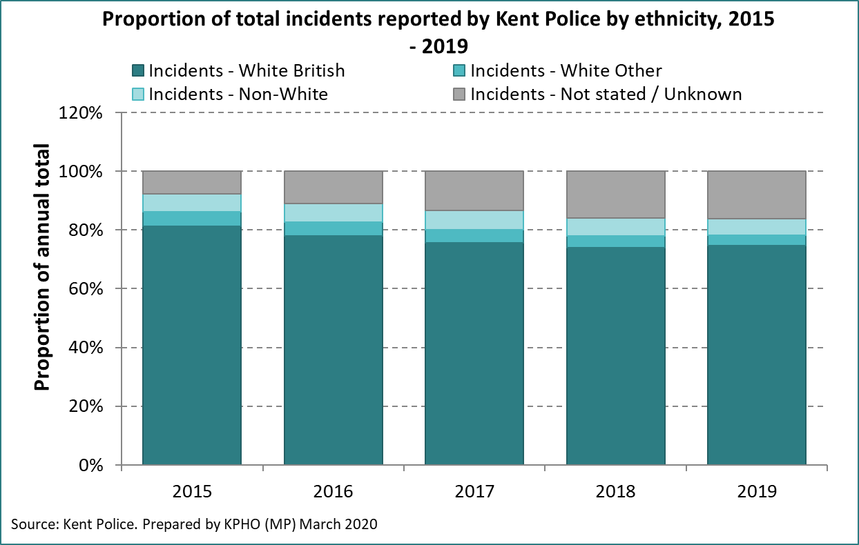

## Geographic variation

**Rates of incidents and crimes**

There are clear variations in the rates of incidents and crimes reported by district in Kent and Medway. Those in more deprived areas tend to have higher rates of reported incidents, with Thanet district having the highest rate at 36.4 per 1,000 adult population, more than double that in Sevenoaks district which has the lowest at 16.0 per 1,000. Crimes followed a similar pattern, and all districts had a similar rate of crimes per incident.

Figure 33: rates of incidents and crimes reported by district in Kent and Medway



**Reporting gaps**

Comparing police recorded incidents by district, with the adjusted estimated prevalence discussed in chapter 3, larger differences appear in the less deprived districts. This is particularly apparent in Sevenoaks, Tonbridge & Malling, and Tunbridge Wells (Figure 34 below). This appears to show those living in affluent areas are also less likely to report abuse. It is thought that the stigma or shame of being a victim of abuse may be greater in certain communities, and this effect may be borne out in the data shown here.

Figure 34: Age and deprivation-adjusted estimated prevalence and crimes by district

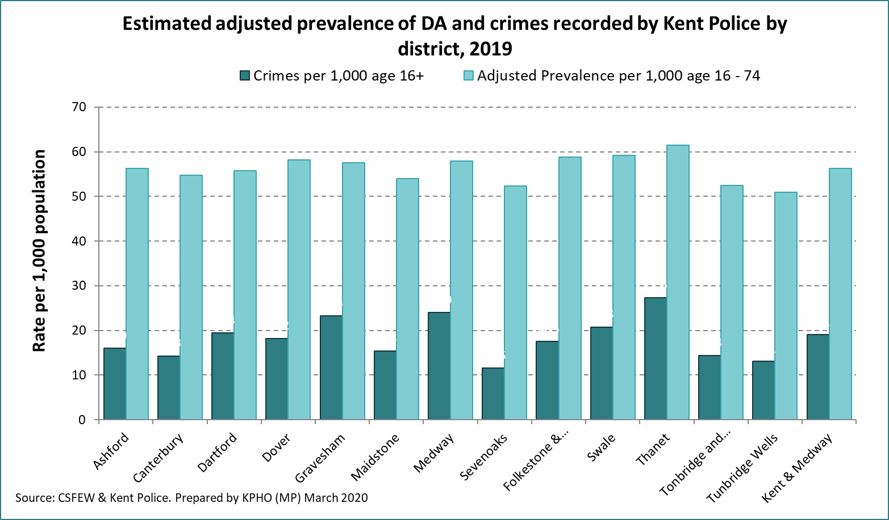

The graph below presents recorded police incidents by District, split by crimes and non-crimes, with the estimated (age and deprivation adjusted) prevalence overlaid. This is presented as a population rate to support comparison between districts.

The graph suggests the gap between estimated prevalence and that reported to Kent Police is greatest in Sevenoaks, Tonbridge and Malling and Tunbridge Wells, and smallest in Thanet, Medway, and Gravesham.

Figure 35: Police incidents and estimated prevalence by District

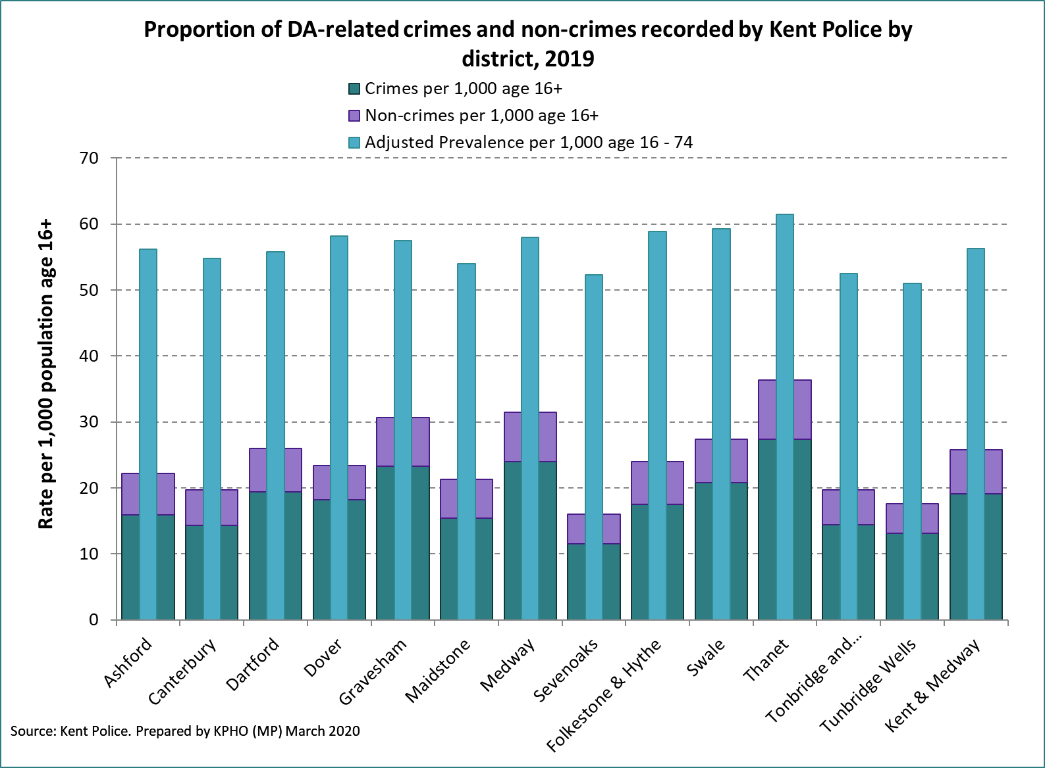

## MARACs

Multi Agency Risk Assessment Conferences (MARACs) are designed for victims and families assessed at high risk of significant harm or homicide. In MARAC meetings, agencies share information and agree to an action plan to support victims. Referrals may be made into this process from a variety of agencies, although are predominantly from the Police.

Typically, around 95% of cases discussed at MARAC involve females[41], and in Kent it is marginally higher than this at around 96%. In Kent referrals are based on escalation.

SafeLives[42] report that nationally there are 4.0 adult females per 1,000 experiencing DA and discussed in a MARAC in 2019. SafeLives also consider this rate to be the minimum safe level of MARAC across a population.

Locally in Kent and Medway, the calculated figure is around 3 per 1,000 females. As discussed in previous chapters, police data indicates Kent and Medway has a higher proportion of reported crimes (18%) as DA than the national average (14%), and therefore local DA crime is likely to be higher than the national average. Looking at this alongside the recommended SafeLives levels, it indicates utilisation of MARACs could possibly be low in Kent and Medway. This suggestion, however, does not take into account the seriousness of incidents and suitability of individual cases to be discussed at MARAC in Kent and Medway compared to the rest of the country.

The table below shows rates of reported MARACs in the Kent and Medway area per 1,000 adult females.[43]

Figure 36: Volumes of MARAC cases and rates per 1,000 adult females in Kent and Medway.



### Referrals

The domestic abuse data tool published by the ONS[44] says 74% of MARAC cases in Kent are referred by the police, compared with 66% in England and Wales.

Referrals to MARAC have been broadly similar for last the 5 years.

Figure 37: Referrals to MARAC per 1,000 resident population, 2015 - 2019

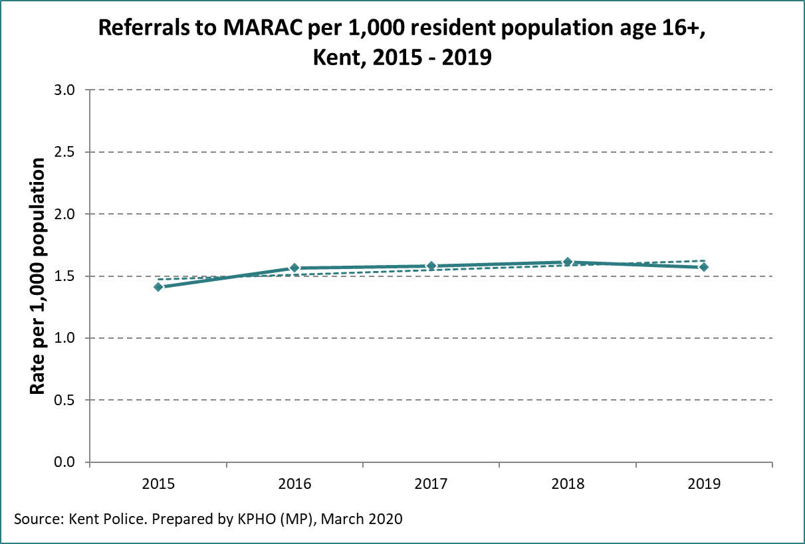

Rates of referral vary by District. Medway, Thanet, Gravesend, and Dartford districts show rates higher than the Kent average across the 5 years 2015 to 2019.

Figure 38: Referrals to MARAC by district

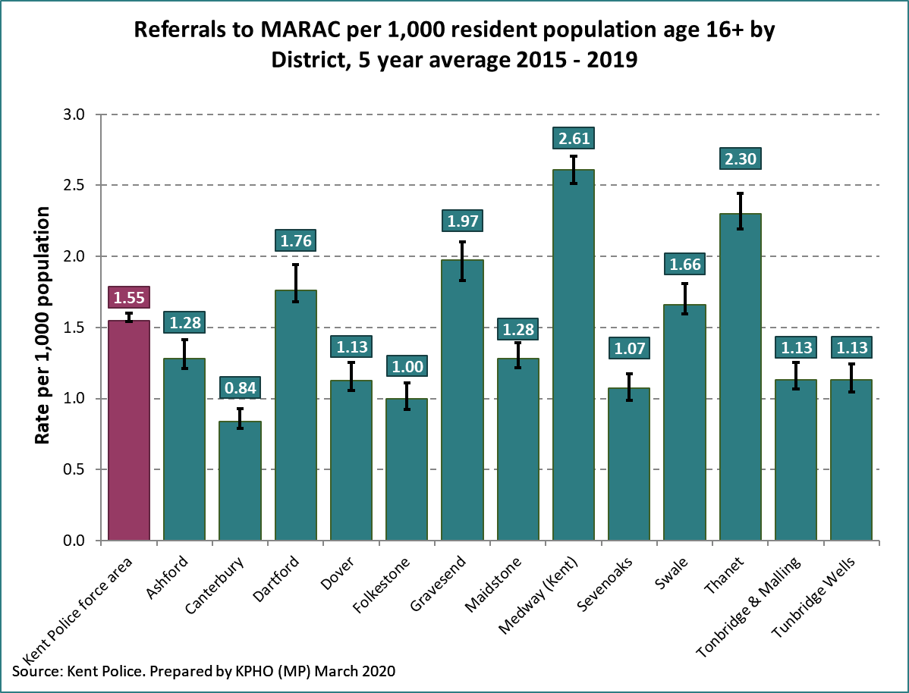

Those higher risk DA cases where the victim has children are more likely to be discussed at MARAC due to the likelihood of more agencies being involved with the family and therefore increased opportunity for referral. On average, 1.4 children are involved for each MARAC case in Kent.

Some variation is seen by district, with those in Swale and Tonbridge & Malling having slightly higher rates than the Kent average, but overall the numbers are similar across the county.

Figure 39: Numbers of children discussed per MARAC case in Kent, 2015 to 2019

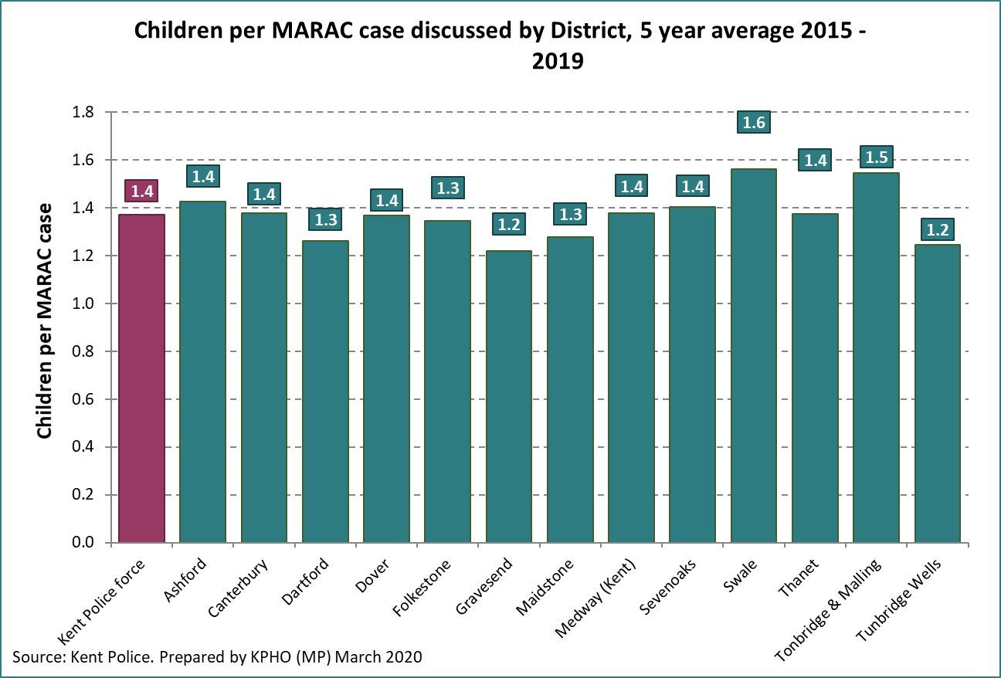

MARAC support high risk victims within complex situations. MARAC cases may in some situations need to be reheard due to the complex nature of cases. SafeLives reported that Kent had a marginally higher rate of repeat cases (31%) than England (28%) in 2017/18.

The graph below shows repeat cases for 2015 to 2019, and generally identifies a stable trend.

Figure 40: Trend of repeat MARAC cases in Kent

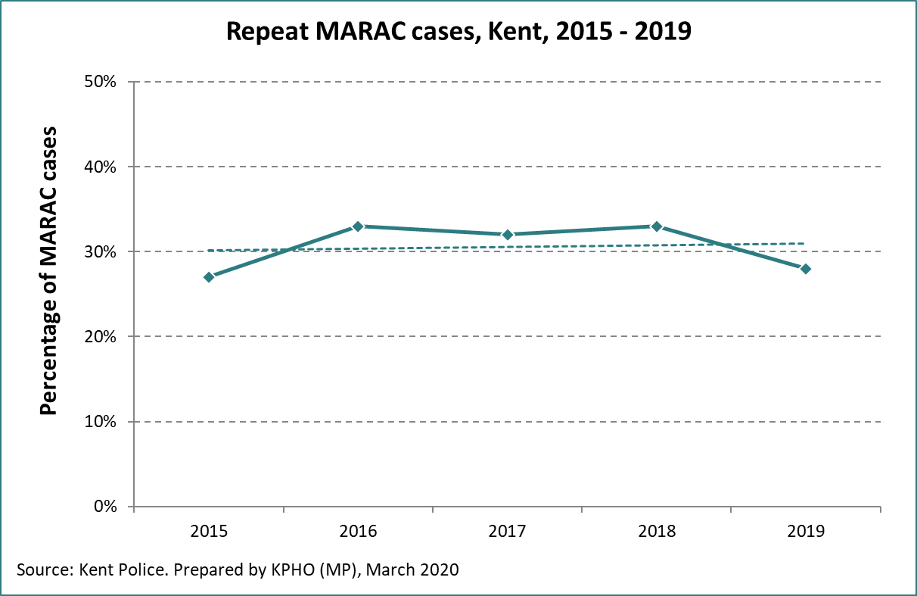

There is variation in numbers of repeat cases by district for the 2015 to 2019 period. Thanet, and Medway showed rates higher than the Kent average.

Figure 41: Repeat MARAC cases by district

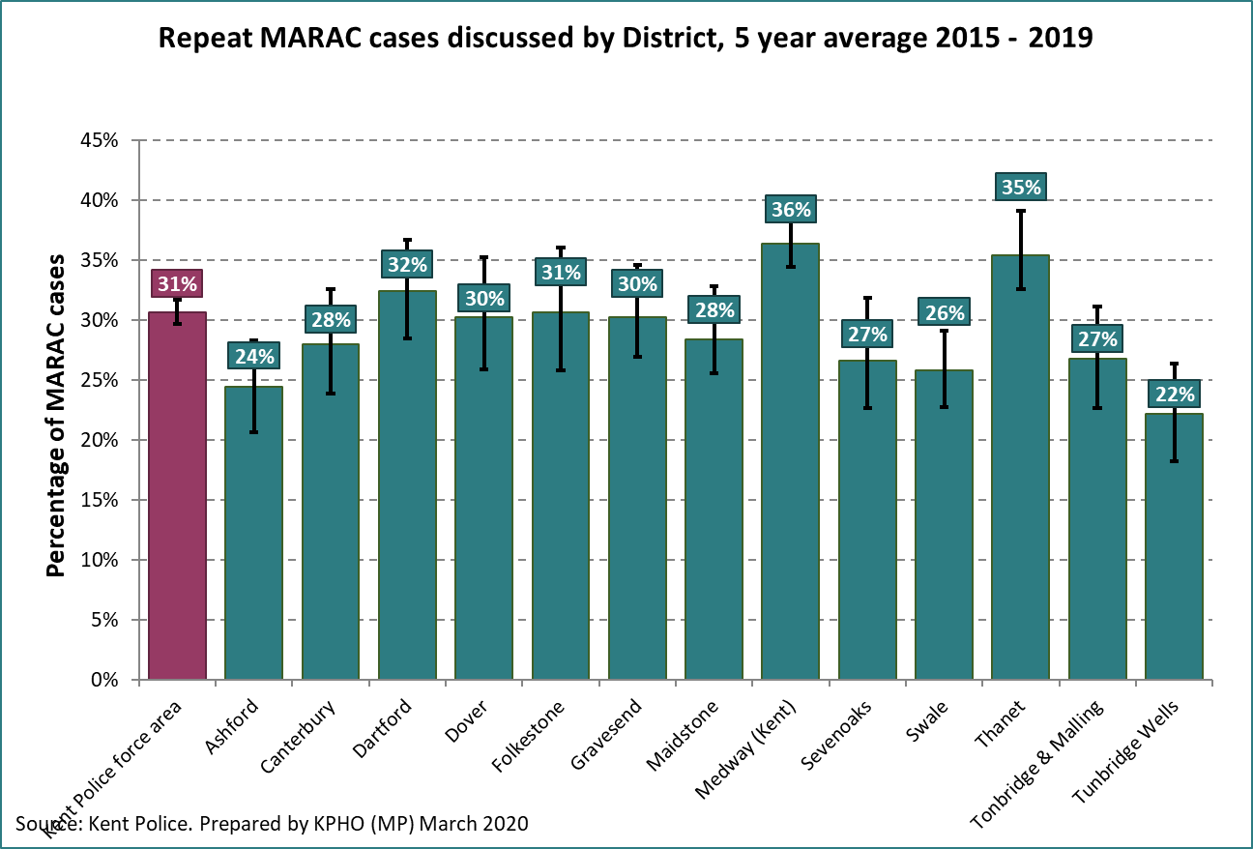

SafeLives report 74% of referrals for MARAC came from the Police in 2017/18, compared to 66% in England. This may be appropriate considering the local pathways in Kent and Medway, or it could indicate other agencies should consider use of MARACs more.

The graph below shows partner agencies referred a higher proportion to MARACs in 2019 than the preceding years.

Figure 42: Referrals from partner agencies (Non – Police)

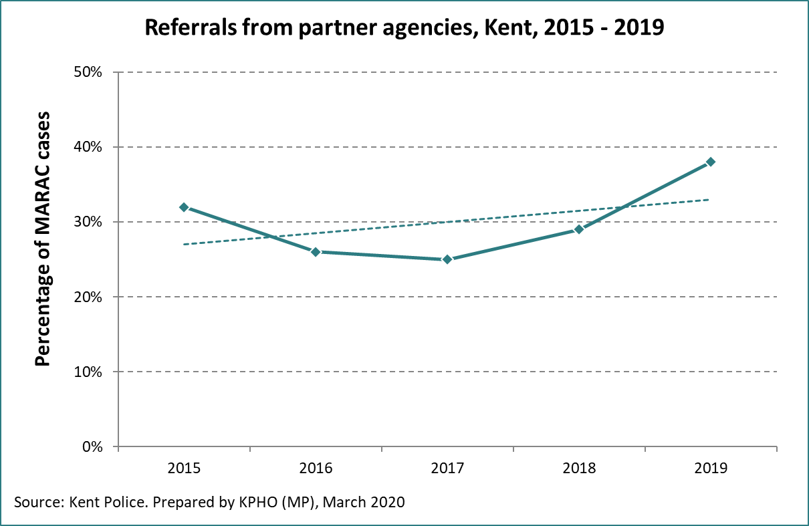

Referrals to MARAC by partner organisations vary by district, with the fewest referrals coming from partner agencies (and not the Police) in Ashford, Sevenoaks, Tonbridge and Malling and Tunbridge Wells, and the most from Medway, Thanet, and Folkestone. This appears to correlate to deprivation, with more referrals from the police coming from the more deprived parts of Kent.

Figure 43: Partner agency referrals by district

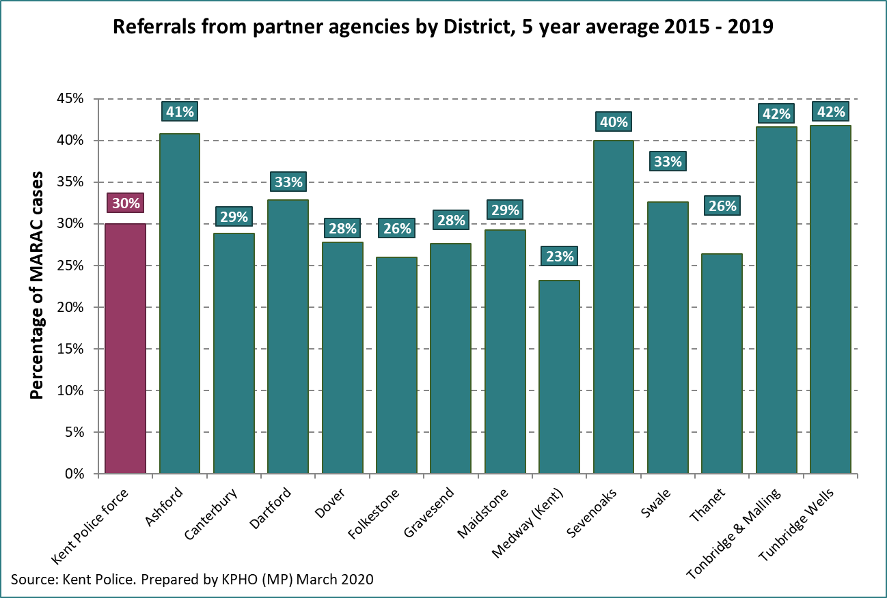

### Protected characteristics

Nationally, it is reported that 5% of MARAC cases involve males. Kent rates are marginally below this at 4% in 2017/18. As reported in chapter 3, survey data indicated around a third of all DA is reported by males.

Figure 44: MARAC cases by gender from the CSFEW

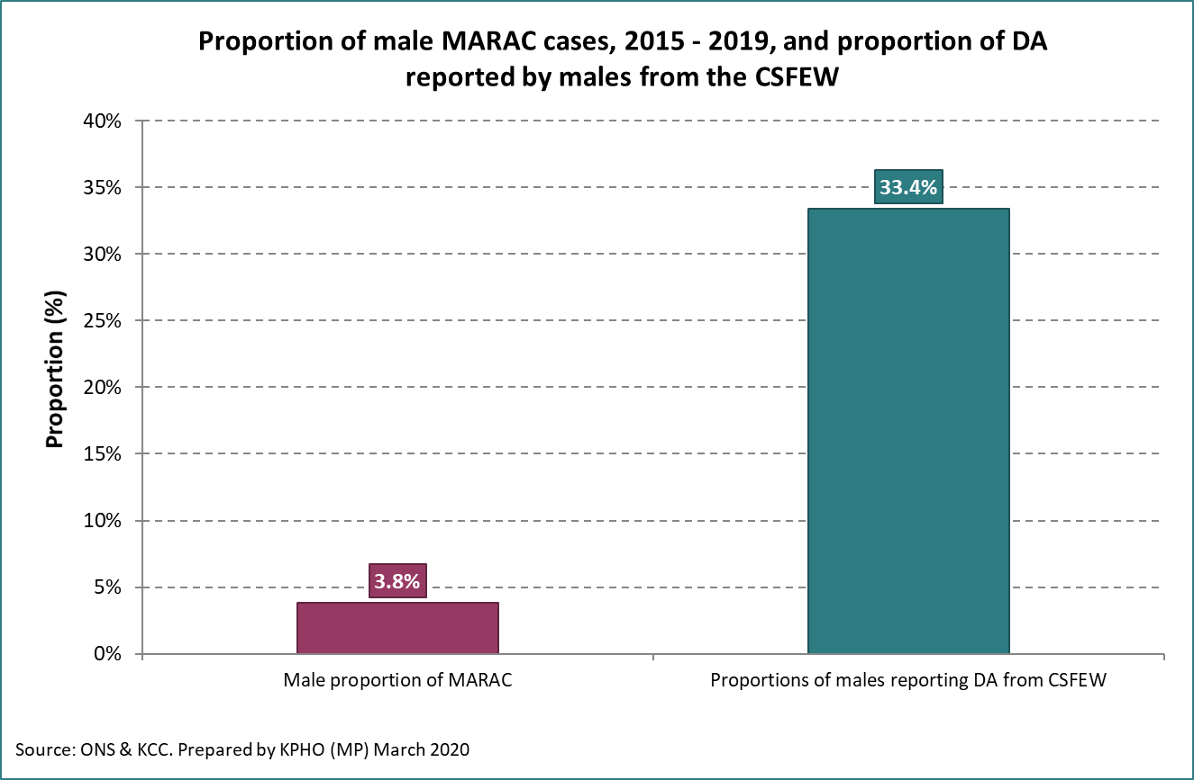

The graph below shows the average Kent rate of MARAC cases amongst disabled victims from 2015 – 2019 plotted alongside the estimated prevalence of DA in the disabled, and estimated numbers of people with a disability in the population. The proportion of disabled victims discussed at MARAC (2.6%) in Kent is considerably lower than the proportion of the general population with a disability (21.7%). SafeLives suggests that nationally only 3.9% of referrals to MARAC were for disabled victims, significantly lower than the SafeLives recommendation of 16% or higher. Although the MARAC team ask on every referral whether the victim has a disability this is hardly ever filled out. Recording mechanisms could therefore be improved.

There may be reasons for this considerably lower rate discussed at MARAC, including suitability for MARAC, lower numbers of children or younger children, or data capture / quality.

Figure 45: MARAC cases where victim is recorded with disability.

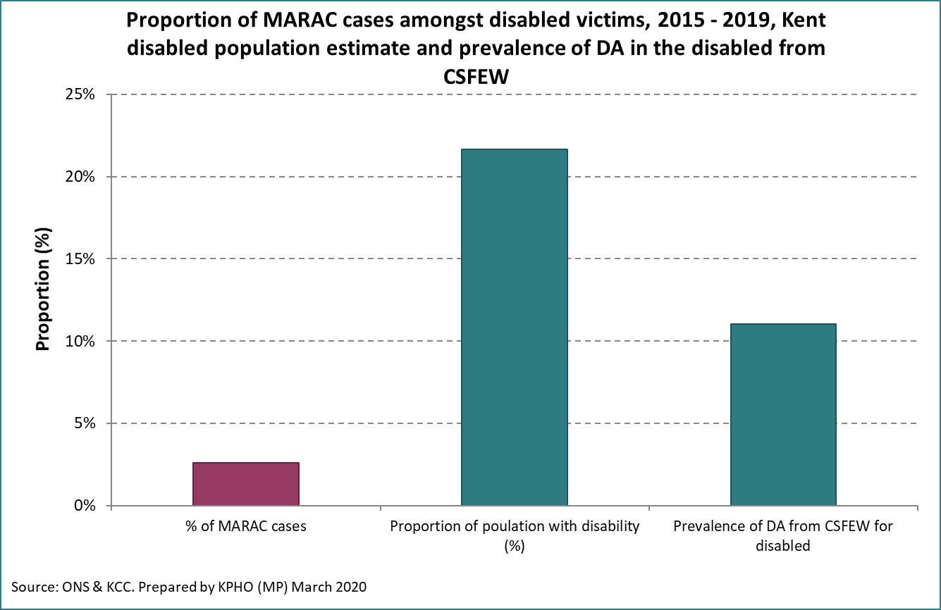

Between 2015 and 2019 10.6% of MARAC cases in Kent were BME. As discussed in previous chapters, the exact prevalence of DA in ethnic minorities is difficult to state definitively, but this rate seems in line with the estimated prevalences seen in minorities.

The graph below shows the Kent MARAC proportion, and the estimated prevalence reported for minority groups nationally.

Figure 46: Ethnicity of MARAC victims in Kent

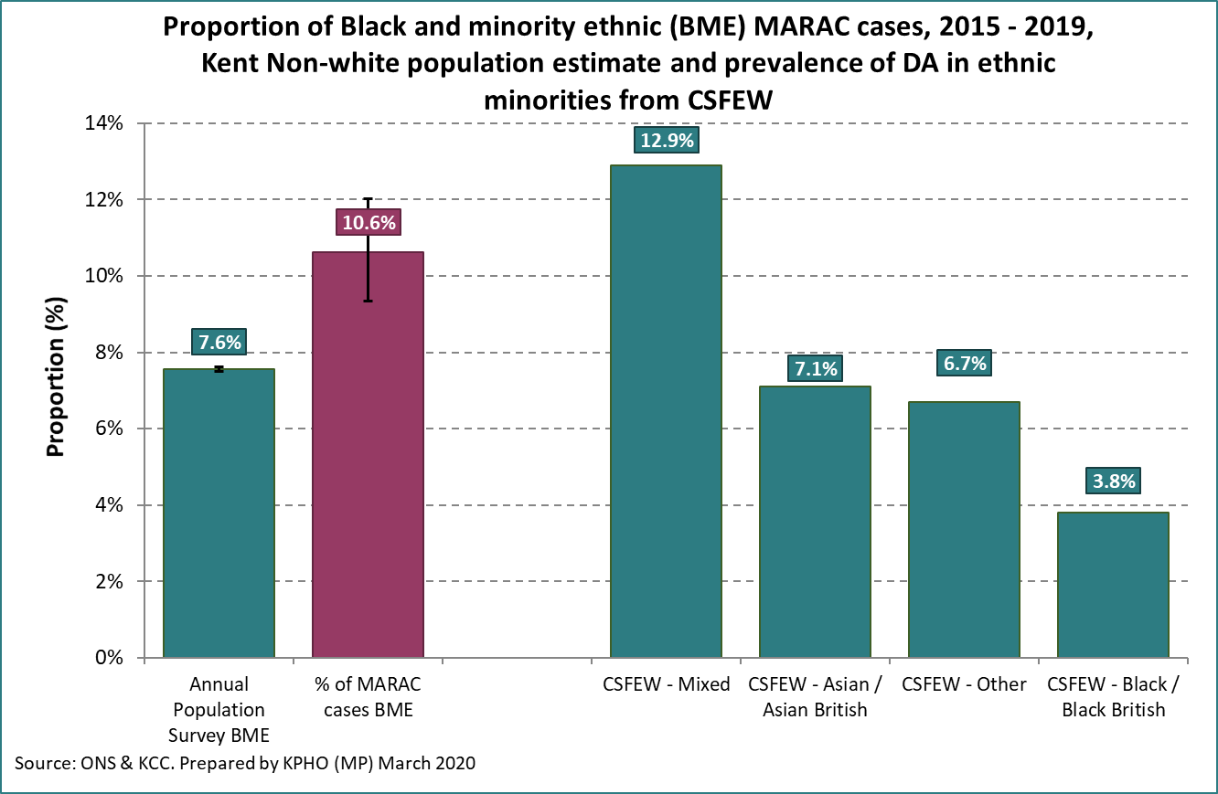

## Probation services

Probation services cover court sentences served in the community and can include unpaid work, community payback or supervision after release. For perpetrators in Kent and Medway, low and medium risk offenders fall under the management of the KSS Community Rehabilitation Company (KSS). High risk offenders fall under the publicly run National Probation Service (NPS). A recently announced decision means that from June 2021 the NPS will be responsible for managing all offenders on community orders or license.

Data supplied below was for the 2018/19 financial year from KSS CRC, and the 2019 calendar year from the NPS. In total there are 1,300 to 1,400 perpetrators of DA in Kent. Around 70% of perpetrators fall under the low to medium risk category under KSS CRC, with around 400 high risk offenders under the NPS. In terms of caseload, there are around 5,000 active cases in Kent and Medway, with over 40% under the NPS.

Figure 47: Perpetrators and Caseloads of probation services in Kent and Medway.



*Counts below 6 have been suppressed (*).*

Most perpetrators, around 95%, are male, with a slightly higher proportion in the high-risk category under the NPS. Compared to the estimated prevalence of DA, and the recorded police crimes where females account for approximately a quarter to a third of estimated DA, this proportion is considerably higher.

Figure 48: Age and gender of perpetrators on probation



Those aged 30 – 39 appear to be the highest age bracket under probation services, closely followed by those aged under 30. This is a slightly lower proportion of younger perpetrators compared to the numbers of crimes being committed (see figure 26).

KSS CRC supplied details by district area for standard and medium risk offenders. This is presented in the table below along with the proportion of total K&M offenders for each district, and the proportion on community orders.

Figure 49: standard and medium risk offenders by district



KSS CRC also supplied a breakdown of offence types and order types. Violence was the most common offence type accounting for around 55% of offences. Public order, theft and criminal damage were also significant offences.

Figure 50: standard and medium risk offences by offence type



Community orders and suspended sentence orders made up two-thirds of the total offences of low and medium risk.

Figure 51: standard and medium risk offences by order type



**4.10 Domestic Homicides and Safeguarding Adults Reviews**

If a domestic homicide takes place in Kent or Medway, Kent Police inform the relevant Community Safety Partnership. After this initial notification, a decision is made about the need for a Domestic Homicide Review (DHR).

Since April 2011, a joint Kent and Medway Domestic Homicide Review Protocol has been in place to fulfil statutory requirements. The Kent and Medway protocols were brought together utilising guidance from the Home Office produced in March 2011 and a subsequent revision in 2013. A domestic homicide review will look at the circumstances of a death of a person aged 16 or over if they have, or appear to have died from violence, abuse or neglect by a person to whom they were related or with whom they were, or had been in an intimate personal relationship with, or within the same household[45].

In December 2016, the Home Office produced new multi-agency statutory guidance regarding the conduct of DHRs. The guidance contained a number of key changes including the requirement to undertake a review where a victim took their own life (suicide) and the circumstances give rise to concern, for example, if it emerges that there was coercive controlling behaviour in a relationship. This recognised the link between DA and suicide. The rate of notifications for Kent and Medway increased following the broadening of the DHR criteria. This was to be expected as cases of suicide where DA was known to be a factor are now identified alongside the cases of domestic homicide. This resulted in the active caseload being managed and coordinated by the Kent Community Safety Team (KCST) in recent years being twice that seen during the years prior to the changes in the guidance.

Domestic homicides represent the extreme end of DA. Each homicide is estimated to cost an average of £2.2 million, comprised of costs of criminal justice, and social and health support for other family members involved over a period of time.[46]

In line with the rate of all DA, the ONS reports that out of 366 domestic homicides 96 of these were male victims, approximately 26% (data from 2019)[47].

The ONS reported 9 domestic homicides over 3 years in Kent between 2015/16 to 2017/18, 3 of which were males[48]. At £2.2m per case this equates to a cost of circa £6.6m annually in Kent.

The ONS 2019 national data shows an average age for domestic homicide victims is reported to be 46 for females and 51 for males, which is older than the average DA victim.

Domestic homicides occur disproportionately more in some ethnic minorities. The CSFEW reported that between 2016 to 2018 76% occurred in the ‘white’ population, who make up 86% of the population of England and Wales. People of ‘Asian’ origin were most likely to be a homicide victim.

National ONS data shows that the majority of homicide perpetrators are the victim’s partner, around 71%. 15% are a parent, and 13% other family and 1% a son/daughter. Thirteen per cent of suspects go on to commit suicide before the conclusion of the court proceedings.

Kent and Medway’s DHRs are published on both KCC and Medway Council’s websites at the following links:

<https://www.kent.gov.uk/about-the-council/partnerships/kent-community-safety-partnership/domestic-homicide-reviews>

<https://www.medway.gov.uk/info/200219/community_safety/604/domestic_homicide_reviews>

Key themes from recently completed DHRs cover the following topics:

* **Adolescent to parent violence** and associated issues regarding family engagement with services and the recording of crimes and incidents within school settings.
* **Stalking and harassment** and the links to increasing risk of homicide. This includes the part this plays in coercion and control and includes the use of social media and cyberstalking.
* **Engaging with services and service transitions** – Recognising that there may be a number of reasons for an apparent lack of engagement with a service, and service users may need additional support and consideration to assist them in accessing the right services at the right time. This should include alternative methods of contact including face to face meetings.
* **Carers** – being alert to the demands on a carer and enabling them to access suitable support.
* **Decision making** – Ensuring you have sufficient information, sharing information with partners including across borders, recognising opportunities for professional curiosity and impacts of cognitive bias.
* **Recognising and responding to potential coercive control**; e.g. reliance on a carer, accompanied to appointments, minimisation of risk, unable to answer or talk freely on the telephone.
* **Appreciation of the wider consequences of DA** including impacts on mental health, an increased risk of suicide and the impact on the decisions and actions of the victim.

**4.11 Safeguarding Adults Reviews**

The Kent and Medway Safeguarding Adults Board (KMSAB) has a duty under the [Care Act (2014)](https://www.legislation.gov.uk/ukpga/2014/23/part/1/crossheading/safeguarding-adults-at-risk-of-abuse-or-neglect/enacted) to carry out a Safeguarding Adults review (SAR) when an adult at risk in Kent or Medway dies as a result of abuse or neglect, whether known or suspected, and there is concern that partner agencies could have worked more effectively to protect the adult. A SAR must also be arranged if the same circumstances apply where an adult is still alive but has experience serious neglect or abuse.

When a new referral is received, a multiagency decision-making panel, chaired by a member of the SAR working group is convened to determine whether the case meets the criteria. The recommendation of the panel is then sent to the Independent Chair of the KMSAB for a final decision.

Key themes from completed DHR’s have also been seen within completed SAR’s including the below:

* Engaging with services and barriers to engagement - recognising that service users may need additional support to assist them in accessing the services that they need.
* Decision making and the importance of clarifying leadership in complex case management when multiple agencies are involved, ensuring information is shared with partners and how this information is utilised and deployed.
* Recognising professional curiosity and asking; what do professionals need to know? What are they concerned about? How are they going to find out? How can appropriate lawful actions assist?

Other key themes seen from completed SAR’s include:

* Quality of record keeping
* Case co-ordination and case management
* The importance of effective deployment of the Mental Capacity Act in Safeguarding
* Self-neglect and clarifying the threshold for safeguarding involvement
* Incorporating Making Safeguarding Personal (MSP) throughout all safeguarding work.

Kent and Medway’s SARs are published on the KCC website at the following link:

<https://www.kent.gov.uk/social-care-and-health/information-for-professionals/adult-safeguarding/safeguarding-adult-reviews>

**4.12 Child Safeguarding Practice Reviews (CSPR)**

A Child Safeguarding Practice Review is a multi-agency case review by the Kent Safeguarding Children Multi-agency partnership (KSCMP) of the circumstances of serious child safeguarding cases.

Serious child safeguarding cases are those in which:

* Abuse or neglect of a child is known or suspected **and**
* The child has died or been seriously harmed

The authority to conduct a child safeguarding practice review is described in [Working Together to Safeguard Children, HM Government 2018.](https://www.gov.uk/government/publications/working-together-to-safeguard-children--2)

Where there is a serious child safeguarding case, any agency can make an electronic notification to the KSCMP for a case to be considered by the KSCMP Rapid Review Panel.

Following the submission of a notification, a rapid review will be commenced where the key points of contact across all KSCMP’s multi-agency partners will be contacted to determine if their agency was involved in the case and if so, to request a summary of this involvement be provided in a report. This will then be discussed at the Rapid Review Panel, where a decision will be made as to whether or not this case identifies any new learning. Should it be agreed that this is the case, the RR Panel will decide the scope and methodology for undertaking a CSPR. The CSPR might involve agencies providing more detailed reports, the undertaking of a Practitioner’s Learning Event, or the completion of case audits.

The purpose of a review is to:

* Establish whether there are lessons to be learnt from the case about the way in local professionals and organisations work together to safeguard and promote the welfare of children.
* Identify clearly what those lessons are, how they will be acted on, and what is expected to change as a result, and therefore, improve inter-agency working and better safeguard and promote the welfare of children.

A CSPR is not a criminal enquiry and is separate from any investigation undertaken by the Police. This process is **not** about blame or any potential disciplinary action, but about an open and transparent learning from practice in order to improve inter-agency working.

When the Review has been completed, organisations will agree what actions they may need to take to change the way they support children, young people and their families and these will be monitored by the KSCMP.

CSPRs, (formerly Serious Case Review - SCRs), can be found on the KSCMP website at <https://www.kscmp.org.uk/procedures/safeguarding-practice-reviews/local-child-safeguarding-reviews-2020> and <https://www.kscmp.org.uk/about-kscb/kscb/kent-scrs>

Key themes identified from recently published serious and local case reviews were:

* Undertaking assessments and the use of historic information
* Inquisitive practice and meaningful engagement
* Engaging with fathers and new adults in the family
* Information sharing and record keeping
* Working with neglectful families and understanding sustained change
* Children’s attendance at appointments
* Multi-Agency Challenge and Escalation
* Working with children where the parents have additional needs
* Vulnerability of small children and babies

Read the full report here <https://www.kscmp.org.uk/__data/assets/pdf_file/0018/100827/KSCMP-Learning-from-Practice-Reviews-Identification-of-Key-Themes-from-2018-19.pdf>

# In treatment: support services

As part of this assessment we were able to access performance data related to commissioned support services across Kent and Medway (generally secondary or tertiary interventions). This chapter seeks to explore variations in service utilisation by equality characteristics and compare usage with estimated need and police reported incidents.

Notes on data quality for this chapter:

1. Kent County Council and Medway Council commission a number of services to support the victims of domestic abuse. Some district councils in Kent also commission their own services. Additionally, a number of local and national charities and other support organisations exist outside of local government. This means there are varied providers and varied levels of support available depending on where victims live in the county.
2. Data availability and quality also differs by provider. Data on community ‘core contract’ services was received from the 4 providers directly by KCC: Choices, Clarion (North and South), Lookahead and Oasis, as well as Choices who Medway contract with.
   1. Within this needs assessment it was necessary to combine data from across these providers into one single local authority total for Kent, and another for Medway. At a provider level, small cell counts became disclosive when analysing by key equity variables such as age, gender, ethnicity, district, etc. Attempting analysis at this level would have required suppression. Consequently, this only allowed analysis of combined data for some of these equity measures.
3. The data received for commissioned support services was generally for the first 9 months of 2019-20. We have therefore needed to proportionally scale-up this data to represent a full year. Consequently, trend analysis over a longer period was not possible, and the data shown here will differ from final year figures for 2019 once they are published.

**National context**

The table below presents some characteristics of clients in commissioned refuges, community-based services and IDVAs, based on national surveys of providers. Around 100 refuge and community providers participated in the ‘census week’ in 2017. SafeLives publishes an annual Insights IDVA report[49], which sampled 22 providers in 2018-19.

Figure 52: Characteristics of clients in commissioned services



Sources: CSFEW (Refuges & Community: Women’s aid annual survey July 2017; IDVA: Insights IDVA dataset 2017/18, SafeLives)

## Referrals

**Initial Referral Assessment and Triage (RAT)**

An initial ‘Referral Assessment and Triage’ (RAT) service acts as a single source of referral into core contracted services commissioned by Kent County Council. This service is managed by Victim Support (an independent charity) and commissioned through the Police and Crime Commissioners Office.

Victim Support receive data automatically from Kent Police for all DA calls attended. They also receive referrals from any other agencies as well as self-referrals. Victim Support triage all calls received and refer cases to the correct provider under the integrated contract after they have made contact with the victim and sought consent.

When triaging cases Victim Support use the Domestic Abuse, Stalking and Harassment and Honour Based Violence (**DASH**, 2009) Risk Identification and Assessment and Management Model. Kent Police use the Domestic Abuse Risk Assessment (**DARA**).

Victim Support offer support to standard risk victims (assessed under DASH or DARA) including providing safety advice, emotional support, onward signposting, support to court services, support services for men and access to home security items. The majority of medium risk cases are referred to the commissioned provider for the area of residence. High risk cases are also sent to the commissioned providers, but many are also referred to MARAC conference.

Providers can additionally receive referrals outside of the RAT process.

Numbers of cases that come into the RAT service (are substantially higher than those they manage to contact / gain consent for onward support. Just under 4,000 referrals were accepted by Kent County Council commissioned services in 2019.

Referrals may be unsuccessful for a variety of reasons, including, but not limited to:

* client not engaging,
* clients not consenting,
* concerns with background checks, or clients having previously displayed offending behaviour,
* level of need,
* clients fear of perpetrator finding out,
* controlling and coercive behaviour of perpetrator.

**Referrals to PCC Commissioned Victim Support**

In 2019/20, 20,873 referrals were received by the PCC commissioned Victim Support. Over half (53%) of all referrals were in the 25 to 34 and 35 to 44 age bands, with significant numbers in the 18 to 24 and 45 to 54-year age bands.

This proportion is slightly lower than those in KCC commissioned services, with 25 to 44-year olds making up around 63% of the total in treatment. Nearly 70% of those in treatment in Medway are 25 to 44.

Figure 53: Age of referrals to Victim Support



75% of referrals were from females and 22% males, and 3% not stated or recorded. Subsequent parts of this chapter discuss gender in treatment services, and while the drop-off is high in both genders between those referred and those who subsequently receive treatment, the vast majority of referred males do not go on to receive support.

Figure 54: Gender of referrals to Victim Support



**Successful referrals into core contract commissioned support services**

The police are the largest referrers to commissioned support services in Kent and Medway. One Stop Shops, Outreach services, IDVAs and Housing departments based in district LAs also refer significant numbers.

Figure 55 – Referral source for KCC commissioned services



*Counts below 6 have been suppressed (*).*

Figure 55b – Referral source for engaged MDAS clients, 1 April 2019 to 31 March 2020

|  |  |  |
| --- | --- | --- |
| **Referral source for engaged MDAS clients** | **Count** | **% of total** |
| Police | 35 | 17% |
| One Stop Shop | 25 | 12% |
| DA Outreach | 0 | 0% |
| IDVA | 0 | 0% |
| (blank) | 0 | 0% |
| LA Housing Depart | 5 | 2% |
| All other | 140 | 68% |
| **Total** | **205** |  |

*Counts below 4 have been suppressed (*). All other counts have been rounded to the nearest 5.*

## Geographic variation

The table below shows the geographic variation of the total of IDVA, outreach and refuge services by district in Kent. It is important to note that Sevenoaks, Tonbridge Wells, Tunbridge and Malling, and Dover districts all have support services we were not able to source full and complete data for, and consequently appear underreported below, and affect the overall Kent and Medway figures.

The data we have been able to access from KCC commissioning teams does not comprehensively provide the picture for West Kent as it only covers high risk clients. Data received from the Office of the Kent Police & Crime Commissioner, shows that in 2019-20 Domestic Abuse Volunteer Support Services (DAVSS) received the following number of referrals assessed as medium risk:

* 287 in Sevenoaks
* 325 in Tunbridge Wells
* 310 Tonbridge and Malling.

Additionally, in Folkestone and Hythe, Home Start supported 110 women through their ‘enhanced new beginning’ programme, and 273 clients attended their one-stop shops.

Of the districts with full data, Ashford had the highest proportion of its population in support services at 3.3 per 1,000 adults, followed by Dartford (3.1), Canterbury (2.9) and Thanet (2.6 per 1,000). This is summarised in the table below. Please note districts with incomplete data are shown in grey.

The totals for Kent and Medway are consequently based on the averages of data supplied.

Figure 56: service use by district, Kent and Medway



Medway has two Refuges with a total of 14 beds. As of 01 April 2019, 9 people were in the refuges. 29 new people moved in between April 2019 & March 2020.

Medway’s Floating Support is a generic service with standard support and a higher option for people with criminal justice involvement or substance misuse. People who are receiving the service may disclose that they also require support around DA. In 2019/20 the service supported 27 people experiencing DA including 5 males.

Sanctuary Service in Medway received 115 referrals for 2019/2020. The service surveys properties where someone has experienced DA and proposes increased safety measures and carries out works (to the average material value of £200.00 per job).

90 households contacted the Housing Options and Preventions service in Medway referencing DA as part of the reason for contact. Of these, 16 were not continued past triage (main reason, online contact by household who did not then progress the homelessness application). The other households were offered advice or assistance (including rehousing where appropriate).

During 2019/20 Medway’s Rehousing service awarded 31 applications priority for DA and rehoused 11 with this priority.

## Age

Clients age 20 to 40 make up approximately two-thirds of commissioned service users, with 25 to 35-year olds being the age groups with the highest usage.

The graph below, covering Kent services only, shows the proportional split by age for IDVA, outreach and refuge services. Those age 25 to 35 are the highest users of services, those age 45 and over and 15 to 19-year olds are much lower.

Figure 57: Proportion of KCC commissioned service usage by age band

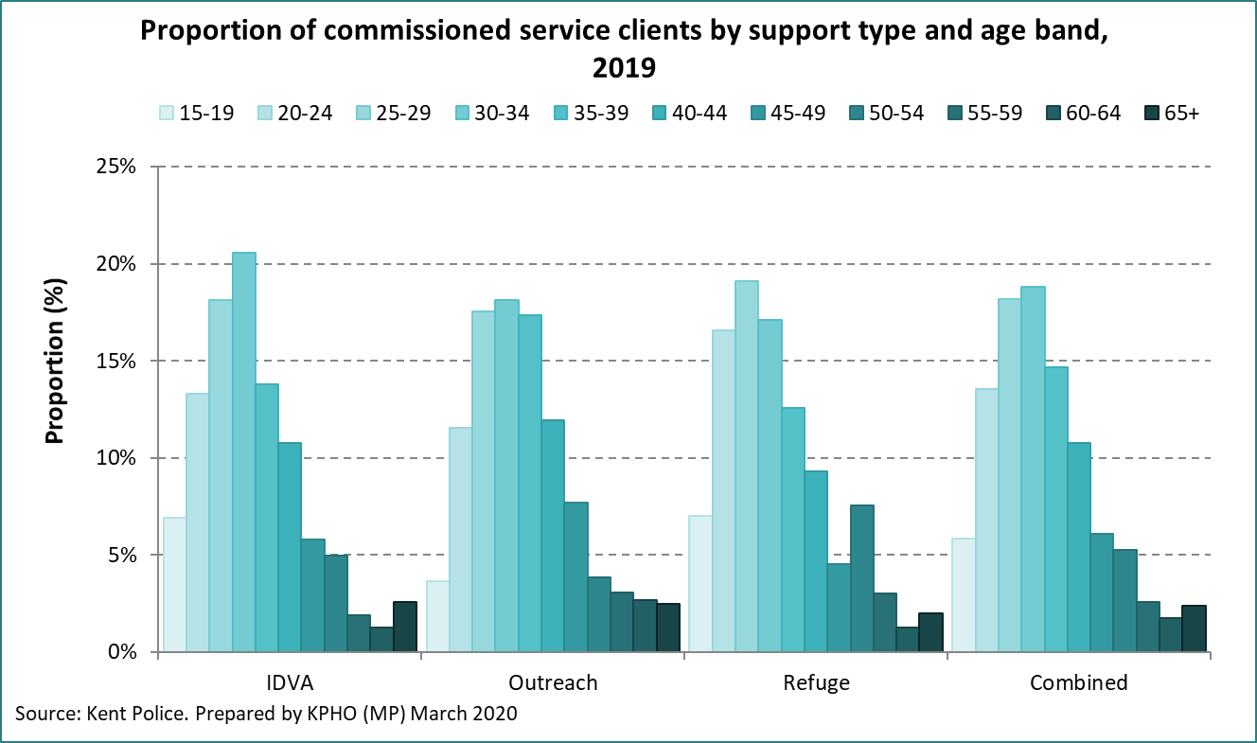

The table below, again covering Kent services only, shows the proportional split of service users by age, alongside the same age bands reported for crimes, incidents and estimated prevalence.

It appears to show those age 25 to 45 are represented in higher proportions in commissioned services than reported incidents and the estimated prevalence in the population.

Figure 58: Proportion of KCC commissioned service usage by age band



Figure 58b: Proportion of MDAS usage by age band, 1 April 2019 to 31 March 2020

|  |  |  |
| --- | --- | --- |
| **Age band** | **Count** | **% of total** |
| 16-17 | * | * |
| 18-24 | 35 | 17% |
| 25-34 | 80 | 39% |
| 35-44 | 60 | 29% |
| 45-54 | 25 | 12% |
| 55-64 | 5 | 2% |
| 65+ | 0 | 0% |
| **Total** | **205** |  |

*Counts below 4 have been suppressed (*). All other counts have been rounded to the nearest 5.*

The graph below illustrates the Kent data when compared to recorded police incidents, and clearly shows older age groups are less likely to be found in support services than those age 25 to 45.

Figure 59: Difference between service usage and police incidents by age (KCC Commissioned Services)

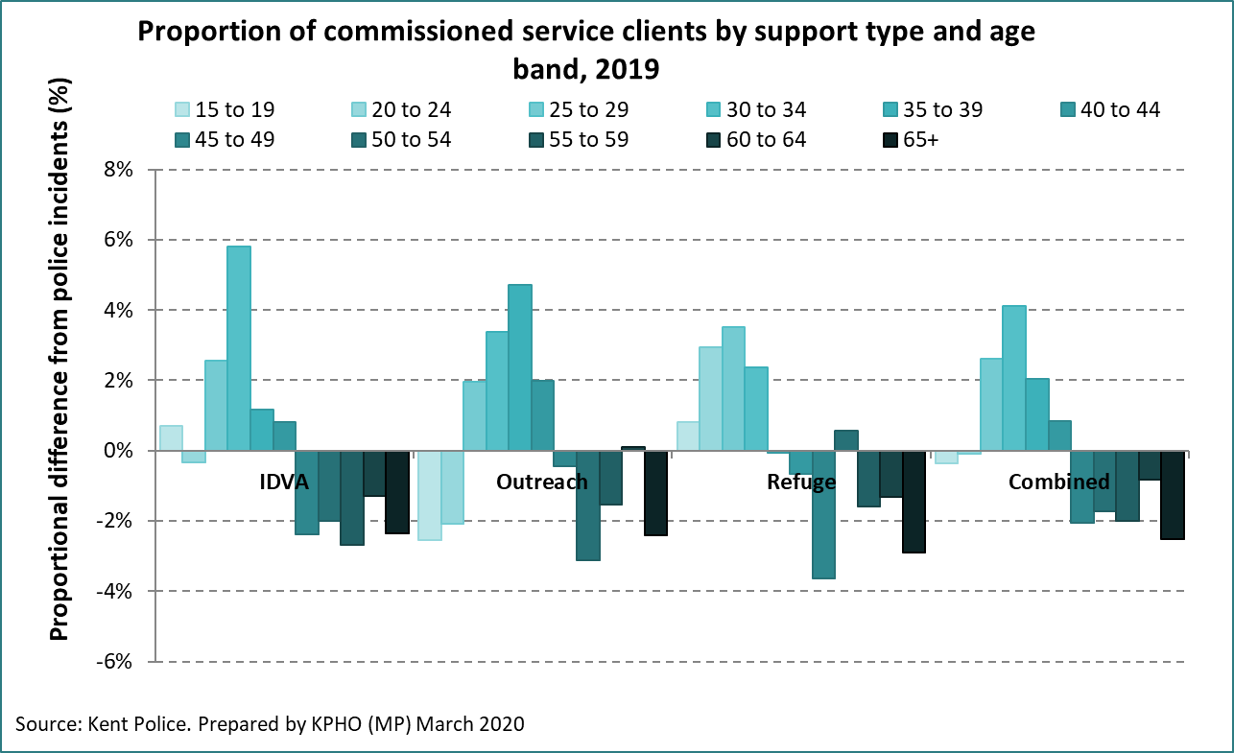

## Gender

The gender of those in commissioned support services are mostly females. Proportionally, males are marginally higher in outreach services than IDVA services.

Figure 60: Gender differences in KCC commissioned support services



Figure 60b: Proportion of MDAS usage by gender, 1 April 2019 to 31 March 2020

|  |  |  |
| --- | --- | --- |
| **Gender** | **Count** | **% of total** |
| Male | 5 | 2% |
| Female | 200 | 98% |
| **Total** | **205** |  |

*Counts below 4 have been suppressed (*). All other counts have been rounded to the nearest 5.*

## Ethnicity

The ethnicity of clients is well recorded in commissioned services. The supplied data was aggregated into 3 categories due to very low numbers within individual ethnic groups. ‘White British’ is the largest ethnic group across both Kent and Medway, in line with the proportion in the general population.

In Kent, non-white clients make up 11.4% in IDVA services, 14.4% in outreach and 24.2% in refuge services, all higher proportions than seen in the general population.

Figure 61: Ethnicity in/using KCC commissioned services



Figure 61b: Proportion of MDAS usage by ethnicity, 1 April 2019 to 31 March 2020

|  |  |  |
| --- | --- | --- |
| **Ethnicity of MDAS clients** | **Count** | **% of total** |
| White British | 155 | 76% |
| White - all other | 15 | 7% |
| Non-white | 35 | 17% |
| **Total** | **205** |  |

*Counts below 4 have been suppressed (*). All other counts have been rounded to the nearest 5.*

Figure 62: Ethnicity by service type (KCC Commissioned services)

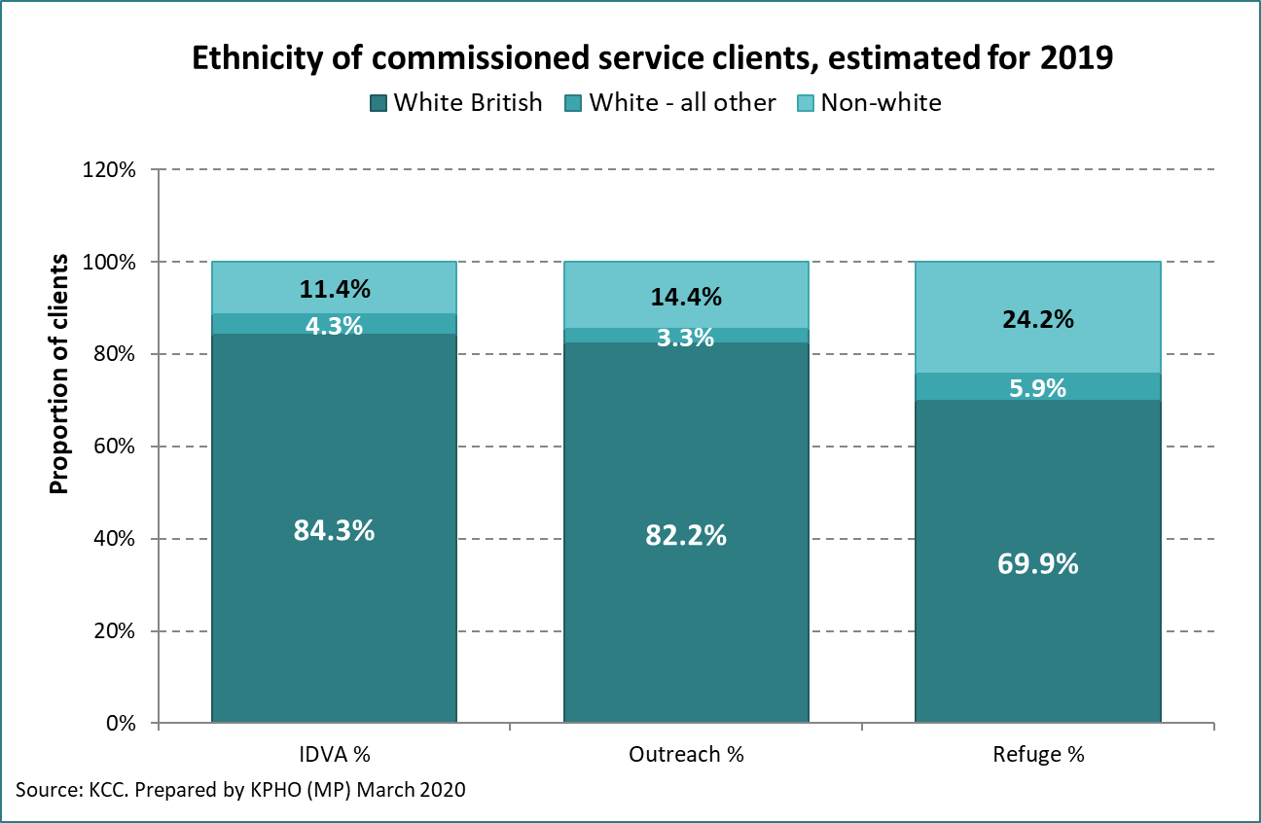

## Sexual Identity

Community services receive data from the majority of clients regarding their sexual identity, which is summarised below from Clarion North, Clarion South, Oasis and Lookahead. 2.4% of those who provided a response reported being LGBTQ. We do not have accurate figures on the proportion of the population in Kent who are in this minority group, but the Annual Population Survey estimates the number to be around 2.8% for the South East.

Chapter 3 previously reported that many in this minority group are at greater risk of DA than the general population, so it is possible they could be underrepresented in community services.

Figure 63: Sexual identity of Kent Community Service Clients



## One Stop Shops

One Stop Shops (OSS) are present in Medway and most of Kent’s towns and serve to provide a range of services and support to victims of DA. Some service is overseen by KCC and Medway Community Safety Partnership’s, Medway Council and Medway’s Domestic Abuse Forum (MDAF) who collated and supplied data for this needs assessment, others are managed directly by the VCS. Some OSSs have a Steering Group in place to monitor local provision.

Data for Medway was available for 2019 calendar year.

Data for Kent was available to cover the period 2015-16 to 2018-19.

The number of visits has been similar across the last 4 years at just over 3,000 annually in Kent.

Although open to men and women, the service is used almost exclusively by females. We know from chapter 3 that males suffer around a third of all DA, but they make up around 6% of OSS clients.

Figure 64: Visit to one stop shops by year and gender – Kent only

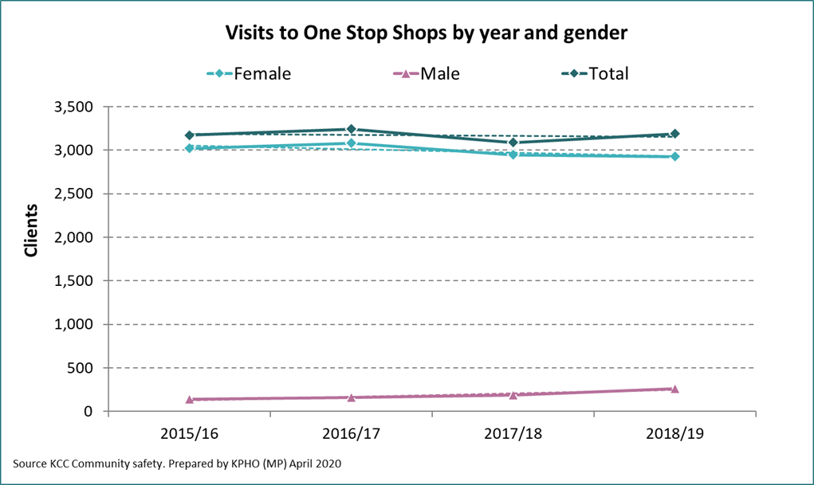

Those age 26 to 39 make up the largest age group of clients to the service, as shown in the graph below.

Figure 65 Numbers of One Stop Shops clients by age – Kent

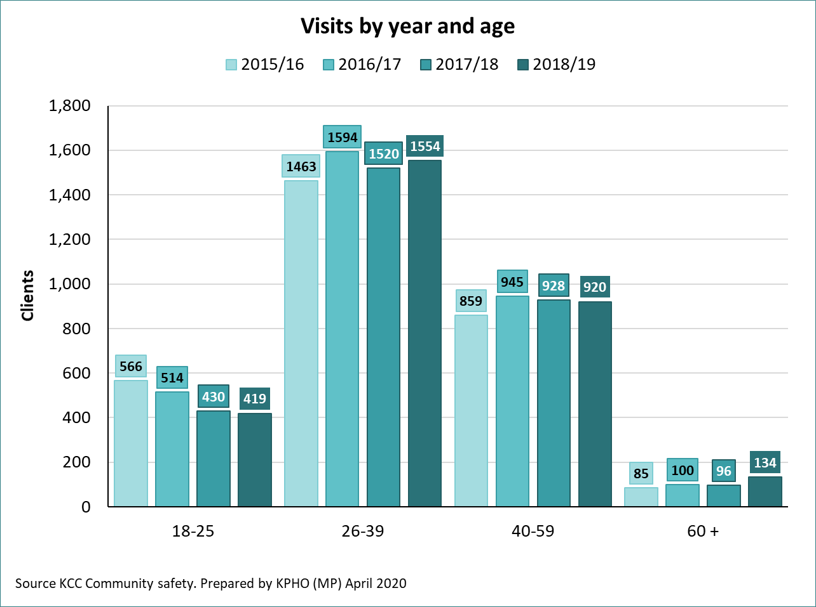

The same pattern of usage by age was seen in Medway.

Figure 66 Numbers of One Stop Shops clients by age – Medway

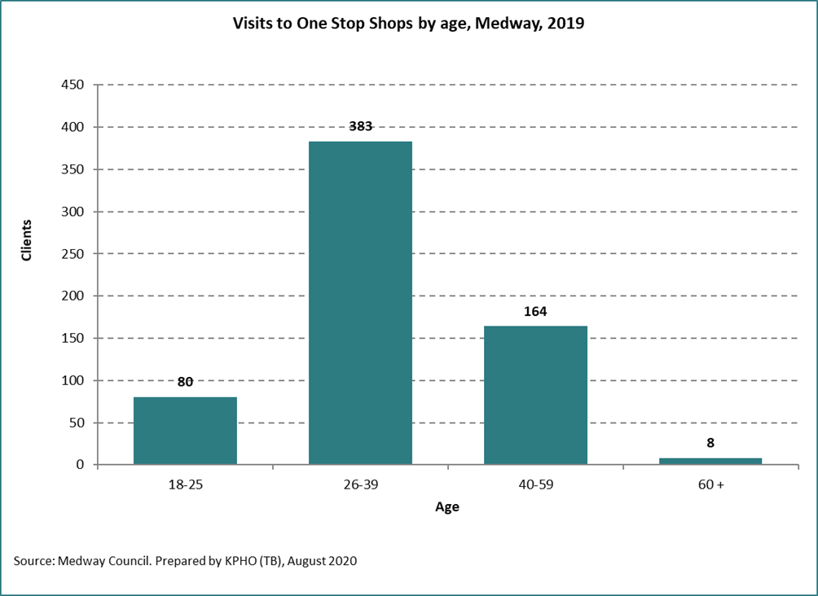

As a population rate, those age 26 to 39 are the highest users of the service. 18 to 25 year olds and 40 – 59 year olds also use the service in significant numbers, but those over 60 use the service infrequently.

Comparing these rates with the estimated prevalence in the population as discussed in chapter 3, the youngest age groups tend to suffer the most abuse but are not using the service as often as 26 – 39-year olds. There may be scope to promote the service to this age group.

Figure 67: One Stop Shops clients by population rate – Kent

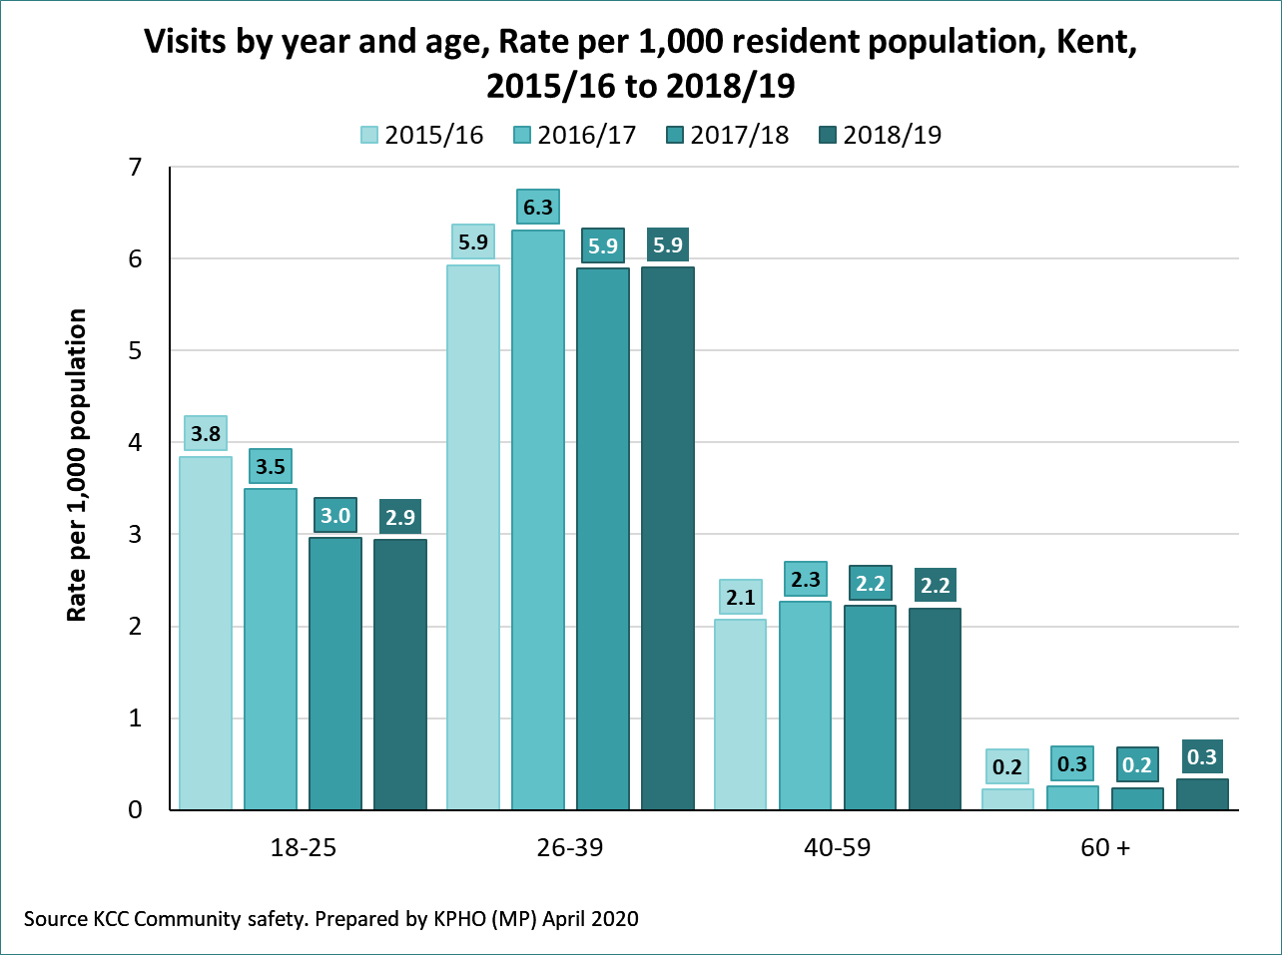

The ethnicity of service users appears to be representative of minority groups. Taking into account the different prevalence of DA amongst different ethnicities, non-White-British groups are using the service in significant numbers.

Figure 68: Ethnicity of One Stop Shop clients – Kent

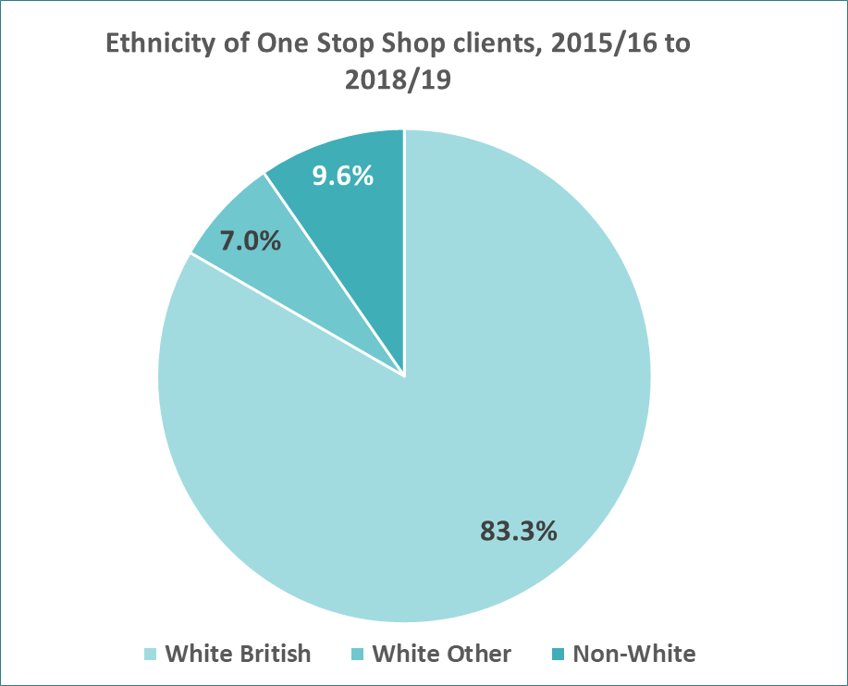

The KPHO was also provided with the types of service used by clients of the OSSs, which is presented below. ‘DA specialists’ and ‘solicitors’ were the two most commonly sought-after services across the County.

Figure 69: Ethnicity of One Stop Shop clients – Medway

Figure 70: Service usage within One Stop Shops – Kent

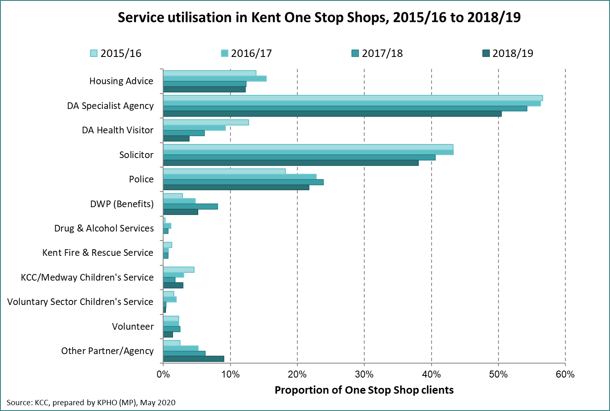

Figure 71: Service usage within One Stop Shops – Medway

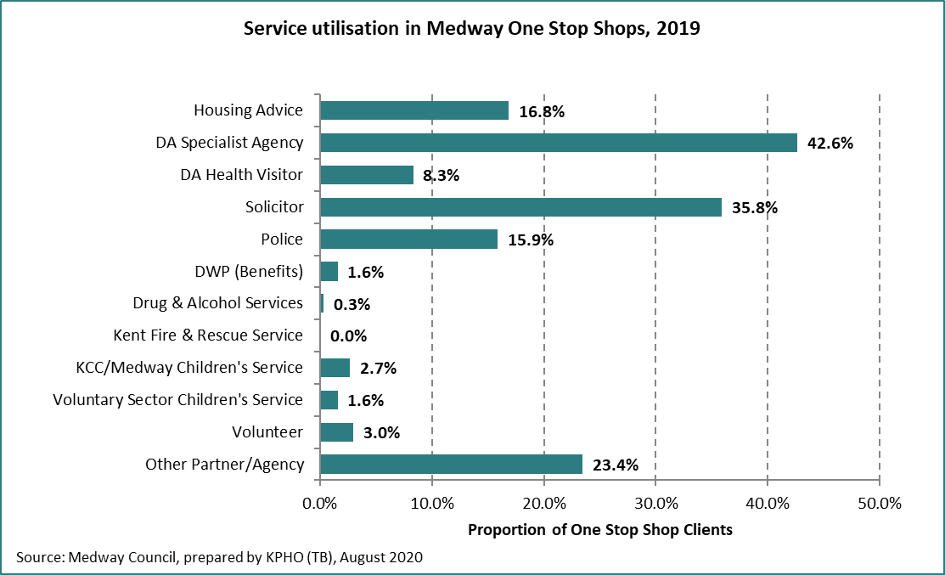

## Adult Social care (safeguarding alerts)

Adult Social Care (ASC) at Kent County Council receive safeguarding alerts via ‘Kent Adult Safeguarding Forms’ (KASAF). These are available for anyone to complete, including the general public, and after submission go to a risk-assessed triage system (KASAF stage 1). If the risk is deemed high enough, it will go to the next stage, KASAF 2, and is logged as a safeguarding enquiry. Further KASAF stages relate to the investigations and interventions put in place by ASC.

ASC at KCC recently underwent a fundamental system change from Swift to Mosaic, which went live on 16th October 2019. This change allowed additional detail to be logged from the referrals received, consequently data that relates to DA is not comparable between the system change dates and has increased since Mosaic was introduced.

KCC ASC supplied nearly 6 months of data since the implementation of MOSAIC to the end of March 2020 relating to DA and total safeguarding alerts at KASAF stage 2. Overall numbers have been scaled up to represent a calendar year, however it is important to note actual annual totals will very likely differ due to the system change and the COVID-19 quarantine.

The table below shows estimated annual totals for DA related safeguarding concerns raised at KCC ASC, and the proportion of all safeguarding concerns that relate to DA. There is a clear difference between males and females, with three times the volume of DA safeguarding issues in females than males, and nearly double the overall DA proportion of safeguarding concerns in females than males.

Figure 72: Estimated annual safeguarding issues at KASAF stage 2, by gender



Looking at differences by social care discipline, the table below shows 37.9% of physical disability safeguarding concerns were DA related, with mental health the second highest at 27.5%. Older persons safeguarding makes up over half of all safeguarding concerns, but the proportion that are DA related is lower at 21.6%.

Figure 73: DA related safeguarding concerns at KASAF stage 2, by discipline



There is a clear age gradient, with younger people more likely to experience a DA related safeguarding issue than older people, although overall volumes of safeguarding issues are higher in those age 65+.

Figure 74 DA related safeguarding concerns at KASAF stage 2, by age band

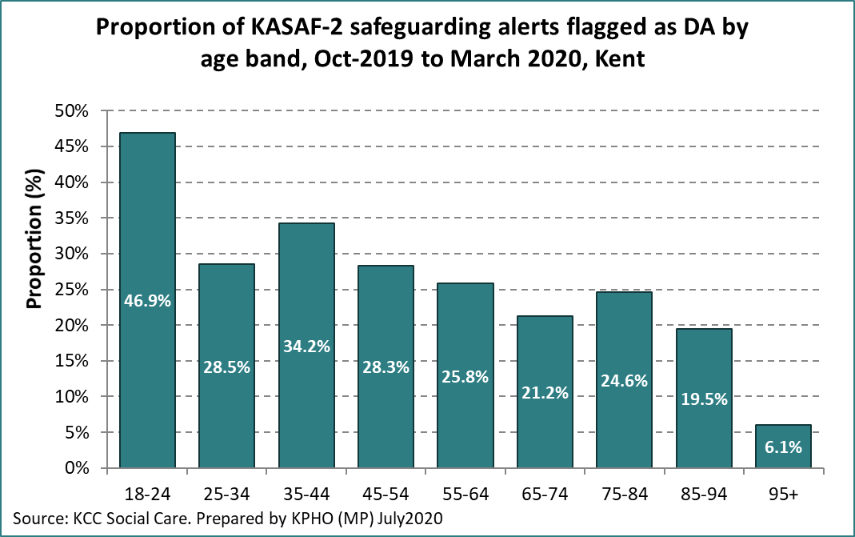

Looking at where DA related safeguarding issues are reported in Kent there are only small variations between district, with the exception of Gravesend which has a significantly higher proportion of DA related safeguarding concerns than the rest of Kent.

Figure 75: DA related safeguarding concerns at KASAF stage 2, by district

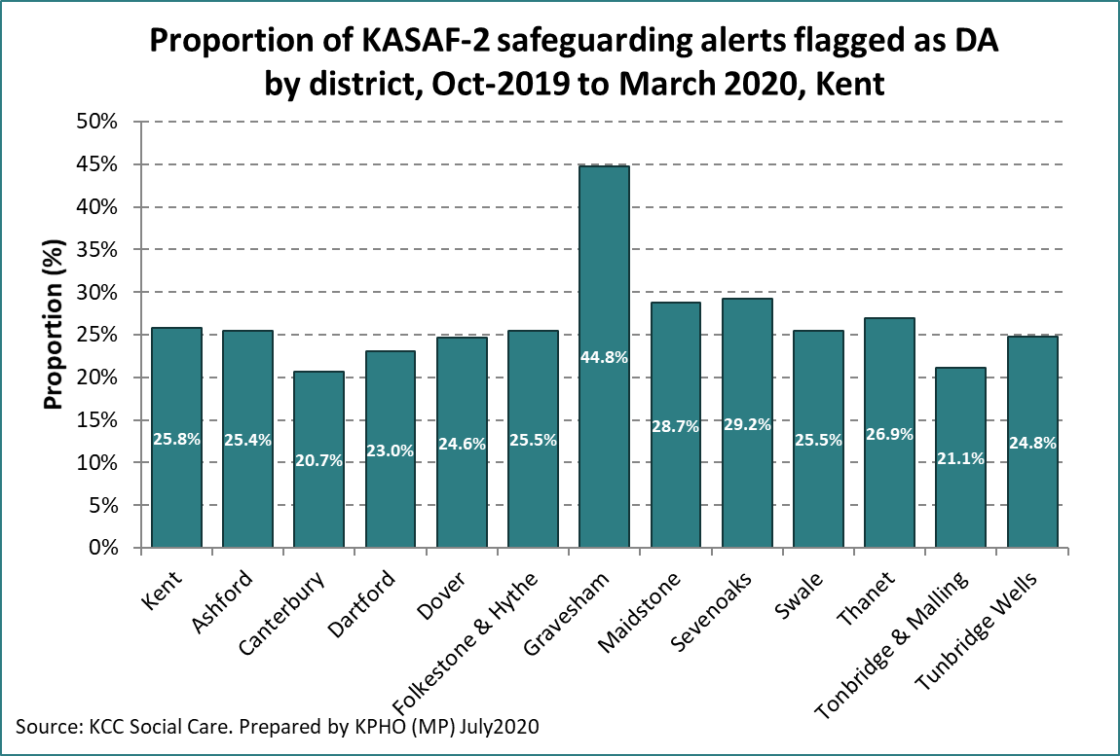

## Kent Fire and Rescue

The Kent Fire and Rescue Service (KFRS) perform Safe and Well visits[50] upon request or through referral from other agencies. Other than fire safety, the team are trained to look out for other harms and offer advice and support or onward referral to clients on a range of social and health matters. The teams are trained to spot the signs of domestic abuse and alert the appropriate services if so. KFRS also receive referrals for visits from organisations such as community safety, safeguarding and DA services.

Three years of referrals for KFRS safe and well visits - from 2017/18 to 2019/20 - are summarised in Figure 76 below.

Figure 76: Referrals for KFRS Safe and Well visits, 2017/18 to 2019/20

1. <https://www.gov.uk/government/publications/domestic-abuse-bill-2020-factsheets/domestic-abuse-bill-2020-overarching-factsheet>. Accessed 30/03/2020
2. Parliament, House of Commons (2020) *Domestic Abuse Bill* Parliamentary Copyright House of Commons 2020
3. <https://safelives.org.uk/policy-evidence/about-domestic-abuse/how-long-do-people-live-domestic-abuse-and-when-do-they-get>
4. Department of Health and Social Care, 2017, Responding to Domestic Abuse: a resource for health professionals [Accessed 01/05/2020] Available at <https://www.gov.uk/government/publications/domestic-abuse-a-resource-for-health-professionals> .
5. <https://assets.publishing.service.gov.uk/government/uploads/system/uploads/attachment_data/file/772180/horr107.pdf>
6. [Oliver, R., Alexander, B., Roe, S., Wlasny, M. (2019) ‘*The Economic and Social Cost of Domestic Abuse’* Home Office Research Report 107](https://assets.publishing.service.gov.uk/government/uploads/system/uploads/attachment_data/file/772180/horr107.pdf)
7. BBC News (2019) *Johnson promises new domestic abuse bill* BBC 12th September 2019. Available at: <https://www.bbc.co.uk/news/uk-politics-49676653> [Assessed 07/02/2020]
8. HM Government (2018) *Transforming the response to domestic abuse* Ministry of Justice Available at: <https://consult.justice.gov.uk/homeoffice-moj/domestic-abuse-consultation/> [Assessed 07/02/2020]
9. Home Office (2019) *Domestic Abuse Commissioner factsheet* Available at <https://www.gov.uk/government/publications/domestic-abuse-bill-2019-factsheets/domestic-abuse-commissioner-factsheet> [Assessed 14/02/2020]
10. Home Office (2020) *Policy Paper: Secure tenancies and victims of domestic abuse facts sheet* [Online] [Assessed 11/03/2020] Available at <https://www.gov.uk/government/publications/domestic-abuse-bill-2020-factsheets/secure-tenancies-and-victims-of-domestic-abuse-factsheet>
11. Home Office (2019) *Domestic Abuse Protection Notices/ Orders factsheet Available at* <https://www.gov.uk/government/publications/domestic-abuse-bill-2019-factsheets/domestic-abuse-protection-notices-orders-factsheet> [Assessed 14/02/2020]
12. Home Office (2019*) Domestic Violence Disclosure Scheme factsheet* Available at <https://www.gov.uk/government/publications/domestic-abuse-bill-2019-factsheets/domestic-violence-disclosure-scheme-fact-sheet> [Assessed 14/02/20]
13. Home Office (2019) *Domestic Abuse Bill 2019: overarching fact sheet* Policy paper. Available at <<https://www.gov.uk/government/publications/domestic-abuse-bill-2019-factsheets/domestic-abuse-bill-2019-overarching-fact-sheet>> [Assessed 07/02/2020]
14. The Home Office, Ministry of Justice (Fed 2020) <https://assets.publishing.service.gov.uk/government/uploads/system/uploads/attachment_data/file/869070/Impact_assessment.pdf>
15. <https://www.thelancet.com/journals/eclinm/article/PIIS2589-5370(20)30092-4/fulltext>
16. <https://www.un.org/sexualviolenceinconflict/wp-content/uploads/2020/05/press/pandemics-and-violence-against-women-and-children/pandemics-and-vawg-april2.pdf>
17. <https://www.bbc.co.uk/news/uk-52157620>, last accessed 20 April 2020.
18. <https://www.kent.gov.uk/about-the-council/information-and-data/Facts-and-figures-about-Kent/economy-and-employment#tab-5>
19. <https://www.ons.gov.uk/peoplepopulationandcommunity/crimeandjustice/bulletins/domesticabuseinenglandandwalesoverview/november2019>
20. <https://www.ons.gov.uk/peoplepopulationandcommunity/crimeandjustice/methodologies/userguidetocrimestatisticsforenglandandwales#appendix-1-recorded-crime-list>
21. <https://www.ons.gov.uk/peoplepopulationandcommunity/crimeandjustice/methodologies/userguidetocrimestatisticsforenglandandwales#offence-types>
22. <https://www.ons.gov.uk/peoplepopulationandcommunity/crimeandjustice/methodologies/crimeandjusticemethodology>
23. <https://www.ons.gov.uk/peoplepopulationandcommunity/crimeandjustice/methodologies/userguidetocrimestatisticsforenglandandwales#comparison-of-the-csew-and-police-recorded-crime>
24. <https://assets.publishing.service.gov.uk/government/uploads/system/uploads/attachment_data/file/597435/DometicAbuseGuidance.pdf>
25. <https://safelives.org.uk/sites/default/files/resources/Spotlight%20on%20HBV%20and%20forced%20marriage-web.pdf>
26. <https://safelives.org.uk/practice_blog/supporting-bme-victims-%E2%80%93-what-data-shows>
27. <https://www.ons.gov.uk/employmentandlabourmarket/peopleinwork/employmentandemployeetypes/methodologies/annualpopulationsurveyapsqmi>
28. <https://www.nomisweb.co.uk/datasets/apsnew>
29. <https://www.ncbi.nlm.nih.gov/pmc/articles/PMC4582621/>
30. <https://www.who.int/violence_injury_prevention/violence/world_report/factsheets/fs_intimate.pdf>

    <http://www.ias.org.uk/uploads/IAS%20report%20Alcohol%20domestic%20abuse%20and%20sexual%20assault.pdf>
31. <https://assets.publishing.service.gov.uk/government/uploads/system/uploads/attachment_data/file/597435/DometicAbuseGuidance.pdf>, last accessed July 2020
32. <https://www.ons.gov.uk/peoplepopulationandcommunity/crimeandjustice/articles/domesticabusevictimservicesenglandandwales/november2019>
33. <https://safelives.org.uk/policy-evidence/about-domestic-abuse/how-widespread-domestic-abuse-and-what-impact#how%20many%20die>
34. <https://assets.publishing.service.gov.uk/government/uploads/system/uploads/attachment_data/file/597435/DometicAbuseGuidance.pdf>
35. Current Home Office guidance provides criteria for the circumstances in which a DHR may be required.  These criteria focus on the death of a victim (not a perpetrator) of domestic abuse.
36. SafeLives (N.D) *Guidance for Multi-Agency Forums: Older People* [Online] [Assessed 12/03/2020] Available at <http://www.safelives.org.uk/sites/default/files/resources/NSP%20Guidance%20Older%20People%20FINAL_0.pdf>
37. ‘A Safe Home’: Breaking the link between homelessness and domestic abuse. All-Party Parliamentary Group for Ending Homelessness. <https://www.crisis.org.uk/media/240459/cri0198_domesticabusebill_appg_report_2019_aw_web.pdf>, last accessed July 2020.
38. Nowhere to turn project, Women’s Aid.

    <https://www.womensaid.org.uk/women-escaping-domestic-abuse-left-at-risk-of-homelessness/>, last accessed July 2020.
39. One example of an incident that would not lead to a crime recording is a loud argument reported by a third party. On investigation, the incident may not have involved an offence. The incident, however, would still be recorded by the Police for intelligence purposes and would still be risk assessed.
40. This is likely to be an underestimate of the percentage of DA in the community which could be going unreported to the Police. Kent Police holds records of both incidents and individuals linked to DA, but most data concerning personal characteristics are stored within incident records. KPHO therefore took the decision to compare estimated prevalence of **individuals** from the Crime Survey for England and Wales with **incident** data from Kent Police. This approach crudely assumes that each individual victim reports just 1 incident per year. Data from Kent Police, however, identifies that approximately 30% of victims report multiple incidents per year.
41. <https://safelives.org.uk/practice-support/resources-marac-meetings/latest-marac-data>
42. <https://safelives.org.uk/practice-support/resources-marac-meetings/latest-marac-data>
43. Using ONS mid-year estimates for Kent age 16+
44. <https://www.ons.gov.uk/peoplepopulationandcommunity/crimeandjustice/datasets/domesticabuseinenglandandwalesdatatool>
45. <https://assets.publishing.service.gov.uk/government/uploads/system/uploads/attachment_data/file/575232/HO-Domestic-Homicide-Review-Analysis-161206.pdf>
46. Oliver, R., Alexander, B., Roe, S., Wlasny, M. (2019) ‘The Economic and Social Cost of Domestic Abuse’ Home Office Research Report 107
47. <https://www.ons.gov.uk/peoplepopulationandcommunity/crimeandjustice/articles/homicideinenglandandwales/yearendingmarch2019#which-groups-of-people-were-most-likely-to-be-victims-of-homicide>
48. <https://www.ons.gov.uk/peoplepopulationandcommunity/crimeandjustice/articles/domesticabuseprevalenceandtrendsenglandandwales/yearendingmarch2019>
49. <https://safelives.org.uk/sites/default/files/resources/Idva%20NDS%20201819.pdf>
50. <https://www.kent.fire-uk.org/your-safety/home-safety/safe-and-well-visits/>