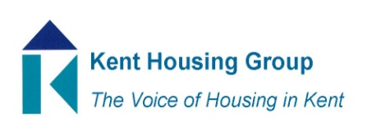
Kent Housing Options Group
Thursday 21st January 2021
The meeting will start promptly at 10.00am
Microsoft Teams (as shared in the calendar appointment)
Agenda
10.00am Matters Arising 10th December 2020 KHOG Call
10.05am MHCLG Update – Marie Gerald, MHCLG
10.25am Safer Renting's Housing Rights partnership service – Ben Reeve-Lewis,
10.45am Protocols Update – including Kent Health & Safety Guide for Colleagues
11.00am PRS Sector & Arrears – CAB Report
https://www.citizensadvice.org.uk/Global/CitizensAdvice/Housing%20Publications/New%20year,%20same%20arrears.pdf
11.15am Commissioning Updates (Adults, YP and Domestic Abuse)
11.35am Feedback/Progress on the Changing Futures Fund EOI
11.45am Prison Release Protocol & Positive Covid Ex-offenders
11.55am Kent Public Health Update – Lin Guo, Kent PH
12.05pm Any Urgent National Policy, Case Law Updates
12.15pm AOB

MEETING TO CLOSE by 12.30pm

