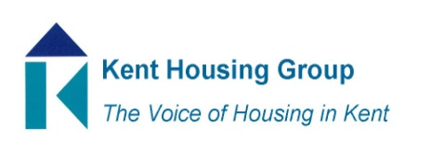
Kent Housing Options Group
Thursday 24th June 2021
The meeting will start promptly at 10.00am
Microsoft Teams (as shared in the calendar appointment)
Agenda
10.00am Matters Arising 22 April 2021 KHOG Call
10.05am MHCLG Update – Marie Gerald, MHCLG
10.30am Move On Accommodation options for Veterans – Will Campbell-Wroe, RBLI
10.45am One You Information – Sarah Martin, NHS
11.00am Commissioning Updates (Adults, YP & Domestic Abuse)
11.30am REFRESHMENT BREAK
11.40am KCC Hardship Funding Update
11.45am KHG/KHOG Protocols Update
11.55am Rough Sleepers and the Covid/Health Response Update
12.05pm Any Urgent National Policy, Case Law Updates
12.20pm AOB (to include any updates from our wider membership representation)

MEETING TO CLOSE by 12.30pm

