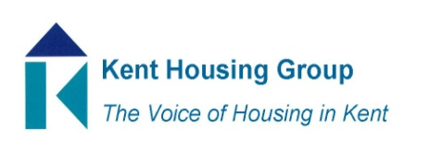
Kent Housing Options Group
Monday 7th December 2020
The meeting will start promptly at 9.30am
Microsoft Teams – joining instructions in the appointment
Agenda
- Introductions and apologies
- NARLA Update – Marion Money
- Kent & Medway Group & HIA Verbal Updates
- KMSEP
- KEEP
- Swale Staying Put
- Chair of KPSHG – Vote and Handover
- Local Authority Roundtable – News/Updates/Top Three Issues
- Matters Arising from Countywide Group Updates*
- RISE Event 2021 Update
- AOB

MEETING TO CLOSE by 11.00am
*Papers shared ahead of the meeting

