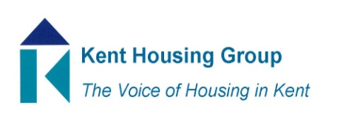
Kent Housing Options Group
21 June 2018
The meeting will start promptly at 10 am, so please ensure that you arrive in good time
Room 6D, Maidstone House, Maidstone
Agenda
1. 10.00 am Introductions & Apologies
2. 10.05 am Action Log from Meeting 15 March 2018*
3. 10.15 am Homeless Prevention Tool - Phil Agulnik, ‘Entitled to’
4. 10.45 am Out of London Placements Data Hub – Tom Knight, Affinity Works
5. 11.15 am Terms of Reference*
6. 11.30 am Tonbridge and Malling Ombudsman Case – Update – Jane Smither
7. 11.45 am Q & A with Specialist Advisor MCHLG re the HRA 2017 – Richard Williams
8. 12 noon Protocols – Standing Item
9. 12.15 pm Recent Case Law – Standing Item
10. 12.30 pm National Policy – Standing Item
11. 12.45 pm Training Opportunities, including local training - Standing Item
12. 1.00 pm AOB

MEETING TO CLOSE AT 1.15 pm

Next Meeting: 13 September 2018 (LA only meeting)
2018 Meetings: 1 November 2018 (Full meeting), 13 December 2018 (LA only meeting) all meetings to start promptly at 10 am and all to be held at MBC Offices
*Papers attached

