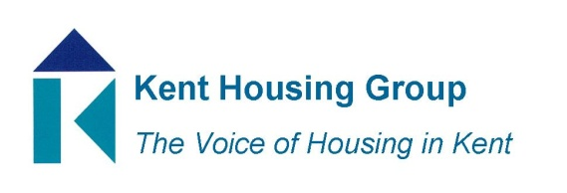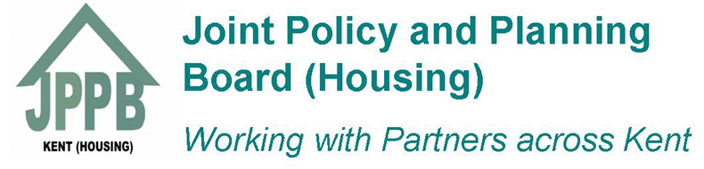

2017 KENT HOUSING GROUP AND KENT JOINT POLICY AND PLANNING BOARD (HOUSING) EXCELLENCE AWARDS
CATEGORIES

1. Excellent Partnership
This award is for an organisation with the strategic vision to recognise working in partnership can improve its overall contribution to its customers and the communities it works in. We’re looking for a partnership that has resulted in an improvement to service or delivery of a particular scheme, for example regeneration, community safety, health initiatives, public health, sustaining tenancies/assisting those at risk.
2. Excellence in delivering services for Vulnerable People
This award recognises the development of excellent services meeting the needs of a specific group, such as younger or older people or another group that requires additional support enabling them to live independently. We will be looking at both your overall approach and specific outcomes achieved. Nominations are invited for a person, organisation or project delivering excellent services to vulnerable people.
3. Excellence in Development
This award recognises the development of homes (new or refurbished) which make a significant contribution to meeting housing needs and improves perceptions of affordable housing. The winning development won’t necessarily be a large scheme as successful development is about meeting housing needs, demonstrating effective delivery of new homes and doing so in a way that delights residents and the wider local community through excellence in design, construction or public realm.
4. Excellence in Any Service
Awarded to a person or team delivering a great service in challenging times and which demonstrates value for money. To win this award you’ll have developed an excellent and efficient service. We’ll be looking at both your overall approach and specific outcomes achieved.
5. Excellent Project led by a Resident or Residents
This award recognises a project or initiative led by a resident/residents benefitting the local community. This could be something which contributes to improving health and well being, improving physical conditions and/or contributing to community engagement or a project which has addressed issues such as vandalism, anti-social behaviour, social inclusion, etc.
6. Excellent Young Achiever (up to 25 years)
This award recognises the work of young people in our sector and their contribution in delivering good quality homes and housing services. We’re looking for someone who has demonstrated excellence in their work and an enthusiasm for their self-development. This category includes recognition for apprentices or trainee employees
7. Excellent Health or Social Care Professional
To be awarded to someone that has made a significant contribution to their profession and/or customers during the year. This award recognises an individual who demonstrates an in-depth understanding and knowledge of the sector. We’re looking for someone who’s a role model, and has personal and professional integrity with the ability to help and support others.
8. Excellent Housing Professional of the Year
To be awarded to someone that has made a significant contribution to the housing profession and/or residents during the year. This award recognises an individual who demonstrates an in-depth understanding and knowledge of the sector. We’re looking for someone who’s a role model, and has personal and professional integrity with the ability to help and support others.

